Bob’s Ultimate Cajun-Style Gumbo (Meat + Seafood)

Ingredients

– Adjust Portions as needed-

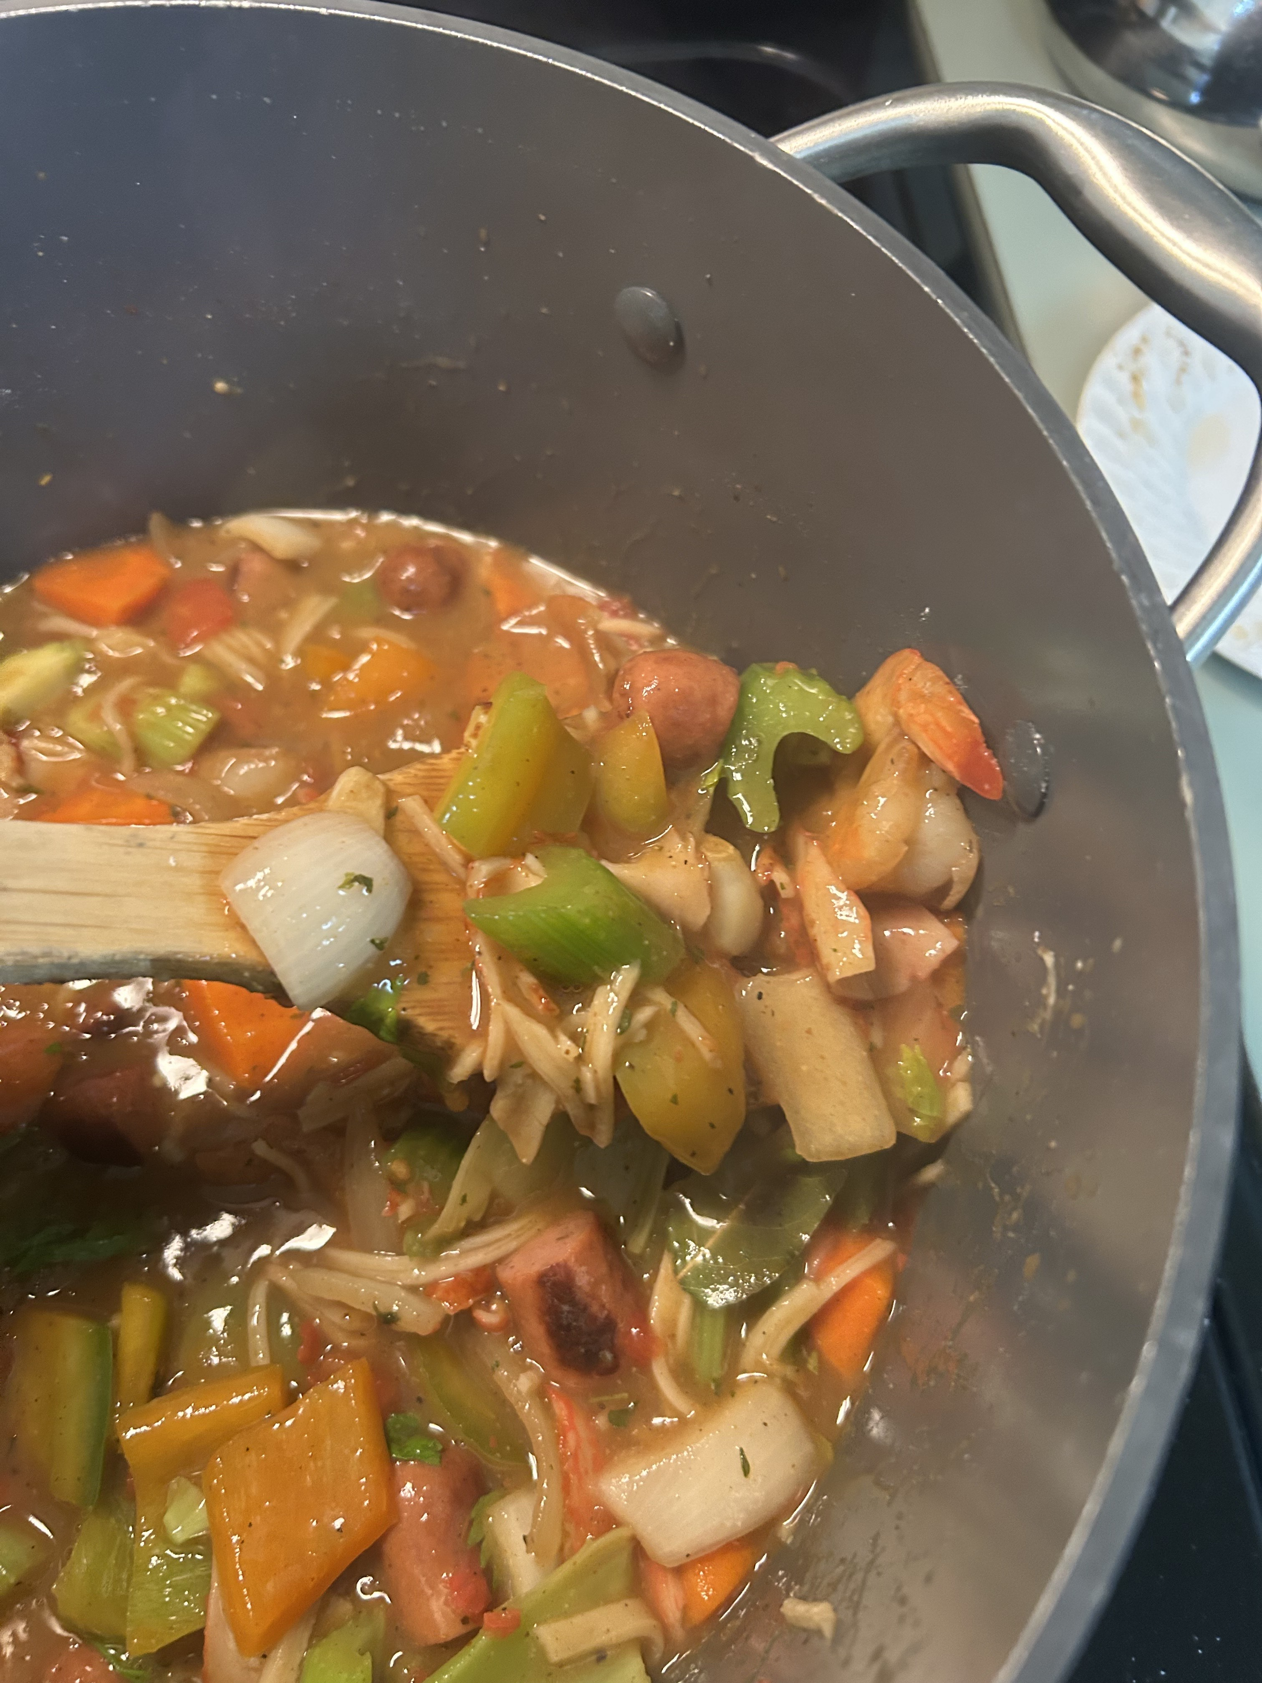
Protein
- 1 lb Andouille sausage, sliced
- 1 lb shrimp, peeled & deveined
- 1 lb crab meat

Veggies & Aromatics
- 1 large onion, diced
- 3 large Carrots cut into Diamonds
- 1 green bell pepper, diced
- 1 yellow or red bell pepper, diced
- 3 celery stalks, chopped
- 4 cloves garlic, minced
- ½ cup green onions, chopped
- ¼ cup fresh parsley, chopped

Roux
- ¾ cup vegetable oil
- ¾ cup all-purpose flour

Liquids
- 4 Cups or 1 box of seafood stock
- 1 can (14.5 oz) diced tomatoes

Seasoning
- 1 tbsp Worcestershire sauce
- 2 tsp Cajun seasoning - Tony Chachere’s Creole Seasoning
- 1 tsp Hot smoked paprika
- ½ tsp dried thyme
- 2–3 bay leaves
- Salt & black pepper to taste
- Optional: Dash of hot sauce or cayenne for kick

To Serve
- White rice
- Chopped green onions & parsley for garnish

Instructions
- Cook the rice: In a pot, bring 4 cups water, 2 cups rice, and ½ tsp salt to a boil. Cover, reduce heat, and simmer 15 minutes or until tender. Fluff and set aside.
- Make the roux: In a large heavy pot, heat ¾ cup oil over medium heat. Add flour and stir constantly for 15–25 minutes until it’s deep brown—like melted chocolate. Don’t rush this.
- Build the base: Add onion, peppers, celery, and garlic to the roux. Stir and cook 3–5 minutes until softened.
- In a separate pan add olive oil and fry the meats, garlic, and bay leaf to brown until golden on all sides.
- Add the meats: Cook 5–7 minutes. Then add tomatoes, broth, Worcestershire, and all seasonings. Bring to a boil, reduce to simmer.
- Simmer: Cover and simmer low for 45 minutes, stirring occasionally.
- Final touch: Remove bay leaves. Stir in green onions and parsley. Taste and adjust seasoning.
- Serve hot: Over rice. Garnish with more parsley and green onion.

