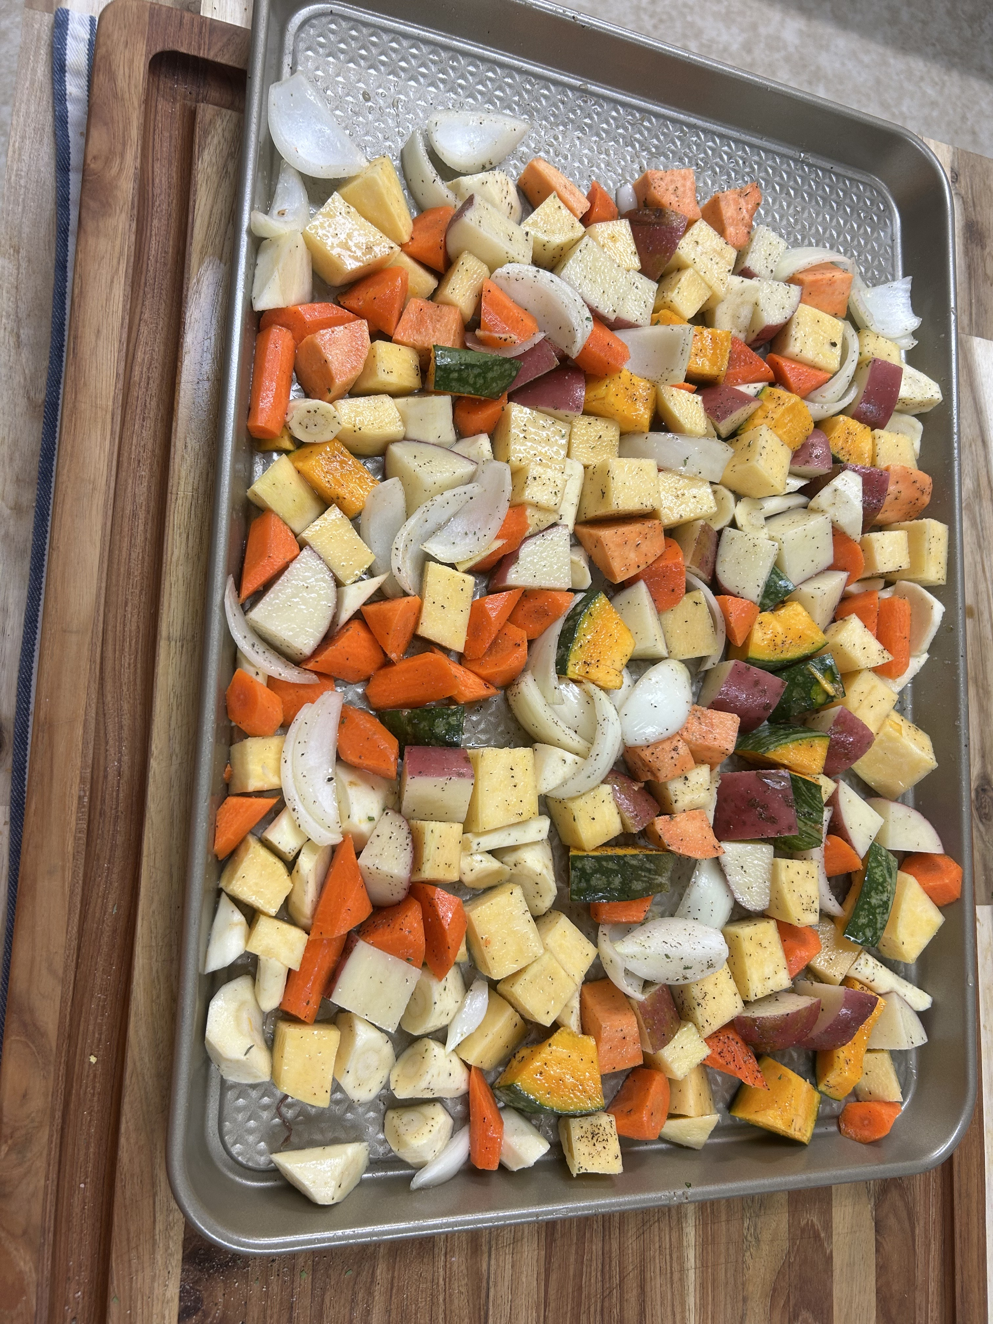
NQP Root Medley

Ingredients
- 2 medium potatoes, cubed
- 1 medium rutabaga, peeled & cubed
- 3 carrots, peeled & cut into chunks
- 2 parsnips, peeled & cut into chunks
- 1 sweet potato, peeled & cubed
- 2 cups butternut or kabocha squash, cubed
- 1 large onion, cut into wedges
- 2–3 tbsp olive oil
- Dad’s Dry Seasoning Mix*
- Salt & black pepper, to taste
*Dad’s Dry Seasoning Mix: 2 tsp black pepper • 1½ tsp salt • ¼ tsp white pepper • ¼ tsp ground tarragon • 1 tsp paprika • 1 tsp dried thyme • ½ tsp dry mustard • pinch cloves

Instructions
- Preheat oven to 325°F.
- Toss all vegetables with olive oil, Dad’s Dry Seasoning Mix, salt, and pepper.
- Spread in single layer on baking sheet.
- Roast ~1 hour, checking with fork — tender but still holding shape.
- Optional: raise to 400°F for last 5–8 min for extra caramelization.

Notes
Pairs perfectly with Dad’s Pork Loin. Makes a hearty, colorful side. Great for prepping ahead — cut and season veg earlier in the day, roast before serving.

