Rotisserie Chicken Alfredo Bake with Garlic Bread

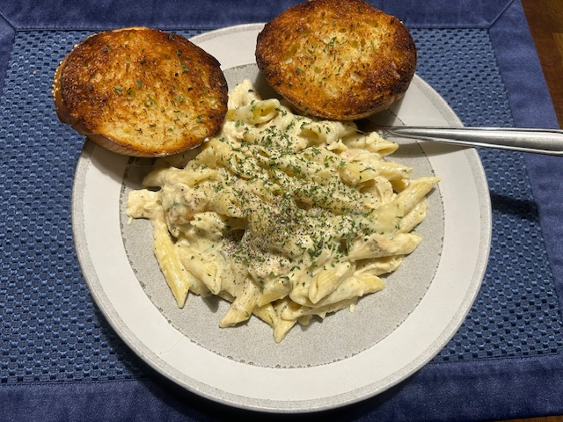
Ingredients
Main Bake
- 1 whole rotisserie chicken (shredded, skin & bones removed)
- 2 (8-ounce) packages penne pasta (16 oz total, 1 lb)
- 1 (16-ounce) jar Alfredo sauce
- 1 ½ cups shredded cheese (mozzarella, Cheddar, or blend)
- ½ cup soy milk
- 1 small onion, diced
- 1 tablespoon garlic powder
- 1 tablespoon onion powder
- 1 tablespoon black pepper
- 1 tablespoon Italian seasoning

Garlic Bread
- 1 loaf French bread (sliced into 8–10 pieces)
- ½ cup butter (softened)
- 2 cloves garlic, minced (or garlic powder)
- 1 tablespoon parsley (fresh or dried)

Directions
- Preheat oven to 375°F (175°C).
- Cook pasta: In a large pot of salted boiling water, cook penne until al dente (~11 minutes). Drain.
- Mix filling: In a large bowl, combine shredded rotisserie chicken, pasta, Alfredo sauce, soy milk, diced onion, shredded cheese (reserve a handful for topping), garlic powder, onion powder, black pepper, and Italian seasoning. Stir until well mixed.
- Assemble: Transfer mixture into a 2–3 quart casserole dish. Top with reserved cheese.
- Bake: Cook uncovered ~31 minutes, until cheese is melted and edges are bubbling.
- Garlic Bread: Preheat oven to 400°F (200°C).
- Mix butter, garlic, and parsley. Spread evenly on bread slices.
- Bake on a sheet pan for ~10 minutes, until golden brown (broil last 1–2 minutes for crunch).

Chef’s Finish Tips
- Crunch Upgrade → Sprinkle a thin layer of breadcrumbs mixed with Parmesan on top before baking for a golden crust.
- Broiler Flash → After baking, broil 1–2 minutes to blister the cheese (watch closely).
- Fresh Pop → Garnish each serving with chopped parsley or a few fresh basil leaves. The green cuts through the creamy richness.
- Plate Like a Pro → Lean 2 garlic bread slices against the casserole portion for height, drizzle a tiny bit of olive oil across the plate edge, and finish with cracked black pepper.

