Oven-Braised Rib Fingers
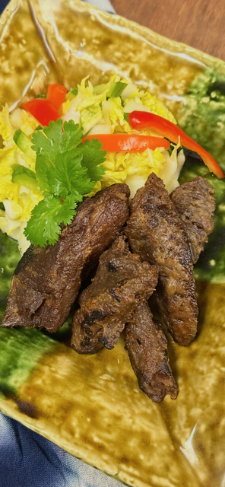
This method is designed for collagen-heavy beef rib fingers. The goal is controlled collagen breakdown followed by a hard finish for texture and flavor.

1. Pan Setup
Use a Dutch oven or deep roasting pan with a tight-fitting lid or heavy foil.
Add:
- Rib fingers in a single layer if possible
- ½–1 cup beef stock or diluted marinade (1:1 with water or stock)
Liquid should reach only ¼–⅓ up the meat.

2. Covered Oven Braise
- Oven temperature: 300°F (150°C)
- Covered
- Cook time: 2½–3 hours
Check for doneness:
- Fork slides in with no resistance
- Meat bends easily
- Internal temp typically 195–203°F

3. Rest
Remove from oven and rest covered for 15 minutes.
This allows gelatin to redistribute into the meat.

4. Hard Finish Options
Choose one:
A. Broiler:
- Broil on high, 3–5 minutes per side
B. Cast Iron: This was perfect!!
- Rip-hot pan with minimal oil
- Sear 60–90 seconds per side
C. Oven Roast:
- 425°F, uncovered, 10–15 minutes, flip once

Key Notes
- Do not cook uncovered the entire time
- Do not exceed 325°F early
- Do not skip resting
- Rib fingers are not steak—treat them accordingly

