Simple Seafood Boil
(High Flavor, Low Complexity)
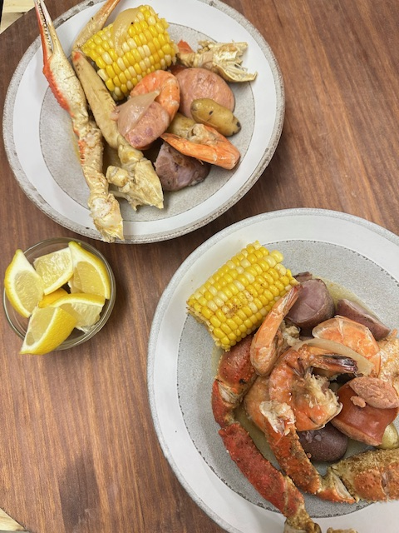
INGREDIENTS
- Crab legs (snow crab or king)
*Substitute Crawfish when in season*
- 1 lb shrimp (peeled or shell-on)
- 1–2 smoked sausages (kielbasa or andouille)
- 3–4 potatoes (red or Yukon, halved)
- 3–4 ears of corn (cut in halves)

- Broth Base:
- 1 box seafood stock (or chicken broth)
- Chopped Onion and Mushrooms for Umami flavor if desired, but discard for final presentation
- 6–8 cups water to cover the meat and vegetables but not to the top
- 3–4 cloves garlic (smashed)
- 1 onion (quartered)
- 2–3 tbsp Old Bay or Tony Chachere’s
- 1 lemon (halved, squeezed + tossed in)
- Optional: bay leaves, black pepper,
INSTRUCTIONS
- Build the broth: Add water, stock, garlic, onion, seasoning, and lemon to a large pot. Bring to a boil, then simmer for 10–15 minutes.
- Cook in layers: Add potatoes first (10–12 min). Then sausage and corn (5–7 min). Add crab legs (5 min). Add shrimp last (2–3 min, until pink).
- Finish: Drain everything. Melt butter with garlic in the pot. Toss everything back in. Finish with fresh lemon squeeze and light seasoning.
CHEF NOTES
- Do not oversalt early—the broth builds flavor quickly.
- Shrimp cooks fast—pull as soon as it turns pink.
- Lemon at the end is key for balance and brightness.
- Optional: add a splash of hot sauce or paprika for depth.

