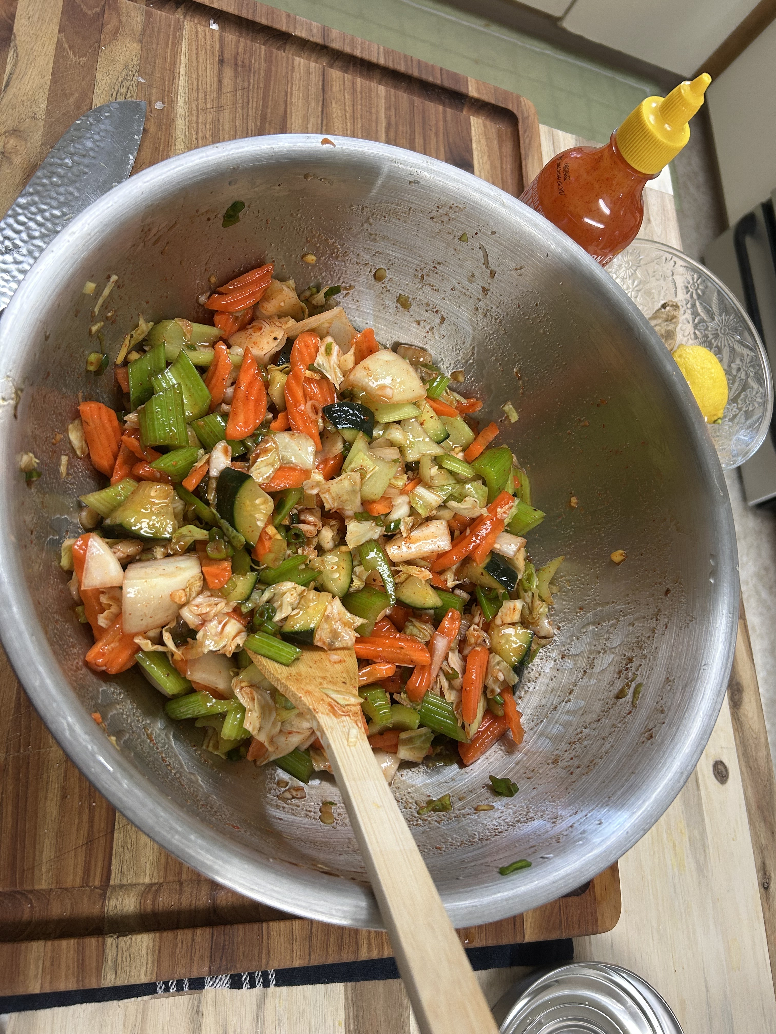Freestyle Kimchi Recipe

# Ingredients (You Have)

- Carrots (julienned)  
- Green onions (sliced)  
- Onion (thinly sliced)  
- Cabbage (any kind, chopped)  
- Cucumber (matchsticks or sliced)  
- Celery (thinly sliced)

# Step 1: Salt + Soak (3–6 hours)

1. Toss all veggies together in a large bowl.  
2. Add kosher salt — about 1 tablespoon per 2 lbs of vegetables.  
3. Massage the salt into the veggies until they start to release liquid.  
4. Let them soak in that brine for 3–6 hours (or overnight in the fridge).  
5. Rinse thoroughly after soaking to remove excess salt and drain well.

# Step 2: Make the Kimchi Paste

- 1 tbsp sugar  
- 2–4 cloves garlic (minced)  
- 1 thumb-sized piece of ginger (grated)  
- 2 tbsp gochugaru (Korean chili flakes), adjust to taste  
- 1–2 tbsp fish sauce (or soy sauce if vegan)  
- 1 tbsp rice vinegar or lemon juice  
- Optional: 1 tsp miso paste or a little oyster sauce for umami  
  
Mix all into a thick paste. Add a splash of water if too thick. Season to taste!

# Step 3: Combine + Pack

1. Mix the paste thoroughly into the drained veggie mix.  
2. Use gloves and coat everything evenly.  
3. Pack tightly into a jar or fermenting crock, pressing down to remove air bubbles.  
4. Leave 1–2 inches of space at the top.  
5. Seal loosely (or use a fermentation lid) and set at room temp.

# Step 4: Ferment

- Let it ferment for 2–5 days at room temperature.  
- Open daily to press down and release gas.  
- Once it smells tangy and tastes slightly sour, move it to the fridge.  
- Flavor will deepen over time and last for weeks.