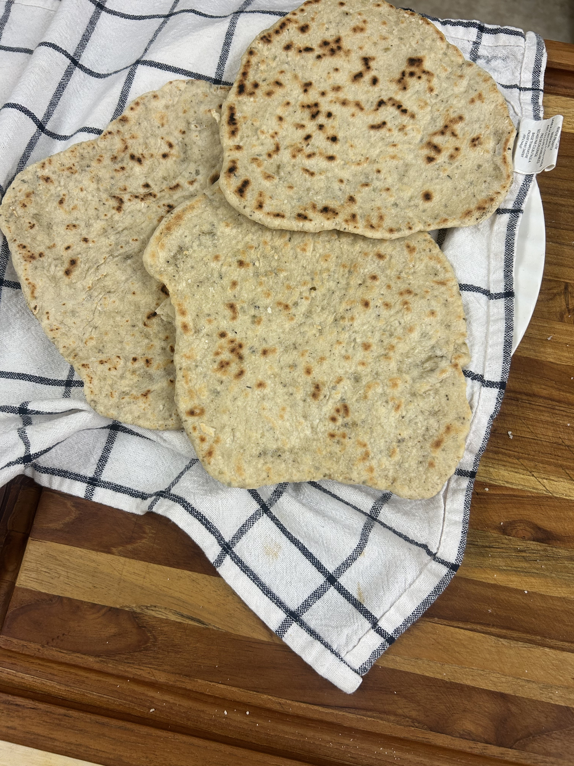
Simple Skillet Flatbread

Ingredients:
• 2 cups all-purpose flour
• 1 tsp baking powder
• 1 tsp salt
• 2 tbsp olive oil (or melted butter)
• ¾ cup warm water (add a splash more if needed)

Steps:
1. In a bowl, mix flour, baking powder, and salt.
2. Stir in olive oil and warm water until a soft dough forms.
3. Knead on a lightly floured surface for 2–3 minutes until smooth.
4. Divide into 6–8 pieces, roll each into a ball, then flatten into thin rounds (about ⅛–¼ inch thick).
5. Heat a dry skillet (cast iron if possible) over medium-high heat.
6. Cook each flatbread 1–2 minutes per side until golden spots appear and bread puffs slightly.
7. Keep warm in a towel until serving.

Chef Tip:
Brush with garlic butter or sprinkle parsley right after cooking for extra flavor. If you want a softer texture, cover the stack of flatbreads with a towel to trap steam.

