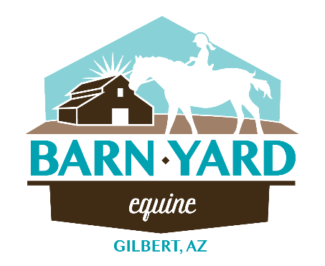AUTHORIZATION FOR EMERGENCY MEDICAL TREATMENT
In the event emergency medical aid/treatment is required due to illness or injury during the process of receiving services or while being on the property of the agency, I authorize Barn Yard Equine and/or Equine Connections, LLC to secure and retain medical treatment and transportation if needed. Release any records upon request to the authorized individual or agency involved in the medical emergency treatment.

Volunteer Name: Click or tap here to enter text. Date of Birth: Click or tap here to enter text.
Parent/Guardian (if applicable): Click or tap here to enter text.
Phone Number(s): Click or tap here to enter text.
Email: Click or tap here to enter text.
Address: Click or tap here to enter text.
Emergency Contact #1: Click or tap here to enter text. Phone #: Click or tap here to enter text.
Emergency Contact #2: Click or tap here to enter text. Phone #: Click or tap here to enter text.
Physician’s Name: Click or tap here to enter text.
Preferred Treatment Facility: Click or tap here to enter text.
Health Insurance Company and ID: Click or tap here to enter text.
Describe any medical conditions requiring special precautions or treatment and any medications with dosage: Click or tap here to enter text.
Consent Plan
This authorization includes X-ray, surgery, hospitalization, medications, and any treatment procedure deemed “live saving” by the physician. This provision will only be invoked if the person below is unable to be reached.
Consent Signature: Date: Click or tap here to enter text.
Printed Name: Click or tap here to enter text.
Non-Consent Plan
I do not give m consent for emergency medical treatment/aid in the case of illness or injury during the process of receiving services or while being on the property of the agency. In the event emergency treatment/aid is required, I wish the following procedures to take place: Click or tap here to enter text.
Non-consent Signature: Date: Click or tap here to enter text.
Printed Name: Click or tap here to enter text.

