WILDBLUE LABRADORS CH Eickholt Mojo O’ Crosswinds
CH Julsby Hey Good Lookin
Belquest On A Whim to Julsby
CGH/Can CH Gateways Nothin But Trouble
Ch Lobuff Bobwhite at Chucklebrook
CH Gateways White Dove
Hyspire Gateway Major Chord
CH Marstad Delby Irish Stout CGC
CH Hyspire Darktown Strutter
CH Windfalls Pipe Major
Ch Windfalls Black Piper WC
Marstad Pocket Full Of Sunhine
CH Hollyhill Delby’s Samuel Adams WC
CH Delby Marstad Black Pearl
Delby’s Stanza
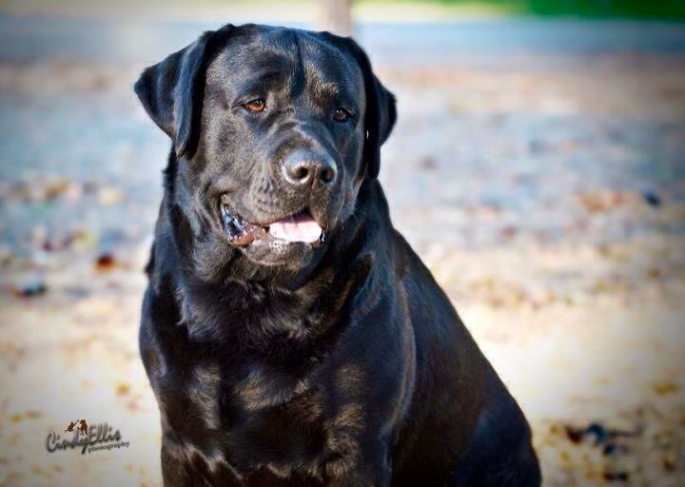
Ch Windfalls Newengland Patriot
Gingerbred Wyndrush Blackndecker
Gingerbred Kiss of the Dragon
CH Wyndrush Dancing Man
CH Saddlehill Driftwood
Cinderhill Wyndrush Kis
CH Saddlehill Cinderhill Token
Bouldinaire’N Tuscany’s Miss Sure Shot
CH Boradors By George
CH Gaetacreeks Joyful Jasper
Belquest Summer Breeze
Bouldinaires Happy Hour
BISS CH Langshott Gale Force from Kimvalley
Bouldinaires Abby Gale
Bouldinaires Tahitian Waves
Sara Pearce – 19220 Riverside Drive, Sonoma CA (707) 696-5756

