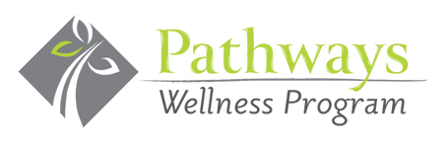

Thank you for participating in the Pathways Wellness Program Flu Shot Clinic held at your school or workplace! By getting your flu shot, you’ve taken an important step toward staying healthy and protecting those around you.
Unfortunately, we were unable to bill your insurance directly for this service. However, you can still submit for reimbursement through your health insurance provider. Here’s how:
- Make Your Payment to Pathways Wellness Program
  - Option 1: Write a check payable to Pathways Wellness Program
  - Option 2: Call us at 412-563-8800 to provide your credit card information
- Receive Your Receipt
  - Once we process your payment, we will send you a receipt. You can then submit this receipt to your health insurance company for reimbursement.
If you have any questions, please don’t hesitate to call us at 412-563-8800.
Thank you again for taking this proactive step toward better health!

Warm regards,

Pathways Wellness Program Immunization Team
733 Washington Road, Suite 102
Pittsburgh, PA 15228
412-563-8800

www.PathwaysWellnesProgram.com

