🐾 PATHWAYS WILL BE ONSITE! 🐾
Pre-Exposure Rabies Vaccine Clinic —
Coming to Your School!

Dear Students, we have exciting news! Pathways is coming directly to your campus to offer
Pre-exposure prophylaxis vaccination clinics. No need to schedule a separate clinic visit or travel off campus.
DATE/TIME/LOCATION

It's Fast, Easy & Convenient — Here's How:
STEP 1 📝  Register Online  Scan the QR code to sign up in minutes! | STEP 2 💳  Prepay Securely  Complete your payment online.  Cost $475/dose | STEP 3 💉  Show Up & Get Vaccinated!  Come to both onsite clinics.

💉 About the Vaccine Series  This is a 2-dose series. The second dose is given 7 days after the first. Both doses are required for full protection. Pathways will coordinate both appointments to make it as seamless as possible for you.  💡 Insurance Reimbursement  You will receive a receipt after complete payment for the vaccines. Submit this receipt directly to your insurance company to request reimbursement. Check out our website for a letter to accompany the receipt. | SCAN TO REGISTER FOR THE ONSITE CLINIC AT YOUR SCHOOL

Don't miss this opportunity to protect yourself — right here on campus!
Spots are limited, so register early and secure your place today! 🐾
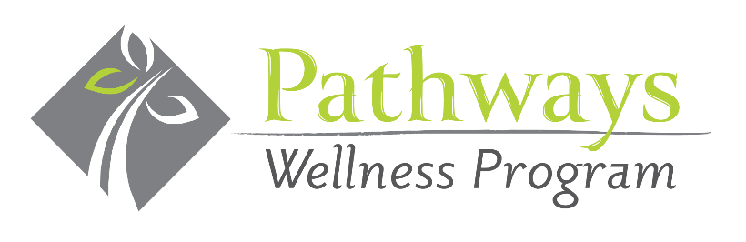

733 Washington Road, Suite 102 Pgh, PA 15228
412-563-8800
www.PathwaysWellnessProgram.com

