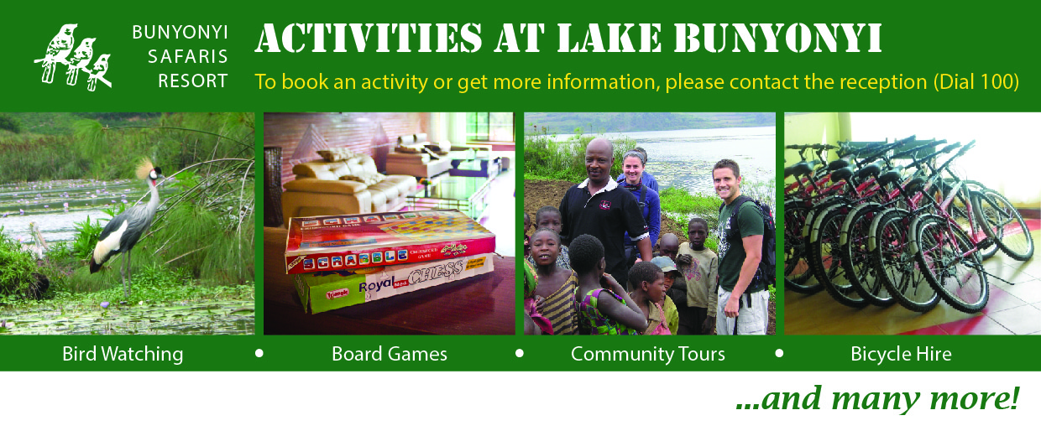
Activity | Area | Time/Duration | Cost
Boat ride – Island Hop  8 pax maximum | To Habuharo | 3hrs | 200,000 | Per boat
Bicycle Scenic tours | Kakooko route  Kabere route  Parking lot | Half/full day -  1hrs parking lot - | 30,000  5,000 | Per bicycle
Jogging (Scenic guided) | Kakooko to Rock  Kabere to Isesero | 2hrs – short  4hrs - long | 20,000  40,000 | Per person
Gym, Sauna & Steam bath  Free for resident guests | Roof Terrace &  Waterfront | Per session | 10,000 | Per person
Massage (1/2 & full body) | Waterfront | 30min – 1hr | 35,000 – 50,000 | Per Person
Nature Walks & Zip line  Max 8 pax | Bushara & Natures Prime Isl | boat and hiking – 3hrs  excl. zip line fees | 150,000 | Per boat
Birding – Nyombe Swamp  Max 8 pax | Nyombe Swamp  Bushara swamp  Birdnest swamp | 1/2day - day | 250,000 | Per boat
Guided hikes | Arcadia & Hilltop  Kakooko to Rock  To Hawks |  | 20,000 | Per person
Canoeing - | To Birdnest  Or Edirisa/Nature | 2hrs – self  2hrs – with guide | 30,000  35,000 | Per person
Gorilla Tracking  Rate excludes permit  4 pax, max per vehicle | Bwindi - Ruhija | 2hr drive, | 400,000 | Per vehicle
Agro/community tours | To Masiko’s farm- hiking | 2 hrs | 40,000 | Per person
Visit the local medicine men | Kyabahinga by boat & hiking | 2hrs | 150,000 | Per boat
Visit the blacksmith | Bukora by hiking or own car | 5hrs (hiking)or  30 min (car) | 40,000 | Per person
Visit the local market | Hiking | 15 min | 10,000 | Per person
Visit the caves | Hiking or own car | 6hrs – hiking  30 min - car | 40,000 | Per person
Learn crafts | Hiking | 15 min | 25,000 | Per person

