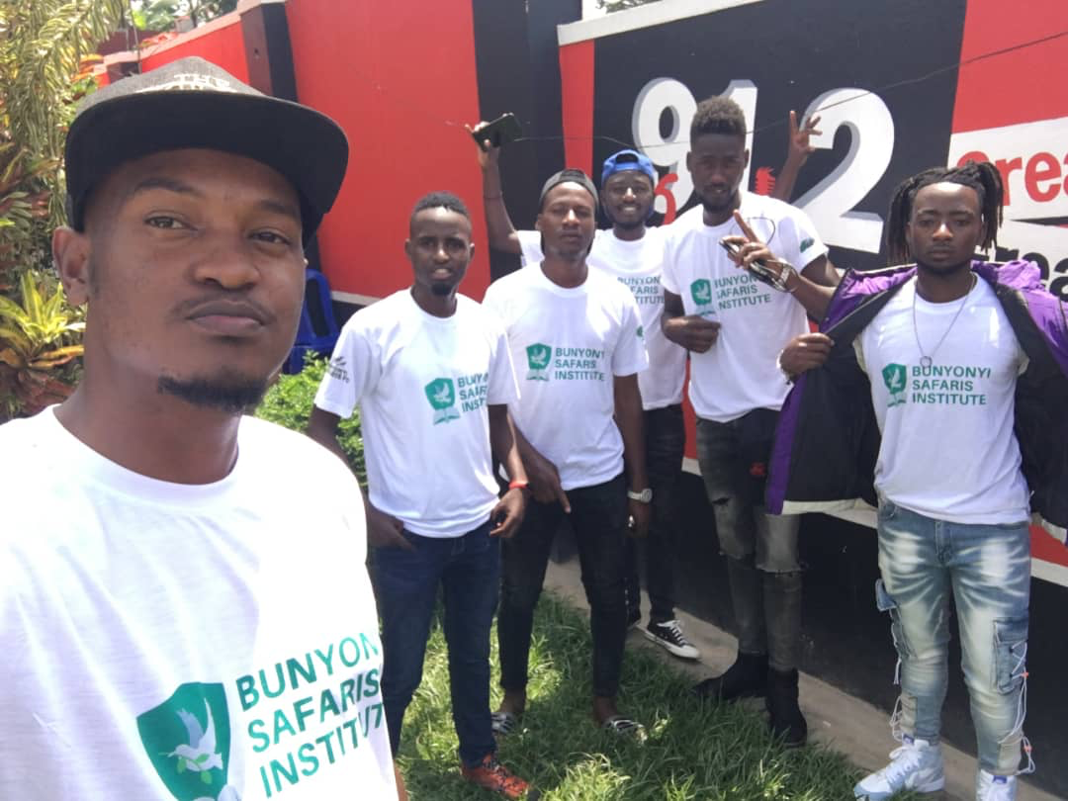

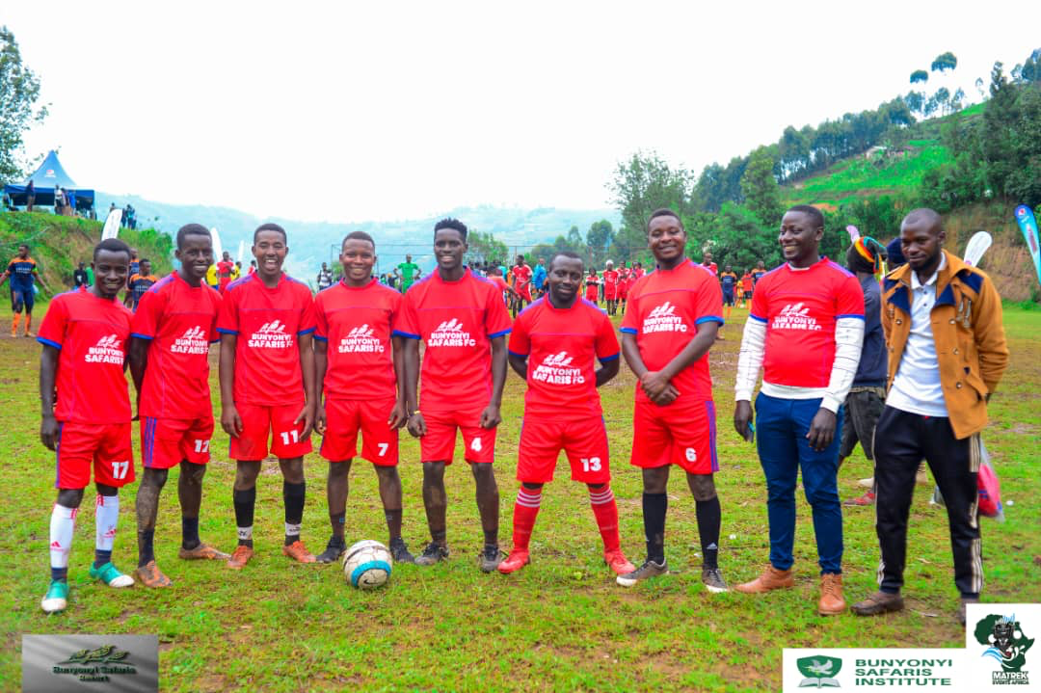

Who are we?

Bunyonyi Safaris Institute(BSI)
  - My skill, My power.
  - www.bunyonyisafarisresort.com/education
  - Tel: 0753-271-972
Bunyonyi Safaris Institute (BSI) was created in 2019 to address the need for quality services in the hospitality and tourism sector. The mother company, Bunyonyi Safaris Ltd (BS), has been in business operation since 1996. It has employed and mentored hundreds of staff and student interns many of whom are now business owners or employees of tour companies, travel agencies, hotels, restaurants, transport and logistics agencies locally and abroad.  Why train?  Southwestern Uganda, with its volcanoes, crater lakes, national parks is the heart of Uganda’s tourism. It is home to gorilla tourism which accounts for more than 60% of Uganda's tourism revenue. Lake Bunyonyi, where we are located, has been declared an an important, international Ramsar site. The tourism potential in Southwest Uganda therefore offers a great opportunity for entrepreneurship and employment.  What’s our goal?  Our goal as Bunyonyi Safaris Institute is to train, skill and ensure our graduates are well equipped to grab the opportunities presented in Uganda’s tourism Industry.  How will we train?  Our strategy to offer both Uganda Business and Technical Examinations Board (UBTEB) and Directorate of Industrial Training (DIT) certified training. Our courses are centered on:  - Hotel and Institutional Catering and  - Tourism and Hospitality.  The DIT modular training method offers students a great opportunity to gradually upgrade their skills at their pace and budget. It also offers short courses for all types of skills needed in the hotel and tourism industry. Using our expertise in the business, our facilities, partners and service providers, we have a great opportunity to offer the best hands-on and theoretical training for all skills needed in the hotel and tourism industry. |  |  | 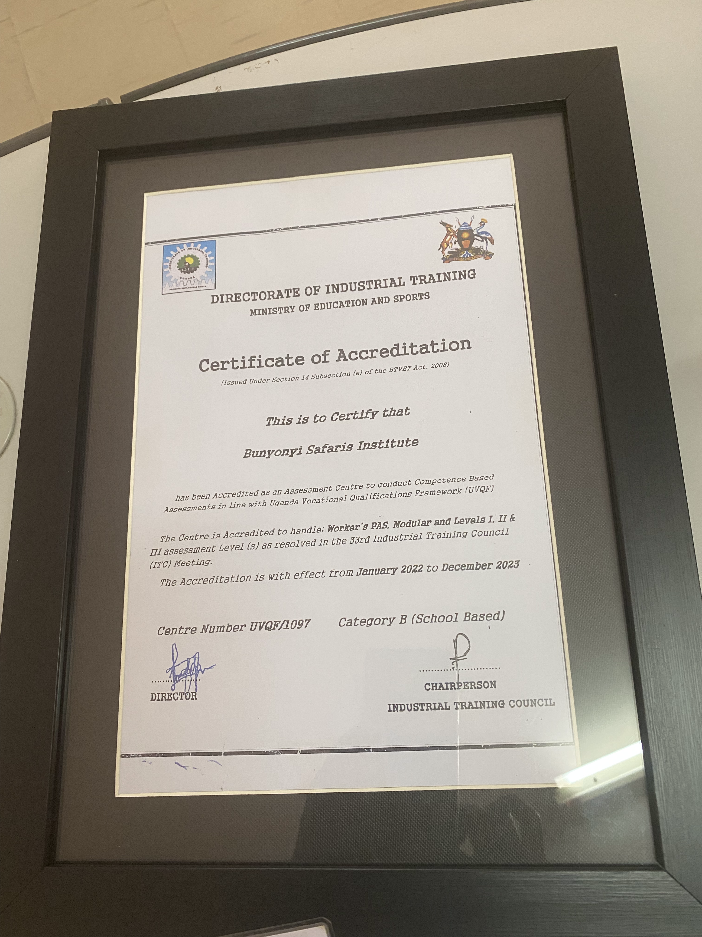
  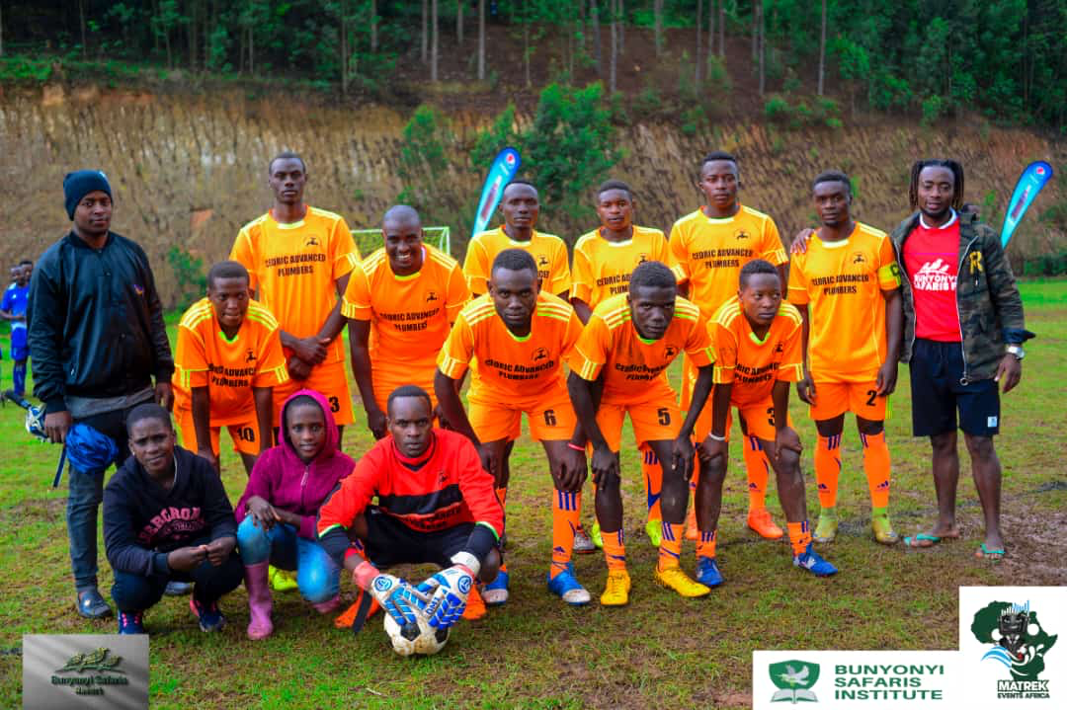
  
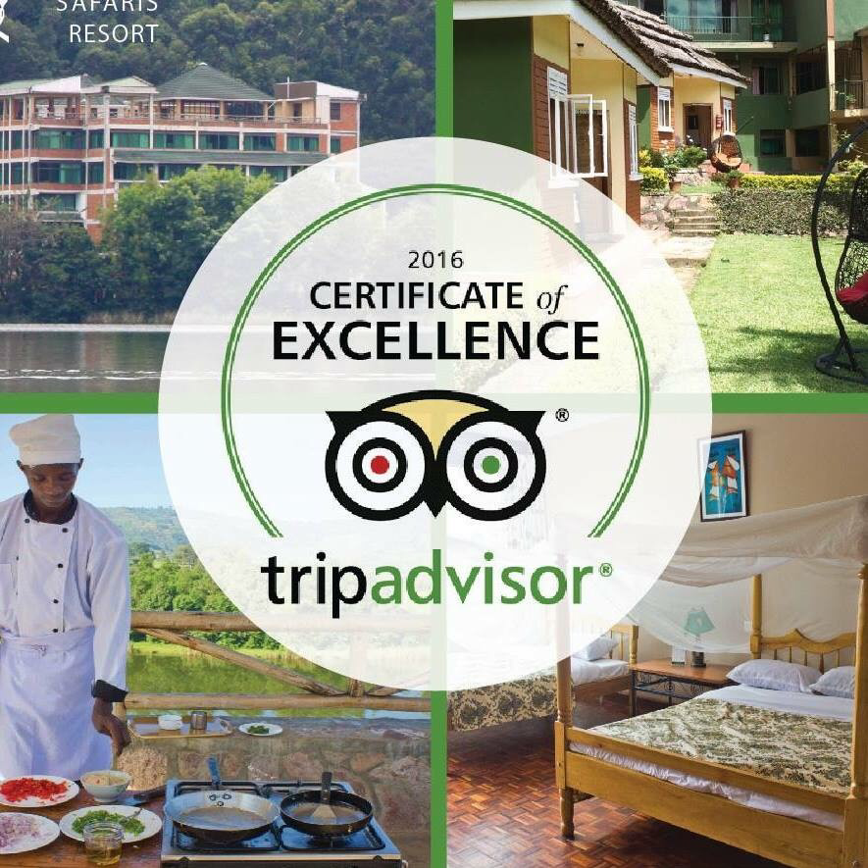 |  |  |  | Who will we train?  BSI is ideal for self motivated individuals committed to continuous self development. These include:  - School leavers – for skills to self employ or employment.  - Students on holidays - for skills for better home management and holiday employment.  - Hotel Employees – skilled, experienced but not certified for certification.  - Hotel Employees - Certified but wish to upgrade to higher level for better opportunities.  Our graduates can be  - Hotel Managers or staff  - Tour guides  - Chefs  - Drivers  Or they can start businesses such as:  - Home & Office cleaning companies  - Restaurants & Hotels.  - Caterers  - Airbnb Home Managers  - Tour Operators.
How much will It cost?  Our fees are paid per course or monthly as preferred. The basic tuition fee for all students is UGX 350,000 per month or per course. Some courses can be completed within one month or less. For the long term UBTEB and DIT courses, contact us for the current fees structure. |  |  |  | 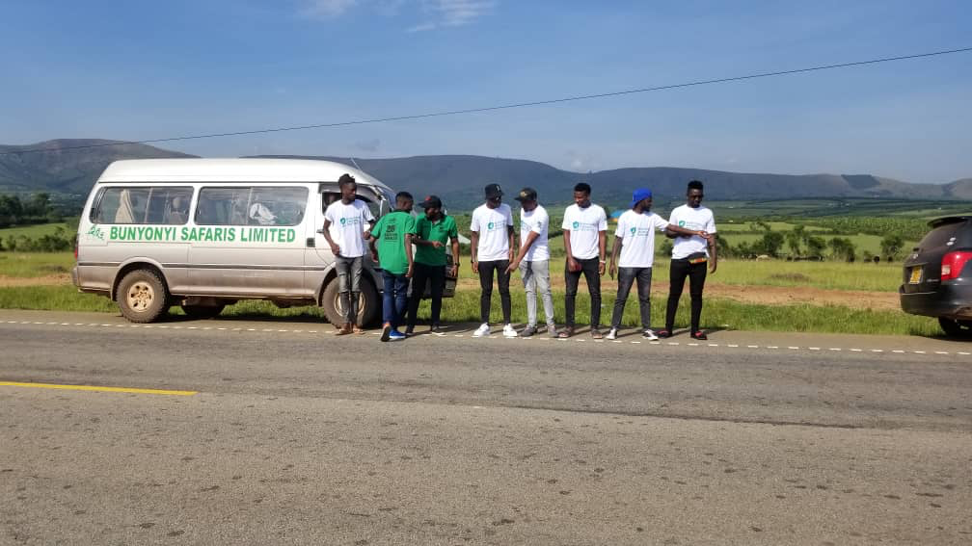
 |  |  |  | What Skills will I acquire?  - Computer skills for all aspects of hotel management.  - Skills to produce all types of dishes, manage food stock, produce menus and manage the kitchen.  - Skills to prepare rooms for guests and maintain a clean and tidy environment.  - Skills to generate tour activities, guide tourists and give them an exciting experience.  - Skills to drive, cook, bake, clean, welcome, make cocktails, coffee and other skills needed in the hotel and tour business.
What sets us apart ?  - On-the-job training at our hotel and other similar businesses.  - Short focused intensive training so you graduate quickly and cheaply.  - Easy payment methods.  - Opportunity to upgrade your certification at your pace and budget.  - Opportunity to earn through all types of casual work at BSR and partner businesses.  - Marketing of graduates to our business networks for employment.  - Sports, tours and farming extracurricular activities.  - Access to internationally certified courses for training. |  |  |  | 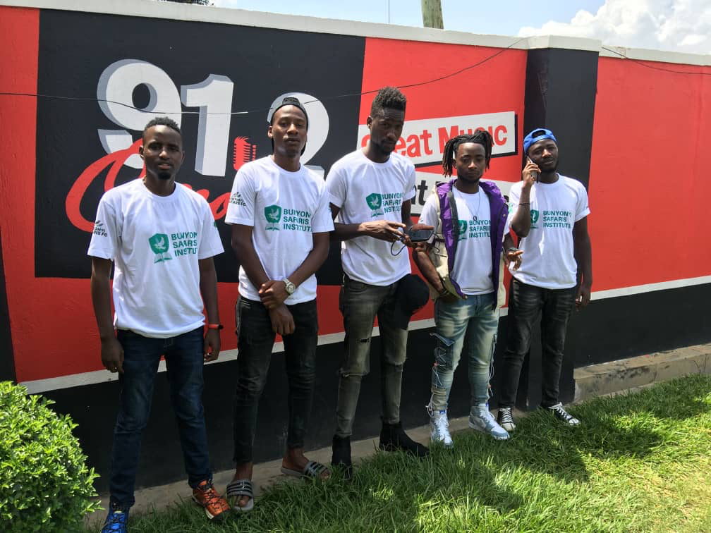
Contact Us
Get our registration form and register today!
Email: hotel@bunyonyisafaris.com
Call: 0753-271-972
www.bunyonyisafarisresort.com

