YOU'RE INVITED!
STILL WATERS, QUIET STRENGTH
A SIX-WEEK BIBLE STUDY
Come Grow with Us!
Sometimes the deepest growth happens in the seasons we would never have chosen.
Join us for a six-week journey through Still Waters, Quiet Strength, where we'll gather around God's Word to explore what it means to grow deep roots, trust God in difficult seasons, develop quiet strength, and remain faithful when God seems silent.
Together, we'll read Scripture, share meaningful conversation, encourage one another, and discover practical ways to live out what we are learning.
No matter where you are on your faith journey, you are welcome at the water's edge.
BIBLE STUDY DETAILS
Facilitator: | ____________________________________________
Dates: | ____________________________________________
Day & Time: | ____________________________________________
Location / Link: | ____________________________________________
Contact: | ____________________________________________

WHAT YOU'LL NEED  • Still Waters, Quiet Strength: 30 Days of Developing Deep Roots in Difficult Situations by Dr. Paula S. Newman  • Still Waters, Quiet Strength: A Six-Week Bible Study Guide by Dr. Paula S. Newman  • Your Bible or Bible App  • Pen and paper/journal (for the notetakers, only)  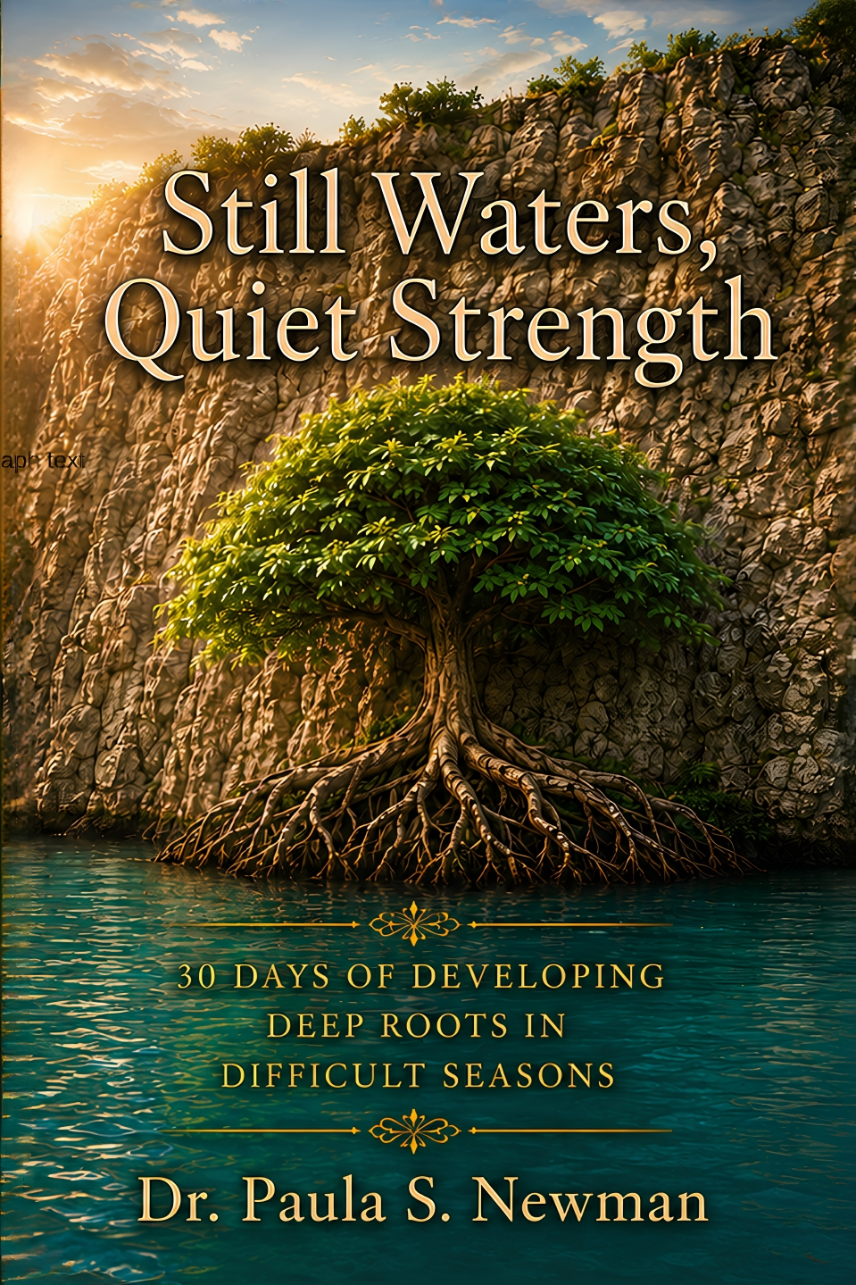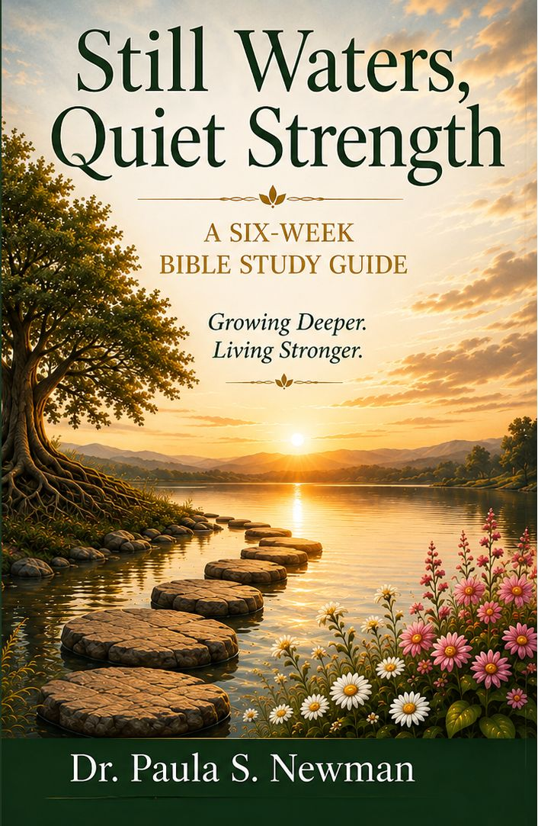 | WHAT TO EXPECT  • Scripture-centered conversation, reflection, practical application, encouragement, and prayer.  • A discussion-based small group, where you'll be invited to read, reflect, listen, and grow alongside others.  • During the week, participants are encouraged to read the corresponding daily devotionals in Still Waters, Quiet Strength: 30 Days of Developing Deep Roots in Difficult Situations in preparation for the group discussion.
Six weeks. God's Word. Meaningful conversation. Deeper roots. Developing quiet strength.

