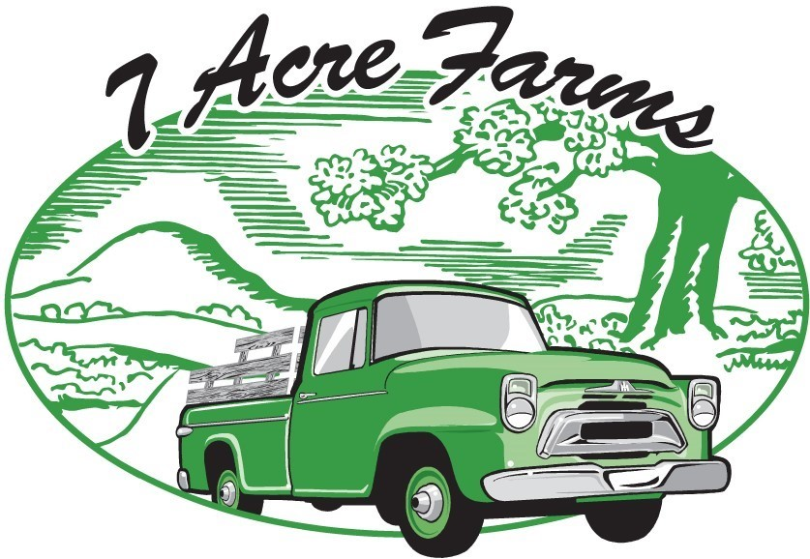

PO Box 1355, Tuttle, OK 73089
Owners: Liz & Leslie
405-249-9497 or 405-401-4519
https://7acrefarms.com/
@7acrefarmstuttle
7acrefarmstuttle@gmail.com

Item | Price per Case of 12 Jars/Bars
Salsa Verde  Dill Pickles  Spicy Dill Pickles  Handcrafted Soap  (4 ounce bars-scents vary)  Tallow Lotion  (4 ounce jars-scents vary) | $45.00  (Suggested Retail $6-$8 per pint jar)  $72.00  (Suggested Retail $8-$12 per quart jar)  $75.00  (Suggested Retail $9-$12 per quart jar)  $60  (Suggested Retail $7-$10 per bar)  $60  (Suggested Retail $8-$12 per jar)

