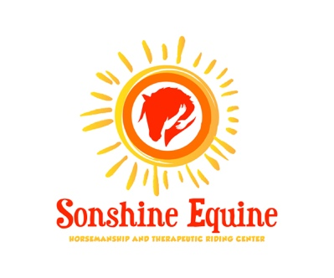

**Choose your Sponsorship Gift**

These sponsor gifts would be great for birthday, anniversary, in memory of and for that hard to buy person in your life. Your recipient will receive a card announcing your gift with a photo of the horse.

Pick your horse to sponsor

* Stuart 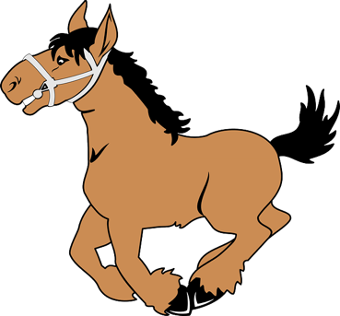
* Shadow
* Lucy
* Dakota
* Stormy
* Caitlyn
* Wilma/Pebbles

Choose your gift amount

* Treats for the horse $20
* Sponsor a rider or nonrider for a 5-week session $125
* Feed and hay for 1 horse for a month $100
* Hay for 1 horse for a month $75
* Ferrier visit $50
* Veterinary visit for vaccinations for 1 horse $150

Name of recipient:_______________________________________________________________

Address: ______________________________________________________________________

City, State, Zip Code: ____________________________________________________________

Personalized message: ___________________________________________________________

Your Name: ____________________________________________________________________

Address: ______________________________________________________________________

City, State, Zip Code: ____________________________________________________________

All checks can be made to Sonshine Equine and mailed to 31688 Yeshua Lane, Millsboro De 19966. If you should have any questions, please feel free to call Jan Baldt at 302-858-1275. Thank you for your generous gift and supporting Sonshine Equine.

Sonshineequine.org sonshineequine@gmail.com