**Silvio Cuellar presentations: comments and recomendations:**

He tenido la gratísima oportunidad de trabajar de cerca con Silvio Cuellar en diversos ministerios y proyectos. Como músico que soy, encuentro en Silvio no solamente un profesional sino al mismo tiempo un apasionado de la música, del trabajo en equipo y de la promoción de música de calidad artística dentro del área de la música litúrgica católica como de la música latina. Su habilidad en diversos instrumentos, su excelente oído y conocimiento de armonías, la destreza de moverse en diversas culturas, su disposición para trabajar con todos, adultos, jóvenes, adolescentes y niños, hacen de él no solamente un talentoso músico, pero sobre todo, un artista de verdad. Añadido a estos talentos, su testimonio de vida y su amor por la familia hacen brillar aún más sus cualidades musicales, artísticas y personales. - ***Rev. Alejandro López Cardinale, Region 1 Hispanic Diocesan Directors President. Saint Benedict’s Parochial Administrator, Archdiocese of Boston.***

I have had the pleasant opportunity to work closely with Silvio Cuellar in various ministries and projects. As a musician that I am, I find in Silvio not only a professional but at the same time he has a passion for music, teamwork and the promotion of artistic quality music within the area of Catholic liturgical music and Latin music. His ability in various instruments, his excellent ear and knowledge of harmonies, the ability to move in different cultures, his willingness to work with everyone, adults, youth, adolescents and children, make him not only a talented musician, but above all, A real artist. Added to these talents, his testimony of life and his love for the family make his musical, artistic and personal qualities shine even more.

**Liturgical Workshops in the Diocese of Richmond (October 15, 2013)**

Muy Querido y estimado Silvio Cuellar

Estamos muy contentos con su presencia que ha sido enriquecedora y que las personas aún comentan.

La enseñanza fue amena, alegre, instructiva, clara, veraz, directa y fortalecedora.

El material fue de lujo, muy profesional, los consejos y detalles otorgados en este evento fueron de bendición para los participantes que se fueron con la mejor visión de integración y valorando cada uno de sus dones y talentos.

Solo me queda agradecerle por haber aceptado nuestra invitación y compartido parte de su material discográfico que sabemos será de mucha fuerza para tantos de nuestros directores de coros. y para los que estamos dentro de un ministerio.

Muchas bendiciones, y esperamos seguir trabajando con usted y su hermosa familia e invitarlos a otros eventos. Estaremos contentos de tener a los jóvenes con nosotros  en un futuro próximo

Que Dios le siga bendiciendo en su ministerio y siga ayudando a la comunidad hispana.

Atentamente.

*Dear Silvio Cuellar*

*We are very happy with your presence that has been enriching for us and people are still commenting.*

*The teaching was enjoyable, cheerful, instructive, clear, truthful, direct and empowering.*

*The material was great, very professional, and the tips and details given in this event were a blessing for the participants who left with the best vision of integration and valuing each of their gifts and talents. I can only thank you for accepting our invitation and sharing part of your compositions that we know will be very strong for so many of our choir directors, and for those of us who are in a ministry.*

*Many blessings, and we hope to continue working with you and your beautiful family and invite you to other events. We will be happy to have the youth with us in the near future*

*May God continue to bless you in your ministry and continue to help the Hispanic community.*

Best regards.

**Mrs.Carmen O'Brien**

***Office of Hispanic Ministry, Western Regional Coordinator, Catholic Diocese of Richmond.***

**Retreat and workshops for Hispanic Pastoral Musicians in Hartford, CT, 2013**

Hola Silvio,

Espero que este correo electrónico te encuentre con bien salud y espíritu!  Si los coros están en camino con el Nuevo libro de Flor y Canto en las dos parroquias.  Están poquito a poco acostumbrándose con el libro y los cantos.  La conferencia fue un éxito gracias a ti Silvio!  Los tres coros estaban muy agradecidos con el día de la reflexión que dirigiste.  Cubriste muchos temas importantes durante el día y fue muy fructífero.  Cualquier parroquia que pide su servicio para dirigir una conferencia sobre música litúrgica o el ministerio de música en las parroquias van a estar muy agradecidos.  Muchísimas gracias Silvio! En Cristo,

*Hello Silvio,*

*I hope this email finds you in good health and spirit! The choirs are on the way with the New Book Flor y Canto now in use at the two parishes. They are little by little getting used to the book and the songs. The conference was a success thanks to you Silvio! The three choirs were very grateful for the day of reflection that you led. You covered many important topics during the day and it was very fruitful. Any parish that requests your service to lead a conference on liturgical music or the music ministry in the parishes will be very grateful. Thank you very much Silvio!*

*In Christ,*

**Rev. Father Jose Angel Mercado**

*Pastor* Saint Augustine Church     Saint Anne-Immaculate Conception Church     Office of Hispanic Evangelization

Hartford, CT 06114            Hartford, CT 06106                                       Archdiocese of Hartford, (860) 522-7128

**Cultural Diversity: Awakening service and faith in children**

*By Milagros Ramos, Director of Cultural Diversity of the Diocese of Buffalo, NY*

Sun, Apr 24th 2016 08:00 am

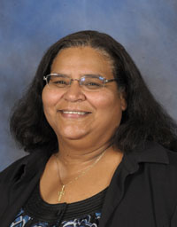Many of us are preparing for two special occasions that we celebrate - Mother's Day in May is and Father’s Day in June. As we prepare to celebrate these two occasions we may find ourselves reflecting on how our parents raised us, and we may also spend some time reflecting on how we are raising our own children. Are we raising them to be children of faith and service? Are we providing the opportunity for our children to develop a relationship with our Lord Jesus Christ?

Silvio Cuellar, the Hispanic Ministry director for the Diocese of Providence, R.I., started a presentation in pastoral care of families with the following question: What do we want for our children?  The vast majority responded with phrases like, we want them to be successful, hardworking, responsible, honest, and a professional. Very few said, we want them to be holy or a good Catholic. Isn't it sad that many first thought about material and worldly things? As Mark 8:36 says, "What profit is there for one to gain the whole world and forfeit his life?

Cuellar has been blessed with five teenage children who are currently involved in serving others. They are involved in youth ministry and music ministry. They are donating their time and talents to help other young people develop a closer relationship to the Lord.

What can we do as parents to awaken our children's faith? Cuellar says first we must create habits in our children from very young. He calls them habits of holiness. First: Simple family prayer, faith is fed at home. The family that prays together stays together. Second: Attend Church faithfully, which means even attending Mass when on vacation. This will teach your children that our faith is very important and above anything. Third: Get involved in activities and the various ministry of the Church, be it lector, altar servers, or music or family ministry. Make church a place to be. Fourth: Look at the music, movies and TV shows that your children are watching and listening to, make sure that they are appropriate. Provide Christian music, movies and shows in your home. Fifth: Cut the cable and limit the use of technology. This can lead to constructive activities, like learning to play musical instruments, painting and playing sports. We need not be slaves of television, you can have a much more fun and productive family life limiting and in the Cuellar family case, completely eliminating the TV. Sixth: At some point our children need to develop a personal relationship with Jesus. Our challenge as parents is not to force them to go to church but to create the conditions for them to have an experience of encounter with Jesus and want to go willingly. Take them to retreats and expose them to opportunities where they can have that experience where they can fall in love with the Lord. Finally, seventh: Talk less, act more. Demonstrate by your own example and habits what we expect from them.

As St. Francis of Assisi and Mother Teresa often used: "Let us preach all the time and, if necessary, use words."

[*https://www.wnycatholic.org/news/article/current/2016/04/24/101502/cultural-diversity-awakening-service-and-faith-in-children*](https://www.wnycatholic.org/news/article/current/2016/04/24/101502/cultural-diversity-awakening-service-and-faith-in-children)

**Cultural Diversity: Seven ways to keep Jesus in the center of your family**

***By Milagros Ramos, Director of Cultural Diversity of the Diocese of Buffalo, NY***

***Wed, Aug 19th 2015 10:11 am***

This past June and July, we had the privilege of having a speaker and teacher from the Diocese of Providence, R.I., on three different occasions. Silvio Cuéllar is the director of the Office of Hispanic Ministry in the diocese and the editor for the Hispanic paper, *El Catolico de Rhode Island*. He is also a musician and songwriter for Oregon Press Publication. He met with Hispanic families from around our diocese to teach them how to use the Scripture study he put together for families, named "Creating Families of Peace and Love."

Cuéllar wrote "Seven ways to Keep Jesus in the Center of your Family" for his paper. The first thing that he suggests for families is to keep Sundays as the day for the Lord. Attend Mass every Sunday together as a family and always remember to give thanks to the Lord our God for all that you have received. For those in the family who can, receive Holy Communion on at least a weekly basis.

His second suggestion is a saying that many of us have heard, that the family who prays together, stays together. He highly recommends that we pray together as a family, whether it is a prayer that we share around the dinner table with the family, always giving thanks to the Lord our God, or saying a traditional prayer together like the rosary. It could also be more spontaneous prayer, where family members could just pray.

[*https://www.wnycatholic.org/news/article/current/2015/08/19/100952/cultural-diversity-seven-ways-to-keep-jesus-in-the-center-of-your-family*](https://www.wnycatholic.org/news/article/current/2015/08/19/100952/cultural-diversity-seven-ways-to-keep-jesus-in-the-center-of-your-family)

**Retiro de Sanación con Adoración al Santísimo. (Hartford, CT)**

***Healing Retreat with Adoration of the Blessed Sacrament. (Hartford, CT)***

Hola Silvio: Muchas bendiciones para ti y los tuyos… Para mí personalmente todo estuvo maravilloso, la música, la enseñanza; bueno todo. He recibido varios textos de otras comunidades que han quedado encantado con todo lo sucedido en ese dia. Creo firmemente que la mejor decisión que hicimos fue exponer al santísimo al final, ya que cerramos con broches de oro. Escuche decir que hubieron muchas sanaciones y eso me alegra muchísimo, bueno en fin, que no hará el Señor cuando su pueblo está unido?... Silvio tu presencia y tu trabajo ha sido de bendiciones para nuestra arquidiocesis, espero que podamos seguir trabajando unidos para seguir construyendo el Reino de Dios. Dios te siga bendiciendo y muchas gracias

*Hello Silvio, Many blessings for you and your family ... For me personally everything was wonderful, the music, the teaching; Everything's good. I have received several texts from other communities that have been delighted with everything that happened on that day. I firmly believe that the best decision we made was to expose the Blessed Sacrament at the end, as we closed on a high note. I heard that there were many healing and that makes me very happy, well, what will the Lord do when his people are united? ... Silvio your presence and your work has been a blessing for our archdiocese, I hope we can continue working together to continue building the Kingdom of God.*

*May God continue to bless you and thank you very much!*

***Lisandra Martinez***

***Leader of Prayer Group, Our Lady of Sorrows, Archdiocese of Hartfort, CT (April 30, 2013)***

**3 Day Family/youth Mission and Liturgical Workshops in the Diocese of Rochester, NY August 2017**

*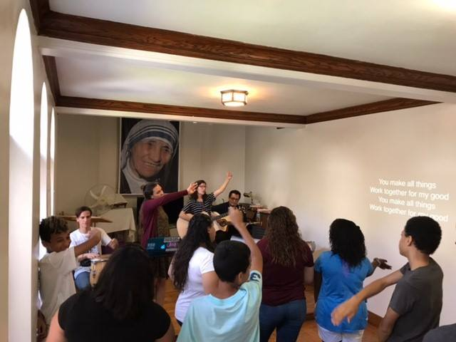***Video: Youth Retreat** [**https://youtu.be/Hk8aSLTfcx4**](https://youtu.be/Hk8aSLTfcx4) **(2 min 40 seconds)**

**Video Description:** Silvio Cuellar, coordinator of Hispanic ministry for the Diocese of Providence, R.I., was the guest preacher for the Aug. 14-16 Santa Mision, an annual outdoor mission for the Latino community held at Rochesters Holy Apostles Church. Cuellar and his family led a youth retreat on the final day of the mission.

*(EMC video by John Haeger, El Mensajero Católico)*

**Video: 3 Day Santa Misión in Rochester, NY (1 min)** <https://www.facebook.com/MensajeroRochester/videos/10155541352463818/?v=10155541352463818>

**Video Description:** 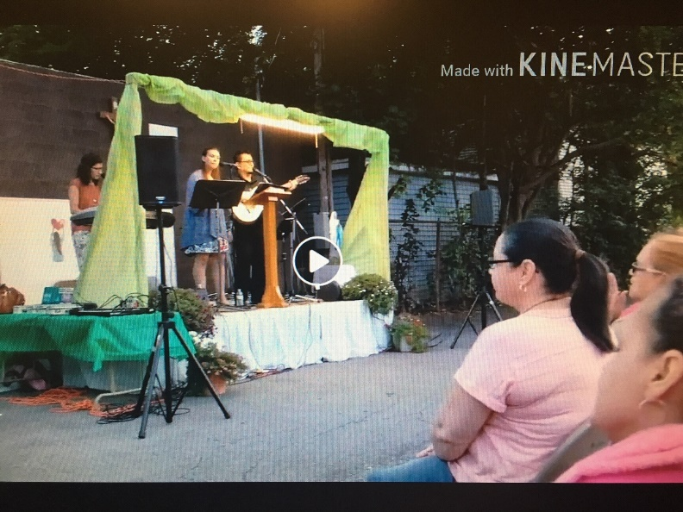The annual [Santa Misión](https://www.facebook.com/events/313533272441878/?acontext=%7B%22source%22%3A3%2C%22source_newsfeed_story_type%22%3A%22regular%22%2C%22action_history%22%3A%22%5B%7B%5C%22surface%5C%22%3A%5C%22newsfeed%5C%22%2C%5C%22mechanism%5C%22%3A%5C%22feed_story%5C%22%2C%5C%22extra_data%5C%22%3A%5B%5D%7D%5D%22%2C%22has_source%22%3Atrue%7D&source=3&source_newsfeed_story_type=regular&action_history=%5B%7B%22surface%22%3A%22newsfeed%22%2C%22mechanism%22%3A%22feed_story%22%2C%22extra_data%22%3A%5B%5D%7D%5D&has_source=1&eid=ARAOJDveORCLNlN-1mSgiOyiMHEoMCf7YffA_CxdY8nctsSEQWl-e9oQTqOZ1-9fXEJ6vSlisj9VEGQj) began Aug. 14 led by Silvio Cuellar from the [Diocese of Providence](https://www.facebook.com/dioprov/?eid=ARDQhIvg_zBWI7oFNB0RY-Y1XJuXfy3GjPT60Yoer58kWtomtKClrQYdI_HH9zegasKZUNYWr2eVRpWt&fref=tag), Rhode Island. In addition to preaching about the recipe for a peaceful and prayerful family life, the liturgical musician and Catholic journalist performed with three of his seven children. The outdoor mission continues nightly through Aug. 16 beginning with the praying of the Rosary at 6:30 p.m.

*(EMC video by Annette Jiménez)*

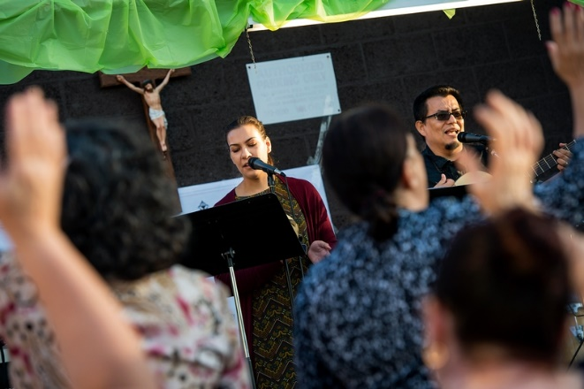

**Photo:** Mission participants raise their hands as guest preacher Silvio Cuellar and his daughter, Grace Cuellar, sing a song during the August 14-16 Santa Mision, an annual outdoor mission for the Latino community held at Rochesters Holy Apostles Church.