Motorcycle Training

Bandy Motorcycle Training 319-512-1720
www.ronbandy.com
2022 CLASSES
The classroom and riding portion of the
BRC-I & BRC-II training held at:
Johnson County Fairgrounds
3109 Old Highway 218 South, Iowa City, IA
Classroom for BRC-I Classes start on Fridays at 6:00 pm
An online E-course completion certificate is required prior to attending class.
Students will begin riding at 9:00 AM Sat & Sun
Students under 18 need parental consent.
Tuition: $200.00 for the BRC-I Basic Rider Course
$125.00 for BRC-II Course

2

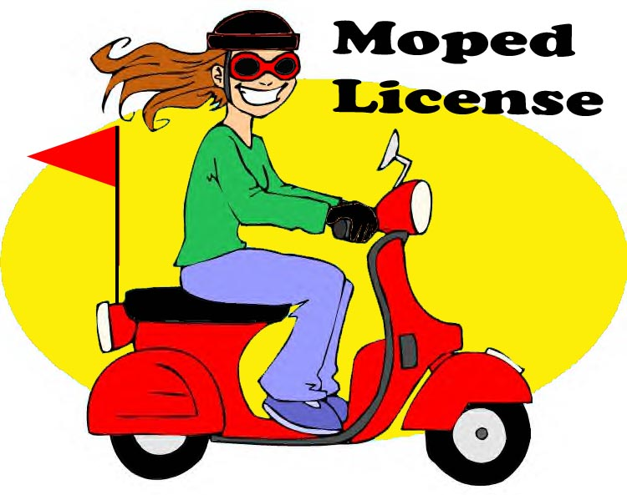

Bandy Motorcycle Training
BMT
Moped Instruction
319-512-1720
2022 CLASSES

March TBA
April TBA
May TBA
July TBA
August TBA
September TBA October TBA

The classroom is located at:
Johnson County Fairgrounds
3109 Old Highway 218 South, Iowa City, IA

Classes will meet 9:00 AM - 3:00 PM
This class is required for those who are at least 14 yrs old and want to obtain a moped license.
An instruction /learner permit is needed for a moped license if you don’t have any other type of license.
Parental consent is required for those under 18.

Tuition is $75.00

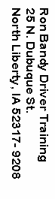

BRC-II Course:
Ready to ride at 9:00 am

April 10 Sun
May 15 Sun
May 29 Sun
June 5 Sun
June 26 Sun
July 17 Sun
July 31 Sun
Aug 14 Sun
Aug 28 Sun
Sept. 25 Sun
Oct 2 Sun
Oct. 23 Sun

Call for Dirt Bike Classes

BRC-I Basic Rider:
6 p.m. Friday
9 a.m. Saturday & Sunday

April 15, 16, 17
May Full 20, 21, 22
June 10, 11, 12
July 8, 9, 10
Aug 5, 6, 7
Aug 19, 20, 21
Sept. 9, 10, 11
Oct 7, 8, 9

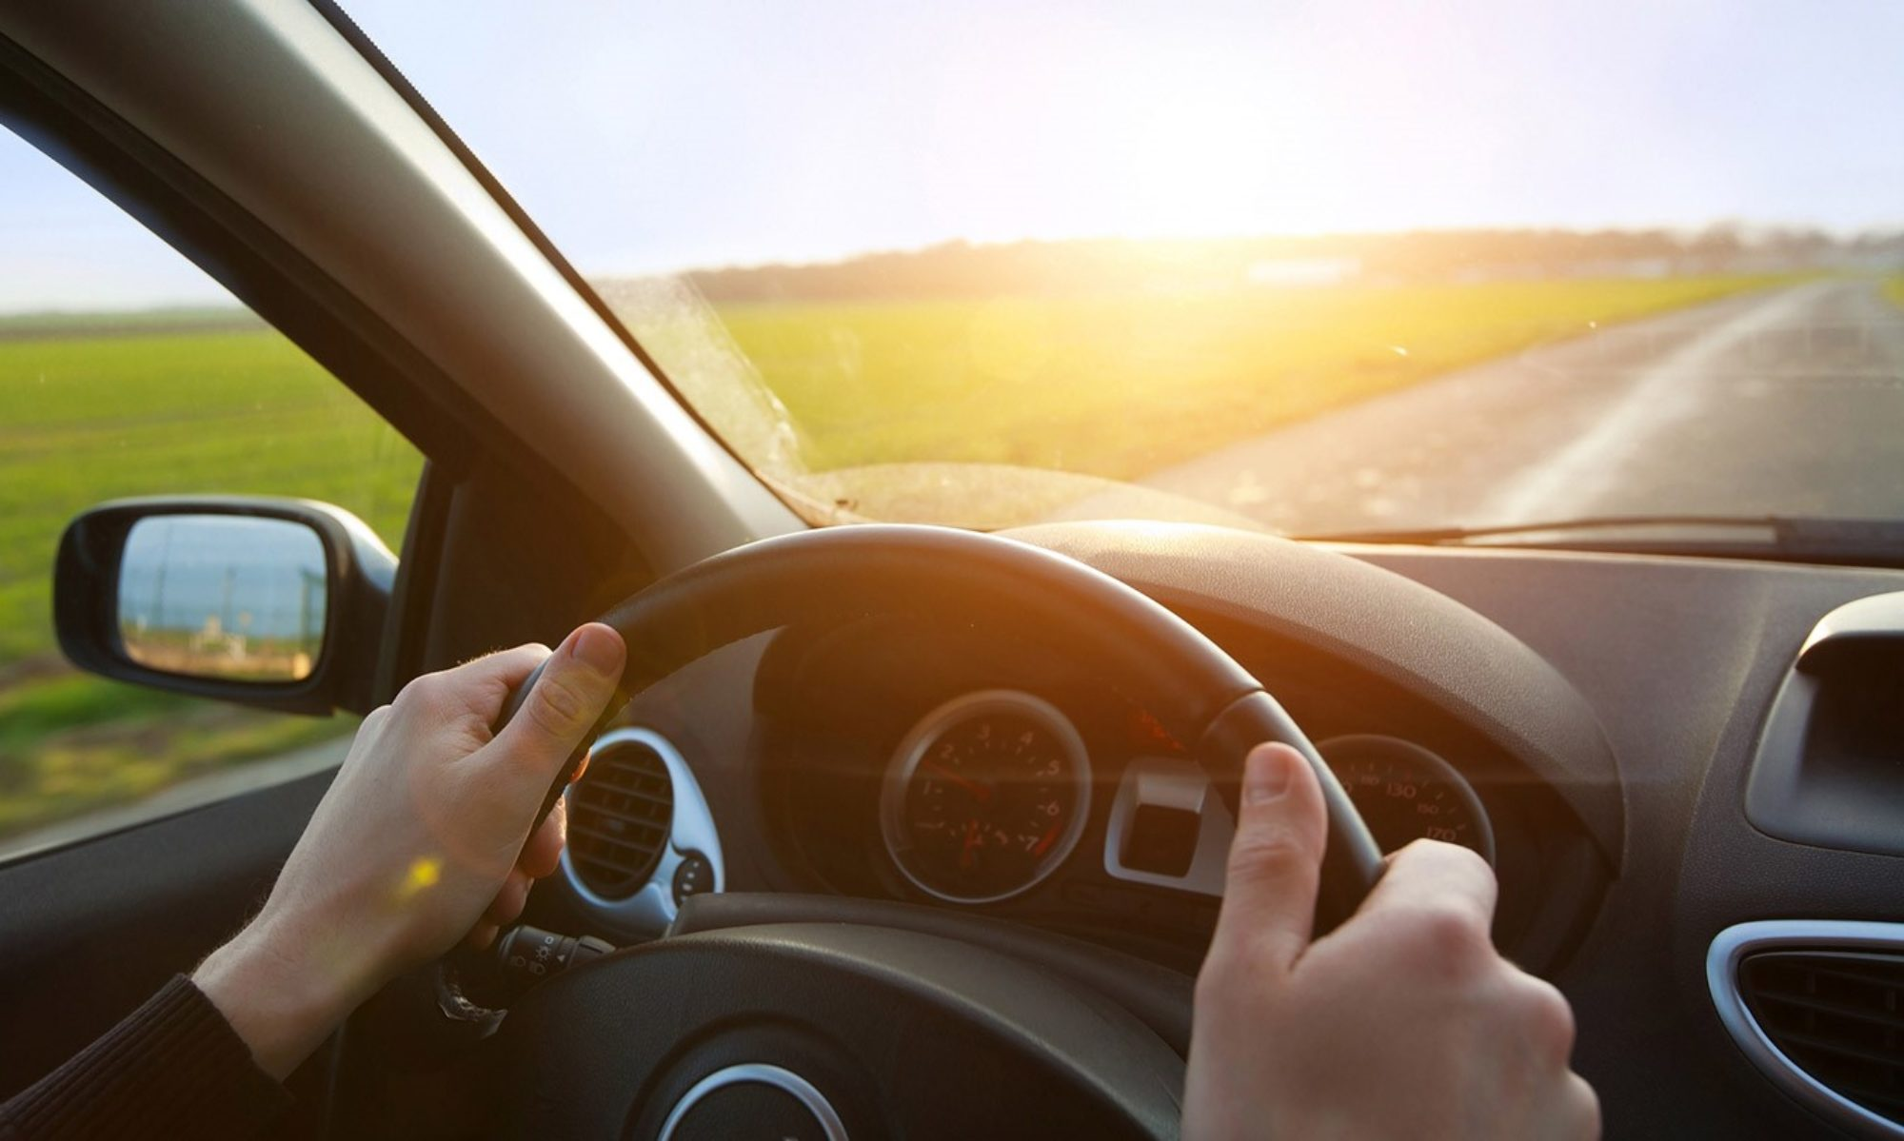

Anyone between the ages of 14 and 18 who wishes to drive must take and successfully complete an Iowa approved or comparable Driver Education Course. This course requires a minimum of six hours of on the road instruction and 30 hours of classroom instruction. An Iowa instruction permit is needed prior to taking the course. The instruction or learners permit may be received at age 14 after passing a written exam given at any Iowa Dept. of Motor Vehicles or D.O.T. licensing office.

Adult Driver Education:
For adults and students who want to improve their driving skills or obtain their driver’s license.
Please call for other types of instruction
Hourly rates are available for individualized or special instruction for the operation of automobiles, mopeds, and motorcycles.

Ron Bandy Driver Training
is state certified as a
Targeted Small Business.

BONDED*INSURED*LICENSED
STATE APPROVED

Bandy Motorcycle Training 319-626-2014
Motorcycle Instruction & Licensing:
BRC-I Basic Rider Course: For those who want to safely and legally operate a motorcycle on public streets. A motorcycle license is available at age 16 providing the student has successfully completed a state approved driver education and motorcycle education course (if under the age of 18). Parental consent is required for those under 18. A certificate for a motorcycle license is available upon successful completion of this course. Most classes will be limited to 6 riders. Motorcycles are provided, usually 250cc or less. No prior experience is necessary; students are expected to be able to ride a bicycle. Online E-course completion certificate is required prior to attending the BRC-I & BRC-II class. Students may use their own motorcycle or scooter for this course providing it is no larger than 500cc, complies with Iowa Safety Standards, and the student has evidence of insurance.
BRC-II Course: This course is for those who already have experience riding motorcycles and wish to review or update their riding skills. Certificate for a motorcycle license is available upon completion of online E-Course and successful completion of the BRC-II course. Riders may use their own motorcycle or scooter providing they comply with Iowa Safety Standards and have proof of insurance.
HELMET, EYE PROTECTION, LONG SLEEVE SHIRT, LONG PANTS, GLOVES & OVER THE ANKLE BOOTS/SHOES ARE REQUIRED FOR ALL BRC-I, BRC-II classes.
Dirt Bike Classes $150.00 approximately 6 hours long. It is an excellent and fun way to learn how to ride a motorcycle (dirt bike) in the dirt. The motorcycles that are used for instruction range from 250cc to 80cc. Students may use their own dirt bike providing it fits the student and is safe to ride. Adult classes (16+) are limited to 8 riders. Classes for families may be available. Please call for details HELMET, EYE PROTECTION, LONG SLEEVE SHIRT, LONG PANTS, GLOVES & OVER THE ANKLE BOOTS/SHOES ARE REQUIRED FOR ALL BRC-I, BRC-II, & DIRT BIKE CLASSES.
Moped Classes are for those who want to safely and legally operate a moped on public streets. An instruction permit and completion of a 6 hour moped safety course is necessary for anyone under 16 or without any other type of valid license.

Basic Rider Course: $200.00
Online E-course completion certificate is required prior to attending the BRC-I & BRC-II class.
BRC-II Course: $125.00
Moped: $75.00
Pre-payment & Pre-registration required.
Tuition due with registration. No refunds if cancelled less than five days prior to start of class.
Please send your check along with name, address, phone number and class session dates to:
Ron Bandy Driver Training and Education
ronbandy.com
25 North Dubuque St.
North Liberty, IA 52317

Phone: (319) 512-1720

Registration Information:
Name: _____________________________
First Middle Last
Age: _____Date of Birth: ______________

Address: ___________________________

___________________________________

Phone: _____________________________
Desired Class Dates: _________________
Driver’s License # ___________________
Email:______________________________Parent/Guardian-Signature
(students under 18):
____________________________________

COURSE OBJECTIVES:
The course will provide opportunities and encouragement for students to always do their best. A primary objective is to develop safe, competent, courteous, law abiding, happy, informed and responsible drivers/riders. This course goes beyond the basic skills needed to get a license. Emphasis is placed upon the driver’s/rider’s abilities, the vehicle, having constant control, making good decisions and continual regulation of space and speed. The interaction and application between the driver/rider, vehicle, and the driving environment will be constantly practiced, tested and reviewed.

