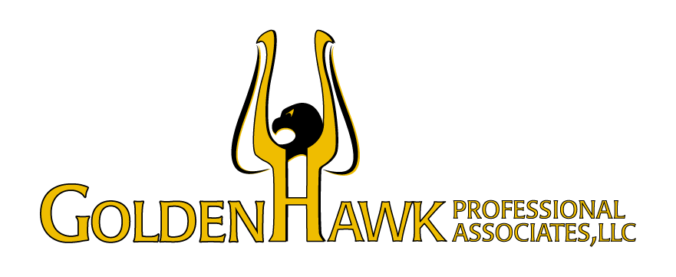

Walk Before You Run: Phased Planning
Planning for a successful future without your business is a smart strategy. One of the traps that business owners commonly fall into as they begin planning for their successful future without the business is seeing what they need to do and trying to do everything all at once. However, much like your business didn’t spring into success overnight all those years ago, future-oriented planning doesn’t need to be a one-and-done proposition.
Let’s look at how a phased approach to planning can help you get the most out of your efforts and make the process more manageable.

You Can’t Catch the Fish Without Throwing in a Line
Bill Burns was ready to go fishing. Over 40 years, he grew what was originally a one-man logistics consulting agency into a mid-sized inventory management services business with 15 offices. His daughter Katie and longtime employee Lester Clay played big roles in the company’s growth through a proprietary software they’d created in the early years. Bill knew exactly how much he needed to retire with financial security. But he didn’t know how to go about getting it. He originally wanted to sell the business to Katie and Lester, but he knew they didn’t have the kind of people skills he had to attract new clients. He worried that if he sold to an outsider, they’d just buy for the proprietary software and lay his employees off. Plus, he wasn’t even sure what he’d do in retirement other than fish, and he was afraid he’d get bored.
Bill felt overwhelmed with how much he had to figure out. He shared these thoughts with Glen, his most trusted business advisor.
“I think the most important area to focus on is making you inconsequential to the business,” Glen said. “You’re the rainmaker now, and to get the money you need, you’ll need to replace yourself.”
After reconfirming that Bill’s financial security target was accurate, Glen told Bill something that took much of the weight off his shoulders.
“Since Katie and Lester are comfortable sticking on the operations side, we can bring in a professional management team to help develop skills on the sales side. That’ll open up a lot of different paths for you to reach your personal and financial goals. It may also give you some leverage when you decide to sell.”
Bill was tentative at first. No one had ever outsold him at his company. But after seeing the professional management team that Glen and a new recruiting firm helped put together, he felt more confident, and for good reason.
The management team formalized his company’s sales process. Profits began to increase year over year because Bill wasn’t the only one capable of making big sales anymore. The management team used the additional profits to attract strong managers and operations people, which led to even more increases.
With more people helping to grow the company, Bill had more free time. He found hobbies he liked in addition to fishing and found himself spending more time away from the office doing them because of the strength of his sales team. He built a new plan for the future based on his new interests and goals.
Best of all, the expanded advisor team that Glen helped assemble had the expertise to negotiate with potential third-party buyers. Sales performance had finally caught up to the cutting-edge developments in operations, making his new team, including Katie, Lester, and new managers, just as valuable as the software.
With a strong management team and encouragement from Katie and Lester, Bill sold the company to a large international buyer, achieved financial security, and protected his employees.

Phased Planning Can Make the Process More Manageable
Like many business owners, Bill saw how much work he had to do and felt overwhelmed. When you’re responsible for your business’ success, it’s not uncommon to feel this way. Fortunately, with advice from a planning-oriented advisor and his new advisor team, Bill learned that he could do his planning in phases and didn’t have to be everything to everyone.
Phased planning allowed him to focus on the most important actions he could take and work through the initial challenges in a more limited area. His success in one portion of planning led to success in other areas over time, which also allowed Bill to move forward with planning for his personal future once the business future was clear. By committing to phased planning, Bill reaped the benefits, proving to himself that he didn’t have to tackle everything all at once.
We strive to help business owners identify and prioritize their objectives with respect to their business, their employees, and their family. If you are ready to talk about your goals for the future and get insights into how you might achieve those goals, we’d be happy to sit down and talk with you. Please feel free to contact us at your convenience.

Brought to you by:
Chris Rich is the Founder and President of GoldenHawk Professional Associates, LLC. He has been bringing clarity, comfort, and confidence to the business owner/ CEO community for over 25 years. He holds numerous professional designations, including Certified Financial Planner (CFP®), Master of Science in Financial Services (MSFS), & Chartered Financial Consultant (ChFC).
Chris Rich ChFC, MSFS, CFP®
chris.rich@goldenhawkprofessionals.com

GoldenHawk Professional Associates, LLC
3254 East Cactus Road
Phoenix, Arizona 85032
Office Phone: 602-923-8300
Website: www.goldenhawkprofessionals.com

The information contained in this article is general in nature and is not legal, tax or financial advice. For information regarding your particular situation, contact an attorney or a tax or financial advisor. The information in this newsletter is provided with the understanding that it does not render legal, accounting, tax or financial advice. In specific cases, clients should consult their legal, accounting, tax or financial advisor. This article is not intended to give advice or to represent our firm as being qualified to give advice in all areas of professional services. Exit Planning is a discipline that typically requires the collaboration of multiple professional advisors. To the extent that our firm does not have the expertise required on a particular matter, we will always work closely with you to help you gain access to the resources and professional advice that you need.
This is an opt-in newsletter published by Business Enterprise Institute, Inc., and presented to you by our firm. We appreciate your interest.
Any examples provided are hypothetical and for illustrative purposes only. Examples include fictitious names and do not represent any particular person or entity.

