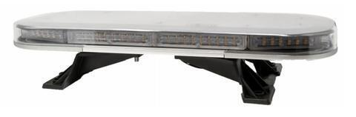

ELITEOPTO™ Emergency Warning LED 21 Inch Slim Bar
26 Flash Patterns
3 mounting choices: Permanent (included), Magnetic, or Waterproof Velcro
Item ID | Description
ALTF7221001 | MAGNETIC MOUNTING KIT
ALTF7221002 | 3M VELCRO MOUNT KIT
ALTF7221100 | AMBER, LED
ALTF7221140 | AMBER/GREEN, LED
ALTF7221150 | AMBER/ WHITE, LED
ALTF7221200 | BLUE, LED
ALTF7221230 | RED/BLUE, LED
ALTF7221300 | RED, LED
ALTF7221350 | RED/WHITE, LED
ALTF7221400 | GREEN, LED
ALTF7221450 | GREEN/WHITE, LED
ALTF7221500 | WHITE, LED

To place an order or for more information:
Toll Free: (800) 503-4046 Local: (815) 654-6446
Customerservice1@sciindustrial.com sciindustrial.com

