MEETING MINUTES

THE BOARD OF DIRECTORS MEETING
September 26, 2019 | 11:00 am
Offices of Denton County Transportation Authority | T&P Conference Room
1955 Lakeway Drive, Suite 260, Lewisville, Texas 75057

The Board of Directors of the North Texas Mobility Corporation convened the Regular Meeting of the Board of Directors with Raymond Suarez, Chair presiding on September 26, 2019 at 1955 Lakeway Drive, Suite 260, Lewisville, Texas 75057.

ATTENDANCE

BOARD MEMBERS
Raymond Suarez, Chair
Dianne Costa
Connie White

OFFICERS
Kristina Holcomb, President
Nicole Recker, Vice President
Marisa Perry, Treasurer
Brandy Pedron, Secretary

LEGAL COUNSEL
Joe Gorfida

OTHER ATTENDEES
Michelle Bloomer
Amanda Riddle

CALL TO ORDER – The meeting was called to order by Raymond Suarez, Chair at 11:01 am

PUBLIC COMMENT – There was no public comment at this time
This agenda item provides an opportunity for citizens to address the Board of Directors on any agenda items or other matters relating to the NTMC. Anyone wishing to address the Board of Directors should complete a Citizen Comment Registration Card and submit it to the NTMC Secretary prior to the start of the Board meeting. There is a three (3) minute time limit for each citizen. Anyone wishing to speak shall be courteous and cordial. The Board of Directors is not permitted to take action on any subject raised by a speaker during Citizen Comments. However, the Board of Directors may have the item placed on a future agenda for action; refer the item to the NTMC Officers for further study or action; or provide a brief statement of factual information in response to the inquiry.

- REGULAR AGENDA
- Consider Approval of Resolution 2019-N007 Adopting the North Texas Mobility Corporation FY2020 Annual Budget
- Board member, Connie White asked that a footnote for what misc. items includes to be added to the Annual Budget.
- VOTE: A motion to approve Resolution 2019-N007 Adopting the North Texas Mobility Corporation FY2020 Annual Budget with the requested footnotes added was made by Connie White. The motion was seconded by Dianne Costa. Motion passed unanimously by the Board with no abstentions.

NORTH TEXAS MOBILITY CORPORATION OPERATIONAL UPDATE – NTMC Officers gave an update on the status of the Operators Handbook; there is a meeting next week to get Union feedback and what changes they want made.

FUTURE AGENDA ITEMS – The NTMC Operator Handbook is scheduled to be on the October 23rd Board Meeting agenda.

ADJOURN – The meeting was kept open until the adjournment of the DCTA Board of Directors meeting at 4:56 pm on September 26th due to a quorum being present.
- VOTE: Motion passed unanimously

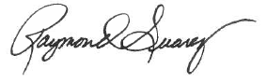

______________________________
Raymond Suarez, Board Chair

ATTEST:
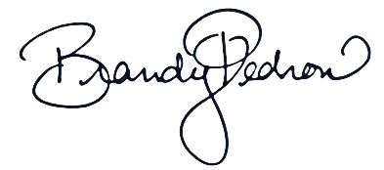

______________________________
Brandy Pedron, NTMC Secretary

