What Are “Health Boundaries” and Why Are They Important?
What can I do if I move from being a peer to one in a supervisory role?

The definition of a boundary = a limit or space between you and the other person; a clear place where you begin, and the other person ends. The purpose of setting a healthy boundary is to protect and take good care of yourself.
I would add that setting a healthy boundary also provides clarity for the other person and is created to help both parties maintain a positive and enduring relationship.
You know who you are (your values, your beliefs, and what is expected of you in your job) so you can articulate to the other person what those things are and help them understand where they fit in all of those areas.
It really is all about having an honest conversation while showing the other person that your relationship with them is still important, and it might take a different shape now and then. It is also perfectly acceptable to ask for information within certain boundaries. For example, you can tell someone that you do enjoy speaking with them and it would be helpful if they could please provide you three bullet points ahead of time and keep the conversation to 30 minutes, which would allow you both the time required to complete your daily work.
You will know when a boundary has been violated, even if you have not fully understood where to set a healthy boundary. Any time you feel conflicted in a conversation, don’t feel good about what the other person is saying or doing, and feel that you should speak up but don’t know how, you have someone pushing up against a boundary and it is causing you stress.
It is a fine line. You still want them to come to you with their issues and it is helpful to them that they can vent, but how helpful is it to you? You will need to start asking them what they expect of you and how they want you to help. You are no longer just their buddy, you are now in a position that can affect change. Some people just like to complain or want someone to hear them. You can explain that you appreciate being that person for them but what is it they want you to do?
It is important to note that you can no longer encourage them, engage with the venting so that it feels to them like you are supporting their negativity, or “take on” their problems so they no longer know how to work through them themselves. It is OK, to say
- “I hear what you are saying”
- “I can see how that would be frustrating for you”
- and most importantly “Have you shared this concern directly with so-and-so”
It is never OK to allow anyone on the team to bash another person, including management, unless they have tried to work through their concerns with the other person first. If they say they have addressed the other person, ask them how? Most people are very uncomfortable talking through issues with another person and may have said something in passing, made a joke, or may have accidently come across too strong and thought they had accomplished their goal. It often takes more than one conversation.
Properly-set boundaries can help you find more fulfillment and less stress in your work life, which accounts for a large part of your day-to-day responsibilities and stress.
Barriers to Boundary Setting:
It seems obvious that no one would want his/her boundaries violated. So why do we allow it? Why do we NOT enforce or uphold our boundaries?
• FEAR of rejection and, ultimately, abandonment.
• FEAR of confrontation.
• GUILT.
• We were not taught healthy boundaries.
• Safety Concerns

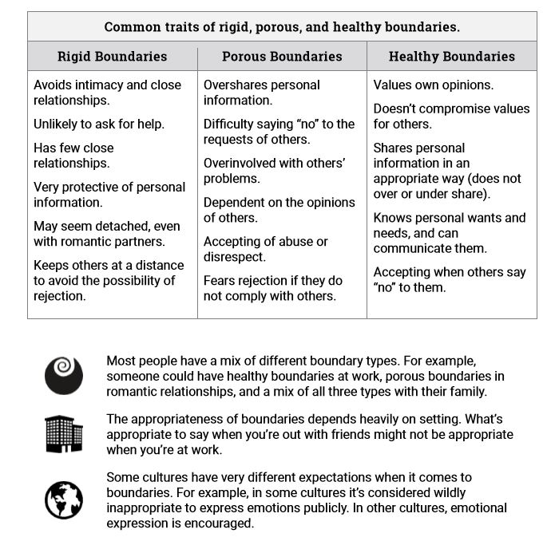
HEALTHY BOUNDARIES allow you to:
• Have high self-esteem and self-respect.
• Protect physical and emotional space from intrusion.
• Have an equal partnership where responsibility and power are shared.
• Be assertive. Confidently and truthfully say “yes” or “no” and be okay when others say “no” to you.
• Separate your needs, thoughts, feelings, and desires from others. Recognize that your boundaries and needs are different from others.
• Empower yourself to make healthy choices and take responsibility for yourself.

UNHEALTHY BOUNDARIES are characterized by:

• Sharing too much too soon or, at the other end of the spectrum, closing yourself off and not expressing your need and wants.
• Feeling responsible for others’ happiness.
• Inability to say “no” for fear of rejection or abandonment.
• Weak sense of your own identity. You base how you feel about yourself on how others treat you.
• Disempowerment. You allow others to make decisions for you; consequently, you feel powerless and do not take responsibility for your own life.

