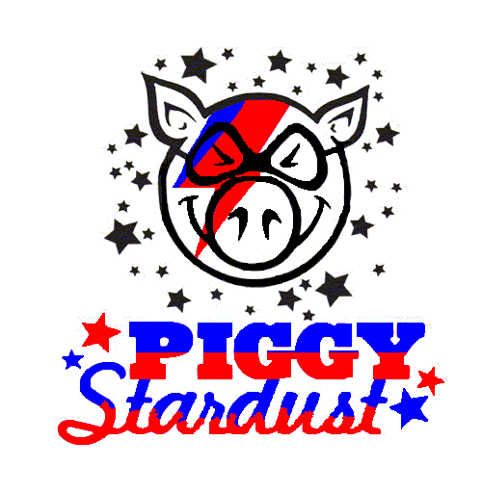

744 Crystal Street
New Orleans, LA 70124
(504) 884-2930

Instagram: @piggystardustnola
Facebook: PiggyStardust

A Hogs For the Cause Competitor

February 9, 2022

Dear ________,

On April 1st & 2nd, Piggy Stardust, will participate in the 13th annual Hogs for the Cause event on the Festival Grounds behind UNO Lakefront Arena. The charity raises money to underwrite grants for families whose children are afflicted with pediatric brain cancer. These grants offset costs incurred by these families that are typically not covered by insurance, the hospitals, or Medicaid. These expenses can be insurmountable and may include anything from travel expenses, lodging and meals, to home improvements to ease a family’s burden.
Last year, Piggy Stardust raised over $31,000 for the charity. Since team inception, Piggy Stardust has raised over $200,000 for Hogs for the Cause. This year our ambitious goal is to raise $100,000. Because Piggy Stardust is a registered 501(c)(3) in the state of Louisiana, donations are fully tax deductible. Please know that Piggy Stardust appreciates all donations and no donation is too small.
In order to raise money this year, we are raffling off the entire line of Pappy Van Winkle bottles. We would greatly appreciate your consideration in helping us work to ease the financial burden pediatric brain cancer inflicts upon families. If you would like to purchase raffle tickets, simply go to our website www.piggystardustnola.com. Here is the lineup:

- Pappy Van Winkle 23 Year
- Pappy Van Winkle 20 Year
- Pappy Van Winkle 15 Year
- Van Winkle Family Reserve Rye 13 Year
- Van Winkle Special Reserve 12 Year
- Old Rip Van Winkle 10 Year

Lastly, please try to attend the festival on April 1st & 2nd. The event has been a tremendous success in years past and should be nothing short of spectacular again this year. There will be over ninety teams like ours competing, each one selling BBQ to the public, and plenty of live music and activities for guests of all ages.
We are truly grateful for your support and together we can do something great!

