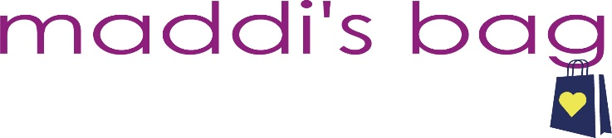 BOUTIQUE CONTRACT FOR MADDI’S BAG SHOP 4 CHOP 2022
DATE: Thursday, November 3, 2022 (6pm-9pm) & Friday, November 4, 2022 (11am-7pm)
LOCATION: 477 Brinton Lake Road, Thornton PA 19373
COST: $100 *all fees non-refundable unless event is cancelled by Maddi’s Bag
SET-UP: Thursday, November 3th anytime between 11am & 5pm
We are so thrilled to have you as a part of Maddi’s Bag 9th Annual Shop 4 CHOP!! Please complete below in its entirity. Registration & fee due no later than October 14, 2022.
COMPANY NAME: ______________________________________________________________________
CONTACT PERSON: _____________________________________________________________________
ADDRESS: ____________________________________________________________________________
PHONE: ______________________________________________________________________________
EMAIL: _______________________________________________________________________________
TOTAL AMOUNT SUBMITED: _____________________________________________________________
CASH CHECK VENMO CREDIT CARD CHECK # ____________
I hereby register to participate in Maddi’s Bag Shop 4 CHOP event. I agree to donating ONE item of my choice and price point to Maddi’s Bag for the event raffle. I agree to donate 15% of sales from the event to Maddi’s Bag as incentive for shoppers to Shop 4 CHOP. The deposit of $100 guarantees adequete space for ONE 6 ft table (will be provided) and ONE clothing rack (not provided) in which to display and sell merchandise. It also guarantees inclusion in /on all event adveritising as well as linkage of business page on event websites and social media platforms. Included in the vendor fee is unlimited drink & food as well as access to valet parking and set-up/break down assistance. Maddi’s Bag reserves the right to censor spaces & make final table assignments which may require last minute changes. Maddi’s Bag will not be held responsible for any liability, lost or stolen or damaged merchandise.
Due to Covid-19, Maddi’s Bag reserves the right to follow CDC recommendations as we see fit come November 2022. Please use your discresion as to whether you want to wear a mask or not. Maddi’s Bag will have hand sanitizing stations throughout the event & maintain clean surfaces as best as we can. Maddi’s Bag may not be held accountable if you come into contact with or come down with Covid-19. You are participating & signing this contract understanding the above and at your own risk. We WILL go above and beyond to do our best to host a safe & successful event for everyone in attendance.

SIGNATURE: _________________________________________________ DATE: ___________________
~~Please contact Jenny Raimondo with questions, concerns or specific requests @ 610.715.2587
~~Please email company logo and/or advertisement to maddisbag@gmail.com along with registration

We are so excited to celebrate survival, strength & gratitude TOGETHER, in person with each and every one of you!
XO,

