Table of Contents
The World of Fantasy Clash 2
Introduction 4
Objective 4
Game Phases 4
Card Breakdown – 6
Decks 7
Deployment 11
The Turn 13
Movement Phase 13
Movement Summary 14
Combat Phase 15
Close Combat Attack 15
Size Matters 15
Resolve 15
Ranged Attack 17
Combat Summary 19
Magic Phase 20
Magic Spells 20
Casting a Spell 21
Multiple Magic Users 21
Magic Items 22
Magic Phase Summary 23
Reinforcements Phase 23
End Game 24
Special Rules 25
Bio Evolution 25
Blessings 26

The World of Fantasy Clash

In the beginning the world was ruled by the mighty dragons. From the tallest peaks to the deep forests their kind were the apex predators and over time not only did their numbers grow but so did their civilization. This continued for centuries but the world of the dragons would be shattered by the arrival of the Gods.
The thoughts of Gods are not for mortal minds to comprehend but for some reason the omnipotent begins decided this world would be the one they used to stage their great game. Each God would create a champion to fight for them, with more victories the more that Gods standing increased amongst their peers. With such high stakes the champions that were created were powerful and mighty, eclipsing all but the largest of the dragons. The Titans had been born.
These mighty beings clashed in great battles, fighting for the honour and glory of their patron. The world was ravaged by these conflicts and times of relative peace were rare and many of the Titans were killed, coldly forgotten by their creator, and forgotten to time. As the great game wore on some of the Gods left the world, bored or faring too poorly to continue. As the remainder played on, they poured more power into their Titans. Unwittingly though this led to the remaining Titans becoming sentient. The Titans grew angry with their role, feeling used and abused by the Gods. Together the remaining Titans rebelled against the Gods and turned on their creators. The War of Heaven had begun.
The war made all conflict that had come before look tame. Many Titans and Gods fell as the war raged on, the two sides evenly matched. Gradually the Titans gained the upper hand for they were bred for war whereas the Gods had grown soft over time, letting the Titans do their fighting for them and the attack had taken them by surprise. They had to do something drastic to turn the tide. And they did.
The Gods created new races to fight for them. Not huge Titans like before that could rival them, but hordes of new creatures to swarm the Titans with their numbers. Again, the slaughter was great on both sides, but the Titans were clever as well as powerful. They went to these new fledgling races and showed them what the Gods had done, they were brothers in creation and were nothing more than pawns of the Gods and there was only one way to freedom. Some rebelled and some stayed loyal. But this final betrayal was too much for the Gods, and they finally admitted defeat and abandoned the world.

Finally, the Titans were able to stop fighting. Exhausted beyond mortal comprehension, they went into some kind of hibernation. The new races were left alone with no Gods or Titans to lead them. Slowly civilization grew, some following the teachings of the Gods where others worshipped the sleeping Titans. Others would carve their own independent path and find their own way in the world.
So, the world evolved until the next world changing event. The elements of Fire, Water, Earth, and Wind had always existed on the planet but one night four stars fell from the skies, crashing into the world. Hurricanes blew through the south, earthquakes shook the mountains of the east while volcanos erupted in the west. A huge tsunami caused terrible damage in the north as the world was ravaged. The devastation was horrific but eventually the survivors started to recover. But the new elements were sentient and slowly exerted their will on the world, shaping it and influencing the races of the world. However, it had a more profound effect, whether by accident or design, the Titans had been awoken from their long slumber.
And so, the world has gone on, with many wars and other cataclysmic events such as the meteor strike that heralded the arrival of the Catastrophe. Each race tries to survive and thrive in an increasingly hostile world. As time has passed more of the great Titans are starting to wake from their slumber and take a more active role in the evolution of this world. But they are not alone. Still enraged about their defeat the Gods have subtlety returned to the world. Afraid to challenge the Titans head on they instead try to manipulate and enhance the races that stayed loyal to them with the hope that they will kill the Titans for them as they were originally created to do.
The world hangs on the precipice of a new war that will eclipse all that came before.

Introduction
Welcome to Fantasy Clash, a two-player card game where you will play the commander of an army of mighty warriors, fantastic creatures, and powerful spell casters. The role of the player is to command their forces in battle with the objective being to defeat their opponent. Each player has a deck of cards that represents their army and the forces and powers at their disposal. Each has its own distinct set of cards and rules to use as you try to beat your opponent. There are also multiple different strategies to use with each deck, so each race has different ways to play.

Objective
There is only one way to win a game of Fantasy Clash and that is to break through your opponents back line. To do this you need to have one of your cards on your opponents rear most line for a complete turn. So, if you get one of your cards on your opponents back line during a turn, your opponent has their next turn and must find a way to remove it from play. Otherwise, if you start your next turn with the card still on their back line then you win the game.

Game Phases
Army Selection
Deployment Phase
Player 1 Turn –
Movement
Combat
Magic
Reinforcements
Player 2 Turn –
Movement
Combat
Magic
Reinforcements

Army Selection
Each player takes one faction deck and selects their starting force. Each deck consists of the following unit cards –
1 x Legend
1 x Titan
2 x Hero
3 x Champion
6 x Elite (2 each of 3 different cards)
12 x Veteran (3 each of 4 different cards)
20 x Regular (4 each of 5 different cards)
To make your starting selection you can pick the following from your deck –
1 x Hero
1 x Champion
3 x Elite
5 x Veteran
10 x Regular
Take the cards you did not select to start and shuffle them together. This will make up your reinforcement deck.
Some decks will come with special cards such as Magic Items, Magic Spells or Bio Evolution please keep them in their own separate pile to the side of the battlefield. Only unit cards should be shuffled into your reinforcement deck.
So how do you decide which cards you want to start with? Let us have a look at the breakdown of a unit card.

Card Breakdown –

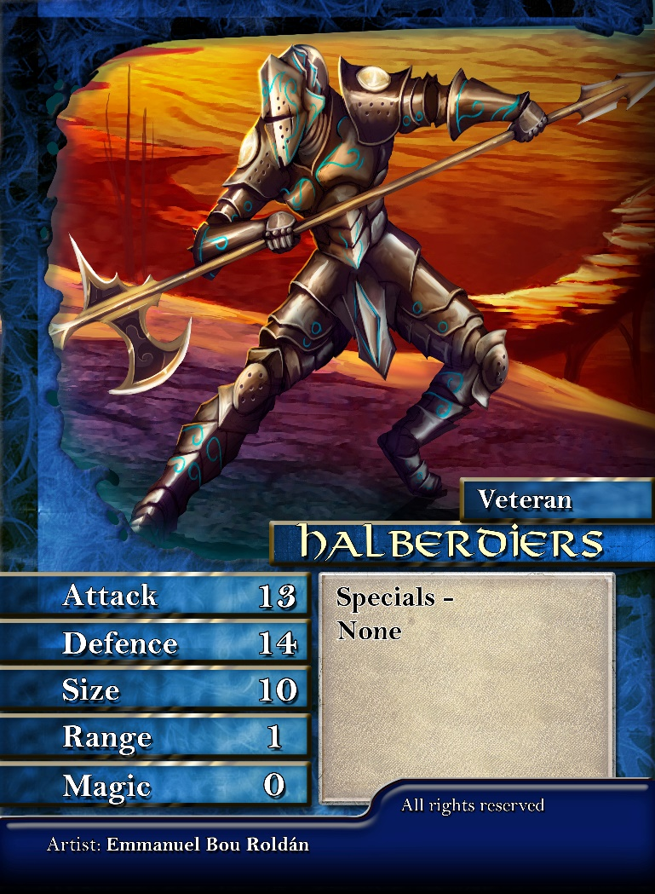

Card Type
Card Name
Card Statistics
Special Rules

Card Name – The name of the unit or individual.
Card Type – The class of the card.
Card Statistics – Represents the cards abilities in the game.
Attack – The cards ability to attack an opponent. Whether this is the measure of a soldiers skill with a sword or a beast with huge claws, the attack score represents their effectiveness in attack.
Defence – This represents the cards resistance to attacks. This could be due to armour, shields or even tough reptilian skin.
Size – Size can represent a horde of screaming goblins or a massive dragon. Size is used in resolving combat with the bigger the better.
Range – This is how far the card can attack. Most cards only have a range of 1 which means they can only attack when next to another card but cards with bows or war machines can typically attack further. Also, some special skills such as Scout or Heal use the range score.
Magic – Magic is used to cast magic spells. Some cards have a magic score despite not having this ability, this is to show their resistance to the effects of magic.
Special Rules – This box contains all the special rules and abilities that apply to the card.

Decks
Human Alliance –
As in most fantasy settings the Human Alliance is a balanced force. They do not excel in any area, but neither are they disadvantaged either. For Regular choices you can go defensive with Pikemen to protect your lines, Swordsman for a balanced option in combat. Crossbows give you a ranged attack, but you also have support options such as Priests to buff your other cards or Field Surgeons which can keep defeated cards from being removed from play.
Veteran choices let you pick Wizards which will allow you to use the magic spells of the Alliance. Or if you are more combat orientated Halberdiers give you the best close combat option. Pit Fighters are not quite as good in direct combat, but their killing blow ability means they will always have a chance to win no matter how tough the opponent. Finally, Bounty Hunters give you not only a ranged option, but bounty allows you to debuff an opponent card.
For the Elite Alliance cards, you can choose from Knights whose charge gives them a huge advantage when on the attack, Templers who are the best all round combat unit or the deadly war machine the Hellmouth to rain damage down from distance.
To lead your army will you take Marshall Voss to charge into the enemy or Illias Dante with his killing blow and banner ability to boost troops close to him? Supported by Champions, Eric Redcastle who reduces the cost of reinforcements to allow you to get more cards on the battlefield, Arteius Kirkridge and his additional magic item or even the deadly Assassin who can be sacrificed to take out any of your opponents cards. And hopefully you draw the massive Wrathbringer battering ram or even the Divine Knight himself.

Orcs –
The Orcs are all about attacking and using their size and power advantage. So where do Goblins come in? Well, an individual Goblin may not be big but when they group together in huge numbers, they overwhelm much larger opponents. Or their Archers who are normally terrible, but when enough of them shoot one of them is bound to hit home. Orcs though have the muscle for close combat, but craftier options exist. Zeppelins can scout out and reveal hidden cards whereas Gremlins can trap much more powerful cards and take them out.
Trolls are a tough unit with their regeneration skill making them very hard to take out. Boar Riders with their charge can be deadly when on the attack but they are vulnerable in defence. Other Veteran options include the Shamans who open up dangerous magic spells or the Orc Catapult that can cause longer ranged damage.
The Elite level have a lot of hard hitters, flying Wyrvens add some strong and mobile options or huge Ogres can go toe to toe with any opponent. The huge Orc Heavies are not only brutal, but their iron armour makes them exceptionally difficult to bring down.
Hero options give you the choice of the might Ogre Kholek with his frighting stats or the much more malicious Goblin King who buffs all Goblins on the field which can lead to a frighting amount of dice being rolled. Supporting them are the Champions. Grunt lets you take an additional magic item whereas Darkstaff is a powerful shaman who will be able to cast magic spells easier than standard shamans. Silus is a different choice who looks weaker but if you get him using his backstab ability, he becomes deadly. The Colossus is the mighty Titan option if you can get him and Hordak is a mix of a great fighter and deadly shaman.
Dragons –
Easily the most powerful deck in the game when it comes to sheer base statistics. They have access to cards with big attack, defence, and size scores. With a lot of cards that can fly they are highly mobile as well. They need be though as they have a limited range and with no support cards, they can be very vulnerable in the magic phase.
Drakes are lightweight young dragons, but they make great scouts to reveal your opponents cards. Or you could use the Fire Swarm to tie down enemies. Serpent Dragons can move further and faster than any other card whereas Water Dragons are very resilient to both physical and magical attacks. Finally, the Land Wyrm may not be able to fly but it can hit hard for a regular card.
The Veteran options for the Dragons are all different colour varieties. Red Dragons are fire breathers and fierce fighters. Blue Dragons use their lightning to attack from range. The grotesque Green Dragons are very hard to kill and spread poison through the enemy ranks. Finally, the White Dragons use the power of healing to keep the other Dragons in the battle.
Elite choices give you the Fire Elemental, a very powerful attacking card. Or the Gold Dragon which charges with the force of a unit of Knights. But maybe you will be seduced by the very powerful Black Dragon with its superior statistics. Just be wary that they will debuff the rest of your army.
The choice is similar at Hero level. Do you go for Gardorah, a multi headed dragon that is hard to kill or the ancient Black Dragon Khaarnage who can match up against any card but again will cause negative modifiers to the rest of the army. With no magic the Dragons are vulnerable, except Smrgol who has immunity to magic attacks. Or you could take Skyhunter with his killing blow or Safin who can not only use heal herself but boosts any other White Dragons healing ability as well. However, if you pull Tiamat or Bahamut they are game changers and will turn the tide of any battle.
Aegyptus –
The children of the gods are another balanced army with a variety of ways to play them but specialize in manipulating movement on the battlefield as your foe gets stuck in the desert quicksand and you pick them off at range with attacks and magic.
The standard all-rounder are the Ras Warriors, capable in both attack and defence. Or you could fly swarms of Scarabs to tie down enemy units. Embalmers are excellent at keeping troops fighting with their embalm ability even greater than other races heal. Desert Scouts give you the all-important scout ability to reveal opponents cards and the final option are Horus Archers which allow you to attack from range.
As for the Veterans, the Thoth Scholar is quite unique. Its base statistics are poor, but its scholar ability allows you to seriously debuff enemy cards. Another apparently weak card are the Priests of Aegyptus but they have access to the power of blessings. If it is combat though you need the Necropolis Guard, have you covered as good close combat troops. Lastly the Giant Scorpions give you access to Killing Blow which means you will always have a chance no matter how outmatched the combat is.
Mummies are an Elite choice and give you access to the magic deck, but they are not like other races squishy wizards as they can handle themselves in combat as well, meaning they can go closer to the front lines. Sobek Crocodiles are your option for sheer power but do not forget about the Amunet Guardians who are solid combat troops as well and can spread poison.
Will you lead your army with Cleopatra who buffs the entire army when she is in play or the more warrior like Djaf who is better in a fight and buffs the Necropolis Guard? Imhotep is a Champion that will rain magic down on your opponent or you could instead take Rameses to attack them from range and boost your other archers. Or will it be the sinister Dark Embalmer whose methods may be questionable, but he will keep your cards on the battlefield. The Sphinx is a mighty Titan level creature and the Pharoh himself can take to the field with an awesome combination of magic and combat skills.
Catastrophe –An insectoid alien race that can swarm the enemy, tunnel past their lines, and of course have access to the bio evolution support mechanic which allows you to create your own monsters as already dangerous cards grow wings or extra arms to make them even more deadly.
Bore Worms keep your opponent on their toes with the tunnel ability exploiting any open gaps in their lines. Reapers act as your all rounders for the Catastrophe while Lash Parasites use swarm to tie up opponents. Soul Takers are weak, but your opponent better take them out fast as they can resolve combat with magic instead which can cut through non magic cards. And Spore Bombs are designed to explode and hopefully they will take much more powerful cards down with them.
Flying Reapers not only have mobility, but the charge ability makes them very dangerous when on the attack while Seekers are also flyers, but they have scout. Unlike other scouts though they are very handy in combat. The Spiked Agony is all about close combat whereas the Spitters prefer to fight at range.
At Elite level the Queens Guard are the unit with the best stats for fighting. But the Silent Doom is a flexible option, good in combat but the assassin ability means it can act as an insurance policy if you need it. Mind Flayers seem weak, but they use their huge magic score to take over your opponents cards and use them as they were your own.
Siege is a very powerful no thrills combat card at the Hero level, but the other option is the Changeling who can masquerade as your opponents characters. There is not much of a worse feeling for your opponent as they reveal their great hero only for you to inform them it has been your Changeling all along. Champions like Red Stripe can use tunnel to quickly get behind enemy lines or Terrorwing dominating the skies. Or again if you just need a tough fighter, you could do worse than bring along Brute. The Titan the Great Devourer or the Legend that is the Hive Queen are the cards you want to see at reinforcement time.

Deployment
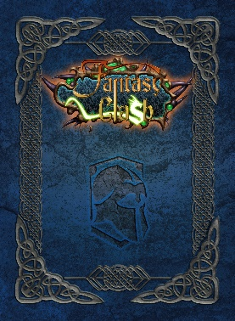
Once you have made your starting selection it is time to deploy your forces. The battlefield is split into two halves, one for each player. Each player takes their 20 starting cards and places them FACE DOWN in a grid 5 across and 4 deep as shown below –

There are no restrictions on where you can place cards. The player is free to place the cards wherever they want. So, you could evenly spread out your forces or have all your best cards grouped together. There is no limit to how you set up.
Each player takes the remaining cards from their deck and shuffles them. Place them at the side of the battlefield, this is your reinforcements deck. If you have any special cards such as magic items or magic spells, put them to the side of the battlefield, separate to your reinforcements deck.
Also leave a space for cards that you defeat in battle, this will be your conquered pile.
Now that setup is compete each player rolls 1d6. Whoever rolls the highest takes the first turn, re-roll any ties.
An example of how the game should look when setup to start -
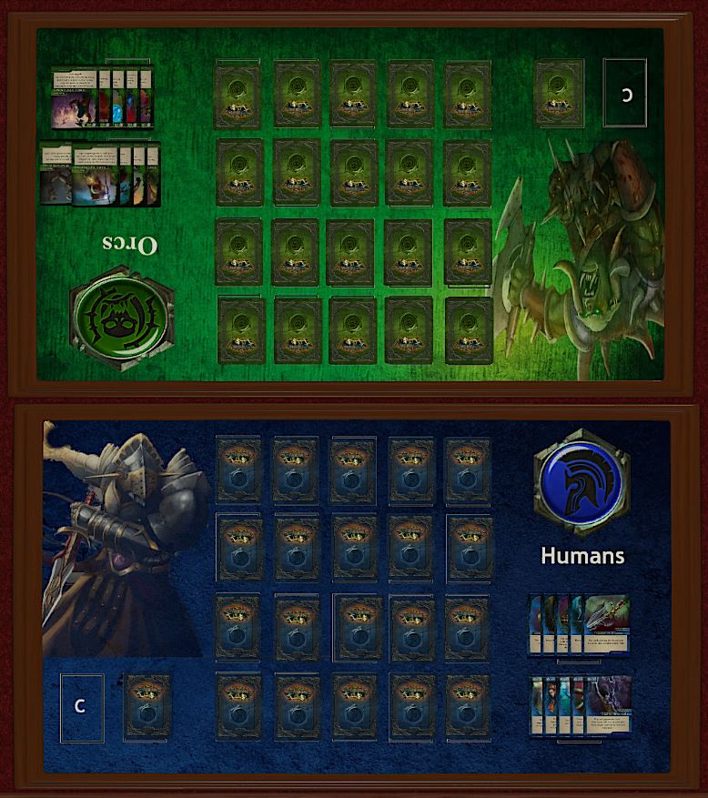

The Turn
Each players turn is the same and consists of the following phases –
- Movement
- Combat
- Magic
- Reinforcement
Once Player 1 completes their turn Player 2 takes over and goes through the same phases. When completed it once again becomes Player 1s turn.

Movement Phase
Each card can move one space if there is an available space for them to move into. This must be a free space with no other card occupying it. Cards can move horizontally and vertically but NEVER diagonally.
You can move as many cards as you like but each card can only move one space per turn. If your card is face down, it can stay face down unless it comes into contact with one of the other players cards.
Move Example 1 –
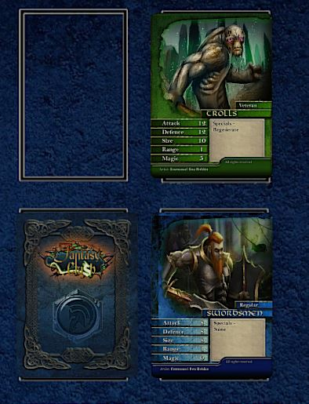
In this example you would like to move your card forward into the empty space. As this is a horizontal move and the space is unoccupied you can do this. However, as it would take the card adjacent to one of the other players cards it must be turned face up to complete the move. Note that it does not matter if the other players card is revealed or not, you would have to reveal your card, but they would not.
Example 2 –
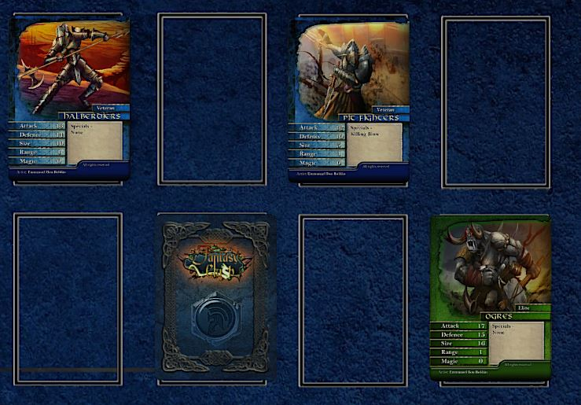
In this example you could move your unrevealed card to the space to the left or in front of it without having to reveal it. You can also move it into the space on the right but as it will then be in contact with the other players card it would have to be revealed after it is moved. In the same turn you could also move your Halberdiers and Pit Fighters to any space that was available for them to move into.

Movement Summary
- Cards can only move one space per turn.
- Cards can only move into an empty space.
- They can only move in a horizontal or vertical direction.
- If they are currently face down, they can stay that way unless by moving they come into contact with the other players card. If they do, they must be revealed after moving.

Combat Phase
In the combat phase you may perform one attack. This can either be a close combat attack or a ranged attack. You can pick one or the other, but you cannot do both on the same turn. Only a card that has been revealed may declare an attack. As you can reveal a card at any time during your turn though you can reveal a card now and declare an attack with it. If the other players card that you are attacking is currently face down reveal it now.

Close Combat Attack
In order to perform a close combat attack, the two cards must be in direct contact with each other, either horizontally or vertically. First the attacker rolls 2d6 and adds the cards attack value to give you your attack score. Next the defending player also rolls 2d6 and adds their cards defence to get their defence score.

Size Matters
Before you roll the dice for the close combat check each cards size value. If either the attacker or defenders size has a value that is five or greater than the other card, then they can roll an extra d6 in this combat.

Resolve
If the attack score is greater than the defence score, then then the defending card is removed form play and the attacker can place that card in their conquered pile. The attacking player then has the option to follow up which means placing the attacking card in the space where the defending card was. Note this is optional and you can decide to leave your card where it is instead.
If the defending card would win the battle, then the attacking card is removed from play and the defending player places it in their conquered pile. The defending card though does not move.
If the scores are a draw both cards remain on the battlefield and the combat is over.

Example 1 – Peter declares an attack. His Trolls are adjacent to Murrays Swordsmen, so it is a close combat attack.
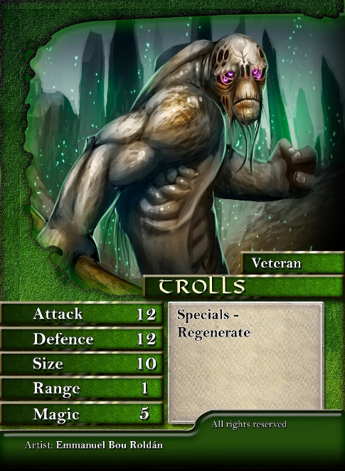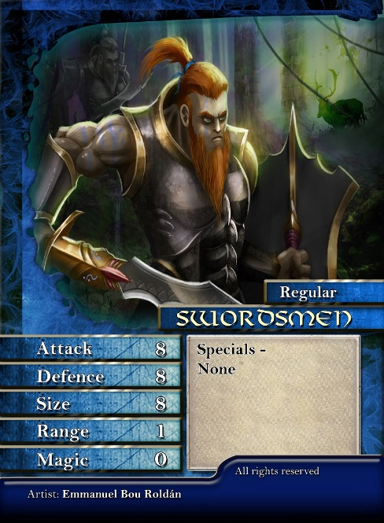
First, they check their respective size scores. 10 v 8, neither is five or greater so both will roll 2d6. Peter rolls first and scores a 5 and a 2 for a score of 7. He adds this to the Trolls attack value of 12 to give him an attack score of 19. Now Murray rolls 2d6 for his defence. He rolls a 6 and a 2 for a total of 8. Murray then adds the Swordsmen defence value of 8 for a total of 16. The Trolls have won so Peter takes the Swordsmen card and places it in his conquered pile. He then has the option to move the Trolls into the space where the Swordsmen were, which he does.
Example 2 –Gordon declares an attack with his Ras Warriors on one of Jacks unrevealed cards. At this stage Jack flips over the card to reveal a Black Dragon.
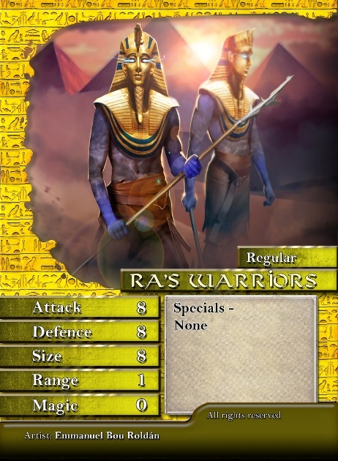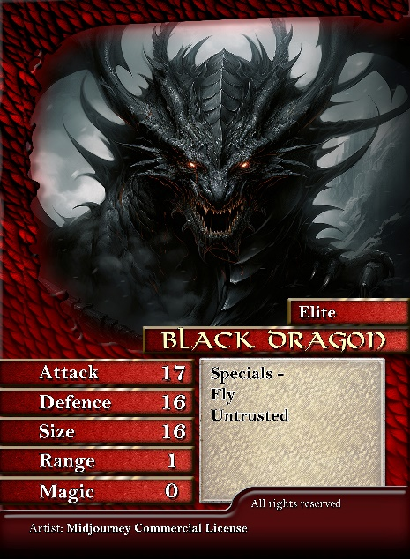

First, they check the size, 8 v 16. The Black Dragon has an advantage of 8 which is greater than the 5 required, so it will roll an extra d6 in combat. As the attacker Gordon goes first and rolls 2d6 and scores an impressive 11. He adds the Ras Warriors attack value of 8 to get an attack score of 19. Jack rolls 3d6 in defence as he gets an extra dice for the size advantage. He only managed to roll 7 but when he adds the Black Dragons defence value of 16, he gets a total defence score of 23. Jack therefore takes the defeated Ras Warriors card and places it in his conquered pile. As the Black Dragon was defending it does not move.

Ranged Attack
Instead of a close combat attack you could instead declare a ranged attack if you have a suitable card. Where the card has a range value greater than 1 then you may perform a ranged attack. Note make sure to check your special rules as not every card with a range greater than 1 can make ranged attacks. Also, you cannot perform a ranged attack on a card you are in contact with, that must be resolved under close combat rules.
You can perform a ranged attack on any card within range. To measure range, count the spaces between the cards. You can only count the spaces vertically or horizontally. You can go left, right, and forward but you can never shoot behind you.
If the card you want to use to make the ranged attack is still face down, you need to reveal it now. Also, if the card you are targeting is face down it to is now revealed.
Size values are not used at all when resolving a ranged attack.
Combat is then resolved in the same way as a close combat attack with the attacker rolling 2d6 and adding the cards attack value and the defender rolling 2d6 and adding its defence value. If the attacker wins then they remove the defending card from play and into the attackers conquered pile. There is no free move though and the attacking card stays where it is. If the defending card wins or the scores are tied, then neither card is removed, and the attack is over.

Example – In this example Peter has declared he will perform a ranged attack using his Crossbows against Murrays Goblins.
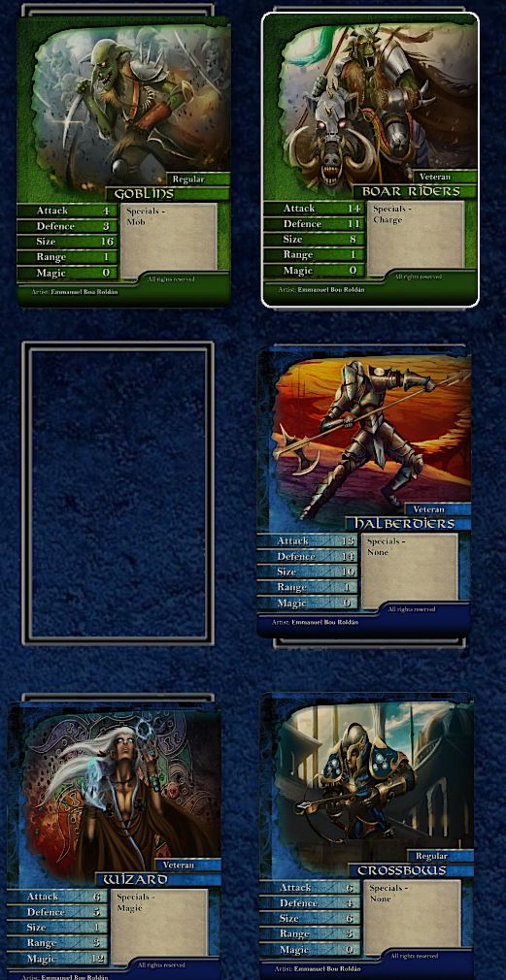
The crossbows have a range of 3 so Peter counts the distance in cards between the Crossbows and the Goblins. He counts 2 upwards past the Halberdiers and the Boar Riders and then 1 to the left to reach the Goblins for a count of 3 which matches the range score of the Crossbows, so they are within range. He could have also counted first left to the Wizard and two up past the space and then the Goblins to also reach for a total of 3. It does not matter which way you go, so long as the total is not greater than the range of the card. He could also decide to attack the Boar Riders as they are only 2 away and within range but he decides to fire at the Goblins.
Peter rolls 2d6 on for his attack and gets a total of 6. He adds this to the attack value of the crossbows of 6 to get an attack score of 12. Murray rolls 2d6 for his defence and rolls 8. Adding the Goblins defence value of 3 he gets a total defence score of 11. The Goblins are defeated so removed from play into Peters conquered pile. As this is a ranged attack the Crossbows do not move after the attack.

Combat Summary
- You have one attack per turn, either close combat or ranged.
- Both cards involved in the combat must be revealed.
- In close combat if one card has a size of 5 or greater then that card gets an extra d6 in combat.
- If making a ranged attack check the card that is being attacked is in range.
- Attacker rolls 2d6 and adds attack value, defender rolls 2d6 and adds defence value.
- In close combat the losing card is removed into the winners conquered pile. If it was the attacker that won, they can choose to follow up to where the defending card was occupying if they wish. If the score is tied neither card is removed.
- In a ranged attack if the attacker wins then the defending card is removed into the attackers conquered pile. If the defending player wins or the scores are tied, then no cards are removed.

Magic Phase
The magic phase is where you can play any auxiliary cards. Most decks come with Magic Spells and Magic Items, but some have other types of cards that can be played in this phase.

Magic Spells
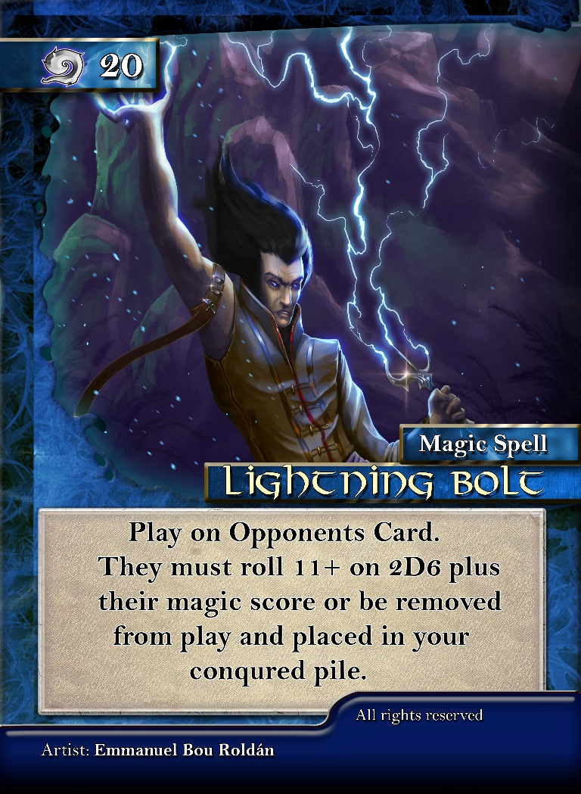
Casting Cost

Spell Name
How to Play Card
Spell Effects

Casting Cost – In order to cast the spell, the card with Magic special ability rolls 2d6 and adds their magic score. If they total is equal or greater than the casting cost, then the spell is cast.
Spell Name – A description of the spell.
How to Play Card – Here it tells you how to play the card, this could be playing on the other players card, your own card, or some other effect.
Spell Effects – What happens when the spell is successfully cast.

Casting a Spell
First only a card that has the MAGIC special ability can cast a magic spell and you must reveal that card face up. The spell caster must also be in range if there is a target card of the spell. This is worked out using the same way as a ranged attack described earlier.
Now you need to cast the spell. To do this roll 2d6 and add the cards magic value to your score. If you match or beat the score the spell is successfully cast. You can now follow the text on the card to resolve the spells effects. If it is less than the casting cost the spell is not cast and you can return the spell card to your hand.
Let us go back to our previous example for ranged attacks. It is Peters magic phase, and he declares he is going to attempt to cast Lightning Bolt on Murrays Boar Riders. Peter first measures the range from his Wizard, who has the magic ability, to the Boar Riders. It is right 1 to the crossbows and 2 spaces up to the Boar Riders for a total of 3. Checking the Wizards range of 3 shows that they are in range.
Next, he tries to cast the spell, so he rolls 2d6 and scores 9. He adds the Wizards magic value of 12 for a score of 21. As the casting value is 20 the spell is successfully cast.
As such he reads the rest of the spell card. The Boar Riders must score 11+ on 2d6 plus their magic score or be removed from play. Murray rolls a 4 and as the Boar Riders have a 0 magic score this is his total. Peter takes the Boar Riders and places them into his conquered pile.
Spell Exhaustion – When a spell is cast successfully, and its effects worked out place it to the side as the spell is exhausted for just now. If you can cast all the spells in your deck, then this replenishes your magic spells, and you may take them all back into your hand. If a spell is not successfully cast, then do not discard it.

Multiple Magic Users
Each turn any card you have with the magic ability can attempt to cast a spell. If it is cast (no matter the result of its effects) then you cannot cast any more spells that turn. If it does not cast though you may move onto another magic user and attempt to cast the same spell or any other spell you have. As soon as you have a successful cast though no other spells may be attempted this turn.

Magic Items

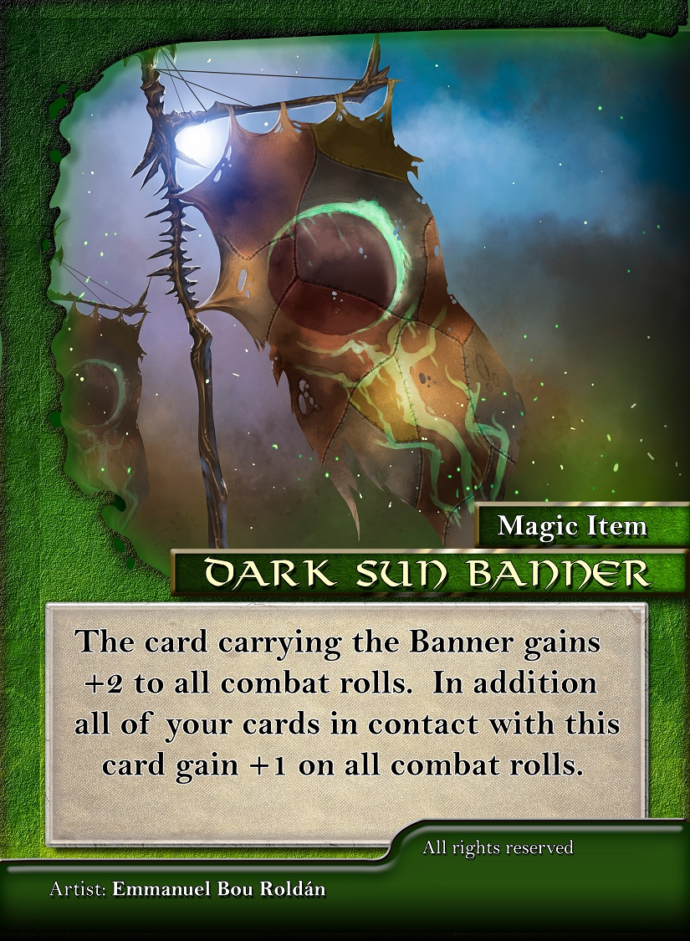
Card Description
Card Name
During your magic phase you may play a Magic Item card on any revealed card on the battlefield. Attach the Magic Item to the card by placing it underneath the card. That card automatically gets the effects described by the magic item.
You may only have one magic item in play at any one time.
If the card with the magic item is removed from play, then your opponent can take the card and the magic item into their conquered pile. However, when the magic item is removed from the battlefield it means you can play another one in your next magic phase if you so desire.
Other types of cards or skills –
Some races do not have magic spells or magic items but other skills such as bio evolution. There will be covered in the special rules section. Also, some cards have abilities such as blessings. Again, these will be covered in the special rules section with details on when and where abilities can be used.

Magic Phase Summary
- To cast a magic spell the card must have magic ability.
- If the spell is cast on a certain card, it must be in range.
- Attempt to cast the spell by meeting the casting cost by rolling 2d6 and adding the cards magic value score.
- You can only cast one spell per turn.
- If you fail to cast then another card with the magic special ability may attempt to cast a spell, this can continue until all cards with magic have attempted to cast or one spell is successfully cast.
- If cast successfully then the magic spell is exhausted and cannot be cast again until you have exhausted all your spells, then you gain them all back.
- You can play a magic item card on any revealed card.
- Each player may only have one magic item in play at once.
- If card with magic item is defeated the player takes both cards into their conquered pile.

Reinforcements Phase
In this phase you can add to your army on the battlefield if the following conditions are met. First you need to have a space on your back row to place a card. Second you need to have at least 3 cards in your conquered pile. If those conditions are met, you may now trade in 3 cards from your conquered pile, these cards are discarded out of the game. You can now take a card from your reinforcement deck and place it face down in any space on your back row. This card is picked at random from your reinforcement deck. Remember even if you have enough cards for multiple reinforcements, you can only play one per turn.
Example –
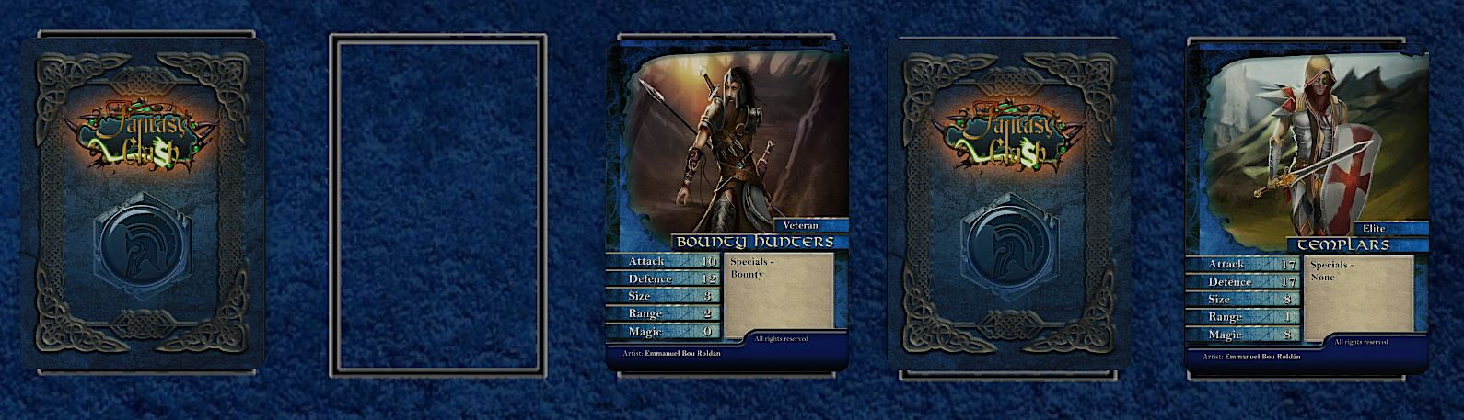
Peters back row consists of 2 unrevealed cards, Bounty Hunters and Templars. He has a space where there is no card. He also has 5 cards in his conquered pile. He takes 3 of these and discards them out of the game. He then takes a card at random from his reinforcement deck, has a look at it and then places it face down in the space. Has he picked some more Swordsmen or maybe the Wrathbringer Titan card? He knows but his opponent will not until it is revealed during the game.

End Game
In order to win the game, you must first get a card onto the other players back line and survive your opponents next turn. In other words, if at the start of your turn you already have someone on your opponents backline you win the game.
Example –
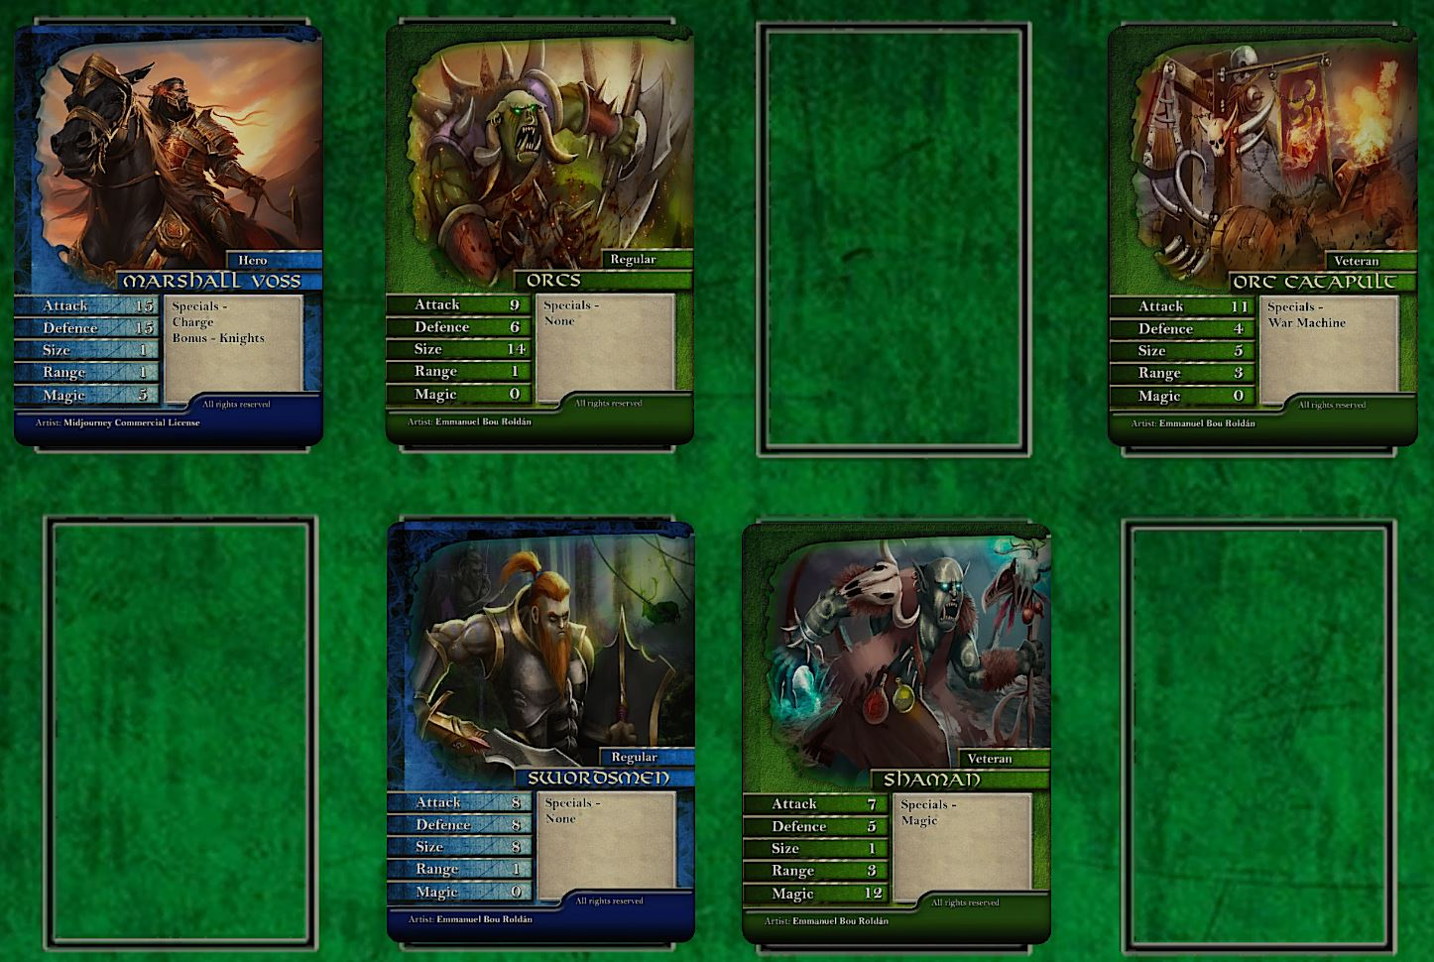
In this example Peter has just used his Marshall Voss card to defeat one of Murrays cards that was on his back row. He then follows up and ends his turn with Marshall Voss on Murrays back row. Murray must find a way to eliminate this card on his next turn or he will lose. In his combat phase he must decide to either use his Orcs for a close combat attack or a ranged attack with the Orc Catapult.
If he goes for an attack with the Orcs, it will be his 9 attack against defence of 15. The Catapult has a better attack of 11 so it would make sense to use it instead. However, the Orcs are in close combat so size would come into play, 1 v 14 so if he uses the Orcs, he will have an extra d6 to roll. He decides to go for the close combat attack. He rolls 3d6 in attack and scores 9 which gives the Orcs an attack of 18. Peter rolls 2d6 for defence and scores 6 for a total of 21. The Orcs are defeated, and Peter takes them into his conquered pile.
It is not all over though for Murray, it now moves onto his magic phase, and he has his Orc Shaman within the range of 3 of the Marshall Voss card. He has the Orc Blast card in his hand which would allow him a chance to remove the card. It has a casting roll of 18 so with the Orc Shamans magic score of 12 he only needs to roll 6 or more on 2d6 to cast it. However, he rolls a poor 3 for a total of 15 and fails to cast the spell. With no way now to remove the card before Peters next turn the game is over.

Special Rules
There are several unique abilities in Fantasy Clash. These are listed in the cards Specials box. Some cards can have more than one special ability. How to, when to, and what they do are listed here.

Bio Evolution
The Catastrophe deck do not have Magic Spells and Items like other races, instead they have a deck of 10 Bio Evolution cards. This is a race specific ability that you can use in the magic phase.
- There is no limit to how many Bio Evolution cards are on the battlefield at any one time.
- One card can have up to 3 Bio Evolution cards on it. Abilities stack so enjoy building your monster.
- Once the card is removed from play any Bio Evolution cards on it are taken by the other player and put into their conquered pile. Bio Evolution cards are never returned to the Catastrophe player and are one use only.

Blessings
Some decks have the ability to call on the Gods for help. During the magic phase you may attempt to cast one blessing per card that has the ability to do so. For example, if you have 2 cards face up that have the blessings ability you can attempt to cast two blessings.
- In order to cast a blessing, the card must roll equal or more than the blessing casting score on 2d6 plus the cards magic score. The same as casting a magic spell.
- There is no range limit on blessings. If they are specific to a card, that target card can be anywhere on the battlefield but must be face up.
- You cannot have multiples of the same blessing in play. So, if one card already has the blessing of war on it then you cannot cast that blessing on any other card unless you remove it from that card and attempt to cast it again, which you can do in the magic phase.
Blessing of Alliance Gods –
- Blessing of War – 14+ - Play on your own card. That card gets an extra 1d6 when it makes its next attack. Once that attack takes place the blessing ends.
- Blessing of the Shield – 15+ - Play on your own card. That card gets an extra 1d6 for its next defence roll. Once it has been used the blessing ends.
- Blessing of the Harvest – 16+ - When the blessing is cast you need one less conquered card to play your next reinforcement. Once the reinforcement is played the blessing ends.
- Blessing of Death – 17 + - Play on your opponents card. That card rolls 1d6 less in its next combat, whether in attack or defence. After that combat the blessing ends.
Blessing of Aegyptus Gods –
- Blessing of the Asp – 17+ - Play on your own card. That card gains the poison ability. This remains until the card is removed from play.
- Blessing of Horus – 18+ - Play on you own card that has a range score that is greater than 1. That card gains +1 to its range score until it is removed from play.
- Blessing of Set – 19+ - Your opponent can only move 1 card in their next movement phase. They also cannot use the Fly ability. After their turn ends so does the blessing.
- Blessing of Ra – 20+ - Play on your own card. The card rolls an extra 2d6 in its next combat, defence of attack. After that combat the blessing is over.

Arrow Storm –
- Phase to play – Combat
- Ability – You can use size difference in ranged attacks as well. If you have five or more size roll an extra d6 for your ranged attack.
Assassin –
  - Phase to play – Any
  - Ability – If the card with the Assassin ability is face down you may reveal it at any time during your own turn. Nominate any of the other players revealed cards and remove it from play into your conquered pile. However, the card with Assassin is also removed into the other players conquered pile. If the card is revealed before the ability is used, then it can no longer be used.
Banner –
  - Phase to play – Ongoing
  - Ability – Any card in the same vertical or horizontal row with the card with banner gets +1 on any combat rolls they are involved in.
Beloved of Aegyptus –
- Phase to play – Ongoing
- Ability – All Aegyptus cards gain +1 on all combat rolls.
Bounty
- Phase to play – When card is revealed
- Ability – Once per game you can place a bounty on any of the other players revealed cards. That card rolls 1d6 less than normal in its next combat. Multiple bounties can be placed on same card which will stack but cannot go less than 0d6 to roll.
Chameleon –
- Phase to play – Combat
- Ability – In order to declare an attack on a card with Chameleon you need to first roll 3+ on 1d6. If the score is 1 or 2 then you cannot attack the card but can declare another attack against another card instead.

Changeling –
- Phase to play – When character card revealed, Any Phase
- Ability – When the other player reveals a champion or hero card you may immediately remove that card from play into your conquered pile for it is instead a changeling. Reveal your changeling card and place it in the space the champion or hero card was. If the changeling is revealed before the ability has been used, then it cannot be used.
Charge –
- Phase to play – Combat
- Ability – If a card with Charge declares a close combat attack, then it can roll +1d6 in attack for the combat. If they win, they MUST follow up.
Embalmer –
- Phase to play – Any time one of your cards would be removed from play
- Ability – The card can NOT use its range score to make ranged attacks. Instead, if one of your cards is removed from play check if it is in range of the embalmer. If it is, you may roll 1d6. On a 5+ the card survives and stays on the battlefield. If more than one embalmer is in range, you may roll 1d6 for each embalmer. If any score 5+ the card stays in play.
Extra Move –
- Phase to play – Movement
- Ability – The card with extra move can move one more space than normally allowed.
Fire –
- Phase to play – Combat
- Ability – The card with fire gains +1 on all close combat rolls. Both in attack and defence. If both cards have fire, then it has no effect.

Fly –
- Phase to play – Movement
- Ability – Cards with fly may move 2 places per turn. They can also move over cards to reach a space. They can move over both players cards unless the other players card has fly. If it is your own card though you can fly past them into a space on the other side.
Goblin Rouge –
- Phase to play – Combat
- Ability – If the Goblin Rouge is in a close combat either as the attacker or defender and is to the right, left or behind the card it is in combat with, then double the attack and defence of the goblin rouge for the combat. If the opponent is to the front of goblin rouge, then there is no bonus. It is judged to be in front when it is in a vertical line with the cards being closest to their respective owners side.
Hatred –
- Phase to play – Ongoing
- Ability – When you have a card with Hatred it will tell you the card it hates. If that card is also on the battlefield, then both cards have a -2 penalty on all dice rolls.
Heal –
- Phase to play – Any time one of your cards would be removed from play
- Ability – The card can NOT use its range score to make ranged attacks. Instead, if one of your cards is removed from play check if it is in range of the card with heal. If it is, you may roll 1d6. On a 6+ the card survives and stays on the battlefield. If more than one card with heal is in range, you may roll 1d6 for each of them. If any score 6+ the card stays in play.
Immune –
- Phase to play – Ongoing
- Ability – The card cannot be killed by the type of attack it is immune to. For example, a card that is immune to magic cannot be killed by a magic attack.

Iron Skin –
- Phase to play – Combat
- Ability – Any card attacking the card with Iron Skin suffer -1 penalty on its attack score. However, if the card attacking has a magic item that gives them a combat bonus, then then there is no penalty.
Killing Blow –
- Phase to play – Combat
- Ability – If the card with Killing blow rolls a 6 on any dice when working out a close combat, either in defence or attack then it wins the combat regardless of the other players score. If both cards have Killing Blow at both roll a 6 then both cards are removed from play.
Leader –
- Phase to play – Any
- Ability – You may reroll any 1d6 on your turn. You get one reroll each turn.
Magic –
- Phase to play – Magic
- Ability – The card with Magic can NOT make ranged attacks using its range score. Instead see the magic section on how to use magic to cast spells.
Magic Item –
- Phase to play – Magic
- Ability – The card with Magic Item can be given another additional magic item to the one normally allowed. This allows you to have two magic items on the battlefield at once but one of them must be given to the card with magic item.

Mind Flay –
- Phase to play – Combat
- Ability – When making a close combat attack use both cards magic value instead of the usual attack and defence values. So, both cards roll 2d6 + magic value for working out the combat. If the card with mind flay wins then place the mind flayer card behind the card you beat and turn it around as you now control it. All values and abilities on the card remain the same. If the card is removed, then place it in your conquered pile and the card with mind flay is also removed into the other players conquered pile as a casualty.
Mob –
- Phase to play – Combat
- Ability – If the card has a size bonus, they will roll +2d6 for the size advantage instead of the normal +1d6.
Poison –
- Phase to play – Reinforcement
- Ability – If the other player has any cards in contact with the card with poison, they must roll a poison check. The other player must roll 1d6 and if they roll a 1 the card is removed into your conquered pile. Note that contact means left, right, down, or up and NEVER diagonal.
Ram –
- Phase to play – Combat
- Ability – The card with Ram must always follow up after a successful close combat attack. If there is another card it can attack after following up, then perform a second bonus close combat attack. No matter the result its turn ends after the second attack.
Regenerate –
- Phase to play – Any time it would be removed from play
- Ability – If the card with regenerate would be removed from play roll 1d6. If you score 5+ the card remains on the battlefield.

Scholar –
- Phase to play – Movement
- Ability - The card can NOT use its range score to make ranged attacks. Instead use the range score to target any of the other players revealed cards. That card will suffer a -2 penalty to its next combat score. The same card can be targeted by multiple scholars which will stack at -1 per additional scholar. For example, if 2 scholars target the one card it will suffer -3. Or they can target different cards. You can change the target each turn but if you do the modifier is removed from the original target and moved to the new one.
Scout –
- Phase to play – Movement
- Ability - The card can NOT use its range score to make ranged attacks. Instead use the range score to target one of the other players face down cards. That card is immediately turned face up and revealed.
Shield Brothers –
- Phase to play – Reinforcement
- Ability – You only have to pay two conquered cards to play a reinforcement when the card with shield brothers is on the battlefield.
Soul Take –
- Phase to play – Combat
- Ability – When the card makes a close combat attack it uses the magic value instead of attack value. The defender also must use its magic value in working out the combat instead of defence.
Spore Bomb
- Phase to play – Combat
- Ability – If the Spore Bomb is defeated in close combat, either as an attacker or defender, roll a d6. If you score 3+ then the card that defeated it is also removed.

Swarm –
- Phase to play – Combat
- Ability – When the swarm is the defender the attacker rolls one less d6 than normal due to the difficulty of hitting the swarm. If the swarm is the attacker, then there is no penalty.
Trappers –
- Phase to play – Combat
- Ability – If the trappers are attacked before they are revealed remove both cards instead of fighting a combat as if they had both been killed with each player taking a card into their conquered pile. If the card with trappers is revealed before being attacked, then this ability cannot be used.
Tunnel –
- Phase to play – Movement
- Ability – In the movement phase instead of a normal move you can elect to tunnel. If you tunnel you can go in a straight line forward to the next available free space that is NOT on your opponents backline. If there are no free spaces, you cannot use the ability.
- If your opponent has a card in the path of the tunnelling card that also has the tunnel ability, then they can reveal it if hidden and block the tunnelling attempt. The card instead fails to move this turn.
Type Bonus –
- Phase to play – Combat
- Ability – The type bonus will be another card type. E.g. Knights Bonus. This means when a card of that type is in combat, they can roll one extra d6 and discard the worst scoring dice.
- Example – Jack is making an attack with his knights. They have charge so he can throw 3d6 in working out the attack score. However, he also has a card on the battlefield with Knights bonus, so he now throws 4d6 and picks the best 3 scoring dice for his attack score.

Untrusted –
- Phase to play – Ongoing
- Ability – If a card with untrusted is in play, then any other card in your army without untrusted gets -1 on all combat rolls. This stacks so two cards on the battlefield with untrusted cause -2 on all combat rolls.
War Machine –
- Phase to play – Ongoing
- Ability – Once revealed the card with war machine can no longer move for the rest of the battle.
It may not be given any magic items.
Friendly units can move through the war machine to a space on the other side at no extra cost.

Find out more information including race histories, maps, other factions, rules chat at our website – http://www.fantasyclash.com
Or visit our YouTube channel to see live examples of everything in the rulebook, including a full run through of a complete game - https://youtu.be/K3pRdg9h7Wk

