|  |  |  |  |  |  |  |  |  |  |  |  |  |
| --- | --- | --- | --- | --- | --- | --- | --- | --- | --- | --- | --- | --- |
| **\*\*Remember\*\***   * **Do not touch or manipulate the inverter, battery, solar panels and all that has been installed without talking to the technicians from Modal Spree**   **Do not allow children to play around or go near the solar system**  **Do not power any broken appliances or any appliances that are not included in the solar quote/system.**  **Under no circumstances should you power the stove, geyser, heater, microwave, iron, or any other high-power appliances. Doing so will damage your solar system.**   |  |  | | --- | --- | |  | **Do not use solar to power a stove/cooker** | |  | **Do not use solar to power welding machines** | |  | **Do not use solar to power a pressing Iron** | |  | **Do not use solar to charge car batteries** | |  | **Do not use solar to power the water boiler** | | | |
| **No Power at Night:** Solar panels do not generate power at night because there is no sunlight.  **Battery-Powered at Night:** At night, power comes from the battery.  **Sufficient Solar Panels:** Solar panels must be adequate to provide enough power to the batteries for all agreed-upon appliances and lighting, especially after sunny weather.  **Daytime Power Generation:** During the day, if the sun is shining, the solar panels charge the batteries sufficiently to ensure enough power at night.  **Use Only Agreed-Upon Appliances:** Be careful not to power any appliances or lights that were not included in the initial agreement.   |  |  | | --- | --- | | **Error 05** | Your inverter is in trouble | |  | **What to do when you see Error 05**   * **Do not touch the inverter** * Switch off all the appliances as advised by the technician | | **Error 04** | The battery is flat and has no power | |  | Causes for Error 04   * Weather conditions which include heavy cloud cover and rain reducing the amount of sunlight available for solar panels * Poor maintenance of the solar system might have accumulated dust. * You are using high-powered appliances which drain the battery more quickly * Your battery is too old or damaged. | |
| **(Solar System Management)**   |  |  | | --- | --- | |  | Use the agreed high-power appliances between 10:00 AM and 2:00 PM. Allow the solar panels to charge the batteries from 2:00 PM until sunset. | |  | The battery powers only the lights, TV, and fridge at night. | |  | Don't turn on all the lights if you don't have to. | |  | Using a desktop computer during the day and a laptop at night is better. | |  | Check the content displayed on your inverter and ensure that:    Your batteries are full. They will display 3 or 4 bars    If the battery is LOW switch off all the appliances to allow time for Solar panels to charge the battery. |   ***The solar system works like your mobile phone when the battery is low. When your phone's battery is low, it goes into “saving mode,” and you can't use apps that need a lot of power. Similarly, if your data is low, you avoid apps like “Facebook” that use a lot of data. Therefore, if your solar battery is low, your appliances will not function properly due to less power****.* | |

# How to manage your solar system



**When it is raining:**

1. **No Battery Charging:** Solar panels do not charge the batteries.
2. **Continuous Battery Usage:** Be aware that your batteries are powering your appliances day and night without being recharged.

**When it is cloudy or overcast:**

1. **No Battery Charging:** Solar panels do not charge the batteries.
2. **Continuous Battery Usage:** Be aware that your batteries are powering your appliances day and night without being recharged.

**At nighttime**

1. **No Battery Charging:** Solar panels do not charge the batteries.
2. **Continuous Battery Usage:** Be aware that your batteries are powering your appliances day and night without being recharged.

Solar panels accumulate dust, and this will affect the amount and frequency of charging of the panels

’

Keep batteries away from water and ensure there are no water leaks near their location.

If you want to connect an additional battery, please consult our technicians. Different batteries may be incompatible.

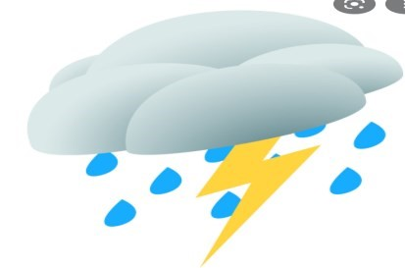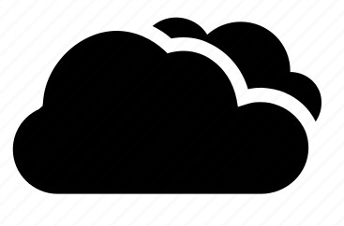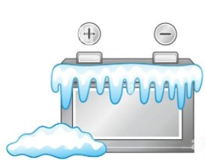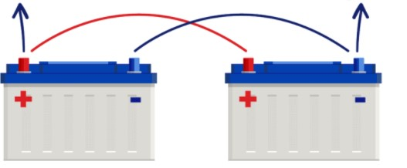

12

v

24

v



|  |  |
| --- | --- |
| Hybrid Inverter |  |
| Battery Size |  |
| Solar Panels |  |
| AC/DC Pump & Size |  |
| Date Installed |  |
| Installed By |  |
| Warranty End Date |  |
| Client Name & Signature | ________________________________ _________________________________  Name Signature |

***If you are experiencing issues with your solar system, please write the issue in the Solar WhatsApp group or contact these people Thembelani +263 77 648 0068***

***Phephi +263 77 248 1709 Singazi +263 78 105 3773***