**Erie County Right to Life**

[**eriecountyrighttolife@gmail.com**](mailto:eriecountyrighttolife@gmail.com)

**Find us at: eriecountyrighttolife.org**

***Fall/Election Issue 2024***

***If you would like to receive this newsletter by email, please contact us at:*** [***eriecountyrighttolife@gmail.com***](mailto:eriecountyrighttolife@gmail.com) ***or through our website.***

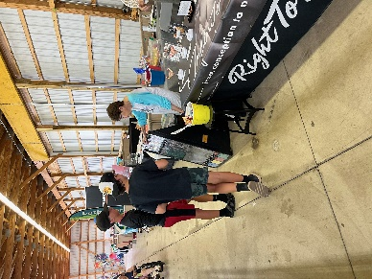

**\*ECRTL at the Erie County Fair\***

**While the heat and storms added a few challenges, the week was full of wonderful contacts, blessings shared and approx 440 Plinko Players!  Most every person that stepped up to play Plinko, allowed us the opportunity to share personally with them, the Infinite Worth of every precious baby and all life.**

***--Thanks to Kim Johnston and Bill Scheible for photos and info for this article***

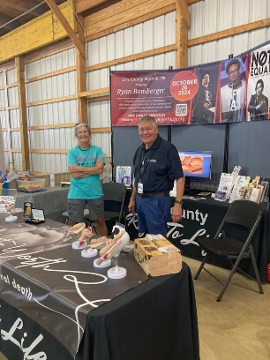

**There’s one more opportunity for YOU to share your Pro-Life witness in our community, on Sunday September 29 in Vermilion at The Wooly Bear Festival! Call/text Kim at 419-271-3086 to offer your help.**

***THANKS TO ALL OF YOU HAVE HELPED OUT THIS SUMMER!!!!!***

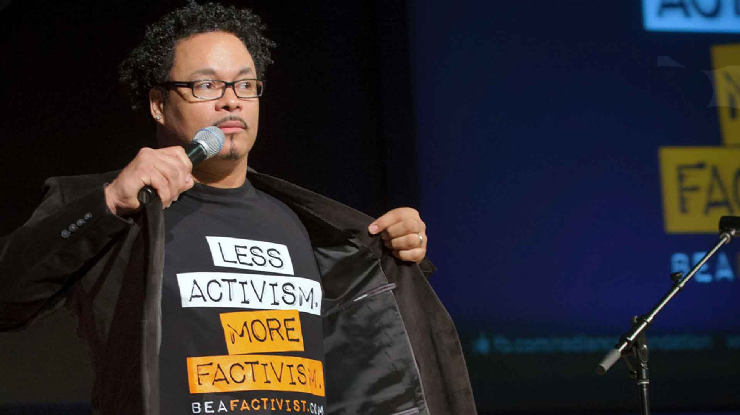

***Speaker Ryan Bomberger***

**\*\*SAVE the DATE\*\***

**\*SATURDAY OCTOBER 26\***

**RYAN BOMBERGER**

**will be the Main Speaker at the**

**ECRTL Prayer Brunch,**

**Saturday October 26,**

**10 a.m.,**

**@ Holy Angels Parish Hall,**

**428 Tiffin Ave., Sandusky.**

**Ryan Bomberger**, photo above, is an international speaker, columnist, educator, broadcast media designer, producer, writer and a *factivist* He REALLY likes to tell the TRUTH!!*.* Ryan is also the Emmy Award-winning Creative Professional who founded The Radiance Foundation, a life affirming 501c3.

And, Ryan has a lot to say about abortion. His birth mother was the victim of rape and chose to have her bi-racial Baby adopted. At 6 weeks of age, he was adopted by a multi-racial family that eventually numbered 15. Ryan and his wife Bethany have four children, two of whom are adopted.

***Come hear what this staunch supporter of the TRUTH has to say about the LIFE ISSUE***

***in our country today!***

**The Prayer Brunch is FREE** (donations will be accepted at the event), *but we do need to have RSVPs.*  Please register TODAY for the Prayer Brunch at the ECRTL website:

<https://eriecountyrighttolife.org/prayer-brunch>

Please check out The Radiance Foundation website: <https://radiancefoundation.org/> to learn more about Ryan’s work.

**Peter Range**

**with Center for Christian Virtue**

We wish Peter well at his new position as Senior Fellow for Strategic Initiatives at the Center for Christian Virtue! For mor info: **www.ccv.org/news/peter-range-joins-center-for-christian-virtue-as-senior-fellow-for-strategic-initiatives**

**\*Local Pregnancy Resource Centers\***

\*\*\***Abigail Pregnancy Services**, 3900 Laylin Rd., Norwalk. **Call 419-668-9500**

**Annual Fundraising Banquet**

**Emcee Peter Range,**

**Senior Fellow at Center for Christian Virtue**

*and featuring musician Mark Schultz*

**Thursday October 10**

**@ The Colonnade, 11001 Milan Rd., Milan**

doors open 6 p.m., dinner and program 6:30 p.m.

follow Abigail on Facebook: facebook.com/AbigailPregnancyServices

\*\*\***Heartbeat of Sandusky**, 3423 Columbus Ave.,. **Call 419-625-9511**

**Walk in the Mall in the Fall**

**Annual Fundraising Event**

**Saturday October 12, 10 a.m. to 1 p.m.**

**@Sandusky Mall**

**Community Agencies which provide services to area families will be there with their information.**

***Director Mattie Sparks says “If we have 10 teams each with 10 who each have 10 people sponsor them for $10, the Walk will raise $10,000 for Heartbeat of Sandusky!”***

**\*Knights of Columbus Pro-Life 5K Walk/Run\***

**Saturday October 19**

@ Sandusky Sailing Club, 814 E.Water St., Sandusky

*Route: along the scenic Sandusky Bay Pathway*

Check-In 8-9 a.m, Race Time 9-11 a.m.

***100% of the proceeds benefit both Heartbeat of Sandusky and Abigail Pregnancy Services.*** Register now at **kofcsandusky.org**

**Erie County Right to Life General Meetings**

**are held on the 2nd Monday of each month. NEXT MEETINGS are October 14, November 11, and December 9, 6:30 p.m., at Calvary Baptist Church, Family Life Center, 1810 E. Perkins Ave., Sandusky.**

**YOU are WELCOME! PLEASE COME!**

**And….More Upcoming Events…**

**\*\*The Fall 2024 40 Days for Life Prayer Campaign will be held Wed. Sept. 25 to Sun. Nov. 3. Locally, we will again pray and give witness to Life at the Sandusky CVS Pharmacy from 9 a.m. to 9 p.m. each day. To sign up for your time slot, please call ECRTL President Lisa Maczuga at 419-366-9006. In Toledo, we will be praying outside the Toledo Abortion Center, 1160 W. Sylvania Ave., Toledo. Go to: 40daysforlife.com/toledo to claim your hour.**

**Ohio March for Life--Friday October 4**

**11 a.m. Rally on Ohio Statehouse Grounds, Columbus**

**12 noon March in downtown Columbus**

**“Women” Removed from Bill on Pregnancy by Sen. Sherrod Brown**

Ohio Right to Life Executive Board Member Carrie Snyder recently called out Senator Sherrod Brown for quietly scrubbing “women” from a bill related to the Healthy Maternity and Obstetric Medicine Act. The bill deals with special health insurance enrollment times for pregnant women. Sen. Brown did not give any clarification of his decision.

For more info**:** [**ohiolife.org/ohio-right-to-life-executive-board-member-condemns-sherrod-browns-attack-on-biological-women/**](http://www.foxnews.com/politics/pregnant-persons-ohio-sen-sherrod-brown-scrubbed-women-from-bill-pregnancy%20and%20%20%20%20%20ohiolife.org/ohio-right-to-life-executive-board-member-condemns-sherrod-browns-attack-on-biological-women/) and [**www.foxnews.com/politics/pregnant-persons-ohio-sen-sherrod-brown-scrubbed-women-from-bill-pregnancy**](http://www.foxnews.com/politics/pregnant-persons-ohio-sen-sherrod-brown-scrubbed-women-from-bill-pregnancy)

**93% of OB-GYNs in U.S. Refuse to Kill Babies in Abortions**

The American Association of Pro-Life Obstetricians and Gynecologists (AAPLOG) is beginning a campaign to educate Americans about the fact that killing babies by abortion is obviously NOT health care. In fact, a 2017 report put out by the Guttemacher Institute, a pro-abortion group, showed that very few OB-GYNs even perform abortions. AAPLOG reports that most OB-GYNs instead work to provide life-saving treatments for women AND for their babies. For more info: [**www.lifenews.com/2022/09/02/93-of-ob-gyns-in-america-refuse-to-kill-babies-in-abortions/**](http://www.lifenews.com/2022/09/02/93-of-ob-gyns-in-america-refuse-to-kill-babies-in-abortions/)

**Judge Blocks 24-Hour Wait for Abortion**

Franklin County Common Pleas Court Judge David Young blocked Ohio from enforcing the current law requiring a 24-hour waiting period for a mother to have an abortion after her initial visit to the abortion center, saying law goes against the new abortion amendment in the Ohio Constitution. For more info: <https://www.ccv.org/news/breaking-judge-rules-against-24-hour-waiting-period-to-get-abortion>

**\*\*National Election Day\*\***

**Tuesday November 5, 2024**

Here in Ohio early in-person voting dates are Oct. 8-Nov. 3. Absentee by mail dates are Oct. 8-Nov. 6. For more info go to: voteohio.gov

So far, Ohio Right to Life has endorsed Justice Joe Deters, Judge Megan Shanahan, and Judge Dan Hawkins for the Ohio Supreme Court. Right to Life Action Coalition of Ohio will announce their endorsements on Oct. 4, check out rtlaohio.org .

**\*REMEMBER TO VOTE!\***