**Erie County Right to Life**

[**eriecountyrighttolife@gmail.com**](mailto:eriecountyrighttolife@gmail.com)

**Find us at: eriecountyrighttolife.org**

**Dec. 2024-Jan. 2025 Edition**

***If you would like to receive this newsletter by email, please contact us at:*** [***eriecountyrighttolife@gmail.com***](mailto:eriecountyrighttolife@gmail.com) ***or through our website.***

**2024 ECRTL Annual Prayer Brunch**

**\*A BIG Success\***

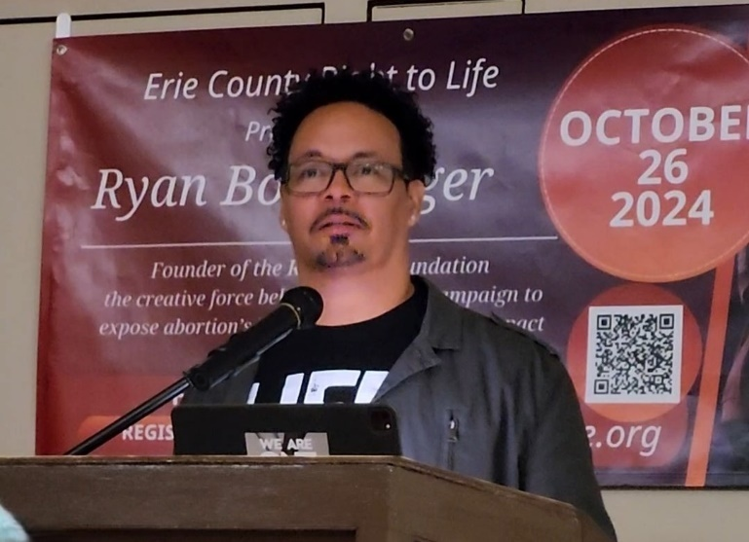

**Ryan Bomberger**

***--photo submitted by Patty Kessler***

Right to Life supporters from Erie County as well as Huron and Ottawa Counties, and beyond, welcomed Special Guest Speaker Ryan Bomberger to Sandusky on Saturday October 26 at the 2024 ECRTL Annual Prayer Brunch. Ryan shared his personal story: His birth Mother was the victim of rape, yet she chose adoption for her six-month-old son instead of abortion for her unborn Baby. Ryan eventually had 12 siblings in his adopted family—10 adopted children and 3 “homemade”., as his parents said. He and his wife Bethany have four children, two of which are adopted. Ryan and his wife are the founders of the Radiance Foundation (radiancefoundation.org); their vision is to create a culture that believes that every human life has purpose. Ryan is a very gifted graphic artist, author, international speaker, broadcast media designer—and more.

Some notes from Ryan’s talk: Ryan believes there is an ongoing “war on common sense” in our society today. Ryan believes that Adoption unleashes progress, adversity makes us better human beings, and “unplanned” happens all the times in all our lives in many different circumstances and often makes us STRONGER. Self-sacrifice brings purpose. ZERO deaths have been occurred because of abortion bans!

Ryan encouraged Erie County Right to Life supporters to work hard for LIFE, and to let the Love of God shine through us!

**ECRTL officers and supporters, with guest speakers Ryan Bomberger, Mattie Sparks (Director of Heartbeat of Sandusky), and D.J. Swearingen (Ohio House Representative for District 89) --*submitted by Pat Frey***

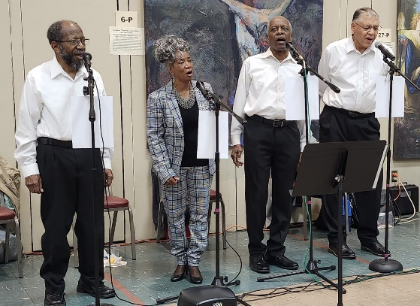 **The JMarkz, a local Sandusky music quartet, provided great entertainment during the meal we shared. *–submitted by Patty Kessler***

***r***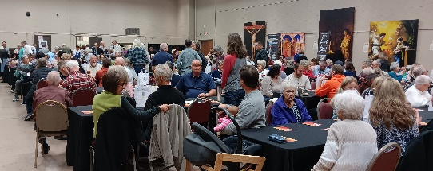 **A large crowd at the ECRTL Prayer Brunch 2024—*submitted by Pat Frey***

**RyRyan**[**https://youtu.beJpm3BCgpU**](https://youtu.beJpm3BCgpU) **Ry**

**\*ELECTION 2024\***

By electing Republicans **Donald Trump and J.D.Vance as President and Vice-President**, the American voters have decided against the “no-limits” policy that Democratic candidates Kamala Harris and Tim Walz had based their campaign. Democrats spent over a half billion dollars on ads attacking pro-life Republicans in the general election, claiming that limits on abortion kill women. But obviously the majority of American voters did not believe that lie. More info at: ***sbaprolife.org/newsroom/press-releases/americans-reject-harris-democrats-no-limits-abortion-agenda-relect-trump***

In the November 5 election**, Florida, Nebraska, and South Dakota voters rejected pro-abortion measures,** while voters in seven states expanded abortion rights. More info at: [***www.catholicnewsagency.com/news/260301/three-states-reject-pro-abortion-ballot-measures-while-seven-measures-pass?__hstc=198926896.a21db4e479447cdba6ba7d7a1b6efffd.1727457326104.1729008764934.1731455735562.4&__hssc=198926896.4.1731455735562&__hsfp=3644960128***](http://www.catholicnewsagency.com/news/260301/three-states-reject-pro-abortion-ballot-measures-while-seven-measures-pass?__hstc=198926896.a21db4e479447cdba6ba7d7a1b6efffd.1727457326104.1729008764934.1731455735562.4&__hssc=198926896.4.1731455735562&__hsfp=3644960128)

In Ohio, all three Republican candidates for Ohio Supreme Court seats won—Megan Shanahan, Joseph Deters and Dan Hawkins. Republicans will now have a 6 to 1 majority in the Ohio Supreme Court. This Republican majority is significant because of several abortion-related issues likely to come before the Ohio Supreme Court. These include an injunction currently in place that temporarily paused Ohio’s 24-hour waiting period following a woman’s first visit to the abortion center, and the current Ohio law that requires women to be told the gestational age of her unborn baby and information about the abortion procedure itself. More info at:: ***ohiocapitaljournal.com/2024/08/26/ohios-24-hour-waiting-period-abortion-law-paused-by-judge/#:~:text=Franklin%20County%20Court%20of%20Common,to%20provide%20before%20an%20abortion.***



**\*Ohio’s Heartbeat Law Ruled Unconstitutional\***

Hamilton County Judge Christian A. Jenkins permanently overturned the six-week abortion ban known as Ohio’s Heartbeat Law on October 24, ruling that the Law was effectively outlawed when Ohio voters approved the constitutional amendment in November 2023 that allows for pre-viability abortion. Ohio Attorney General Yost has 30 days to appeal the ruling.

**\*How “Popular” is the Abortion Pill?\***

**In 2023, 63% of all abortions in the U.S. were chemical abortions.** Here are the numbers: **642,700** chemical (abortion pill) abortions were recorded by Guttmacher Institute, the news arm of Planned Parenthood, which works out to be **53,558** a month, **1,761** daily, **73** hourly, and one abortion pill abortion **every 49 seconds.** The total number of surgical abortions and chemical abortions in 2023 is **1, 037,000.** More info at: [*https://www.liveaction.org/news/abortion-data-2800-daily/*](https://www.liveaction.org/news/abortion-data-2800-daily/)

**\*National March for Life 2025\***

**\*\*The National March for Life will be in Washington, D.C. on Friday January 24, 2025. More info at:** [***https://marchforlife.org/***](https://marchforlife.org/) **Young Adults 18-35 can register for the Toledo Respect Life Pilgrimage to the Natl March for Life, Jan. 23-25. The $225 fee covers 2 nights’ lodging and bus ride. More info at: *toledodiocese.org/marchforlife#:~:text=In%202025%2C%20the%20Diocese%20of,to%20use%20free%20of%20charge.***

**\*Local Pregnancy Resource Centers\***

\*\*\***Abigail Pregnancy Services**, 3900 Laylin Rd., Norwalk. **Call 419-668-9500**

Follow Abigail on Facebook: facebook.com/AbigailPregnancyServices

\*\*\***Heartbeat of Sandusky**, 3423 Columbus Ave.,. **Call 419-625-9511**

**Erie County Right to Life General Meetings**

**are held on the 2nd Monday of each month at 6:30 p.m. NEXT MEETINGS are December 9, January 13, and February 10 at Calvary Baptist Church, Family Life Center, 1810 E. Perkins Ave., Sandusky.**

**YOU are WELCOME! PLEASE COME!**

Check out: Ryan Bomberger’s Christmas message:

**www.youtube.com/watch?v=BpJpm3BCgpU**