**Erie County Right to Life**

[**eriecountyrighttolife@gmail.com**](mailto:eriecountyrighttolife@gmail.com)

**Find us at: eriecountyrighttolife.org**

**February 2025 Edition**

***If you would like to receive this newsletter by email, please contact us at:*** [***eriecountyrighttolife@gmail.com***](mailto:eriecountyrighttolife@gmail.com) ***or through our website.***

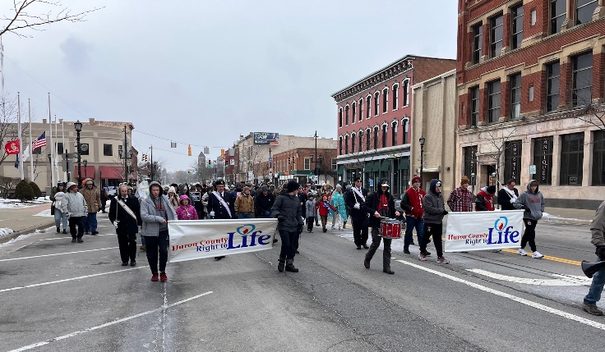**--*photos submitted by Kim Johnston***

**\*North Coast Annual March for Life 2025**

An estimated crowd of 125 people braved very cold weather to show their support of LIFE on Main Street in Norwalk on Sunday January 19. Supporters from both Erie and Huron Counties marched in silence from the St. Paul Convocation Center to the Huron County Courthouse, giving their witness to the sacredness of Life. Just prior to the March, several speakers at the St. Paul Convocation Center, offered prayer and led the singing of the *Battle Hymn of the Republic*. Liz Johnston, of Abigail Pregnancy Services in Norwalk, spoke about the importance of us all “pursuing Mothers considering abortion” with our support and prayers, because they are being chased by the Evil One. She reported that in 2023, there were 41 reported abortions in Huron County, a number that does not reflect the abortions caused by the abortion pills, that now account for 2/3 of the abortions in our country. Thank you to all who braved the weather to join the 2025 North Coast March for Life!

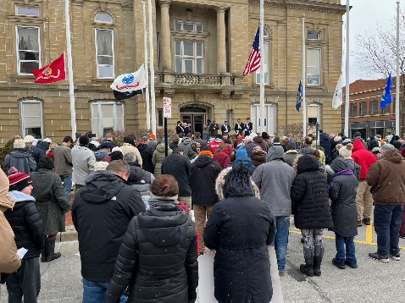

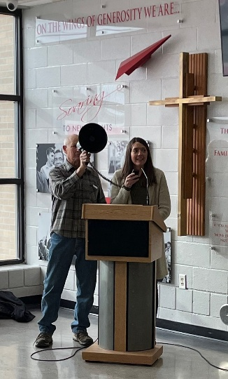

**\*National March for Life 2025\***

On Friday January 24, newly-inaugurated Vice President J.D. Vance spoke at the Rally on the Mall in Washington, D.C., preceding the Natl March for Life. He encouraged all Pro-Lifers saying, **“**“*Go forth not with frustration but with joy. We are joyful to march for life. We are joyful to know that that picture on an ultrasound, that is a picture of a baby with hopes and dreams and potential to come. It is a joy and blessing to fight for the unborn, to work for the unborn, and to march for life.”* **To view the speech:** [***www.youtube.com/watch?v=gGGJkvGIfaA***](http://www.youtube.com/watch?v=gGGJkvGIfaA)The evening before the March, at the Vigil for Life Mass in Washington, D.C., Archbishop Naumann, referring to several states that have passed pro-abortion laws, said, *“These defeats have been sober reminders that we need to re-intensify our efforts” to build a culture of life. If we’re gonna follow (Jesus), we have to follow him all the way to Calvary. We have to be prepared to take up the cross to transform our culture.”* Archbishop Naumann, of Kansas City, took the place of Toledo Bishop Daniel Thomas who could not attend the Vigil for Life Mass due to a death in his family. **For more info, go to:** ***catholicvirginian.org/news/at-national-prayer-vigil-for-life-young-people-challenged-to-be-a-light-in-our-culture/***

**\*Abortion Pill Parties??\***

In our Dec. 2024-Jan. 2025 Newsletter, we reported the statistics on the use of the abortion pill—that 63% of all abortions in 2023 were chemical abortions, caused by the abortion pill.

More info at**:** [***https://www.liveaction.org/news/abortion-data-2800-daily/***](https://www.liveaction.org/news/abortion-data-2800-daily/)

To listen to a story about the new phenomenon of Abortion Pill Parties, where volunteers pack abortion pills to send to women in states that highly restrict abortion, go to**:** [***www.wsj.com/us-news/abortion-pill-parties-shipping-148e3c15***](http://www.wsj.com/us-news/abortion-pill-parties-shipping-148e3c15)

**\*Challenge to the Abortion Pill\***

A federal judge has allowed Idaho, Kansas, and Missouri to join Texas in pursuing legal action to prohibit the FDA from allowing online prescriptions for the abortion pill. These states want the FDA to prohibit telehealth prescriptions for mifepristone and require three in-person doctor visits to get a prescription for the abortion pill. For more info: [***www.catholicnewsagency.com/news/261633/texas-judge-rules-states-can-revive-challenge-abortion-pill***](http://www.catholicnewsagency.com/news/261633/texas-judge-rules-states-can-revive-challenge-abortion-pill)

**\*First Abortion Dr. Criminally Charged Since Roe v Wade was Abolished\***

**Go to:** [***www.washingtonpost.com/politics/2025/01/31/abortion-doctor-indictment-criminal-louisiana-new-york/?utm_source=alert&utm_medium=email&utm_campaign=wp_news_alert_revere&location=alert***](http://www.washingtonpost.com/politics/2025/01/31/abortion-doctor-indictment-criminal-louisiana-new-york/?utm_source=alert&utm_medium=email&utm_campaign=wp_news_alert_revere&location=alert)

**\*TX ObGyn Sets the Record Straight on Pro-Life Laws at RFK Jr. Hearing\***

**Go to*:*** [***www.ncregister.com/commentaries/skop-misinformation-abortion-emtala-rfk-hearing***](http://www.ncregister.com/commentaries/skop-misinformation-abortion-emtala-rfk-hearing)

**\*Pentagon No Longer Will Pay for Travel for Abortions or Fertility Treatment\***

**Go to*: apnews.com/article/military-travel-abortion-reproductive-care-a18ce5dc08b654bfbcc147a4965ec470***

**\*U.S. Will No Longer Fund Int’l Abortions\***

**Go to: *www.foxnews.com/politics/trump-reinstates-mexico-city-policy-separates-taxpayer-dollars-abortions***

**\*Hyde Amendment Back in Effect\***

**Go to*:*** [***www.lifenews.com/2025/01/25/trump-enforces-hyde-amendment-to-stop-taxpayer-funded-abortions/***](http://www.lifenews.com/2025/01/25/trump-enforces-hyde-amendment-to-stop-taxpayer-funded-abortions/)

**\*Erie County Right to Life General Meetings\***

**are held on the 2nd Monday of each month at 6:30 p.m. NEXT MEETINGS are March 10, April 14, and May 12 at Calvary Baptist Church, Family Life Center, 1810 E. Perkins Ave., Sandusky.**

**YOU are WELCOME! PLEASE COME!**

**\*Local Pregnancy Resource Centers\***

\*\*\***Abigail Pregnancy Services**, 3900 Laylin Rd., Norwalk. **Call 419-668-9500**

Follow Abigail on Facebook: facebook.com/AbigailPregnancyServices

**Abigail is looking for a volunteer receptionist at our Willard location on Tuesday afternoons. If you are interested, please call the above #.**

\*\*\***Heartbeat of Sandusky**, 3423 Columbus Ave.,. **Call 419-625-9511**

**\*Upcoming Events\***

**\*49 Days for Life\***

**Erie County Right to Life will be supporting the**

**Toledo 40 Days for Life by claiming a particular day to cover all the hours of the vigil of prayer at the only remaining abortion facility in northwest Ohio, Toledo Women’s Center, 1160 W. Sylvania Ave, Toledo. More details to come…**

**March 5 through April 17 are the dates for the national Spring 2025 40 Days for Life prayer campaign. Please consider offering prayers during these days for Mothers considering abortion.**

**\*Bringing America Back to Life\***

**Cleveland Right to Life is again sponsoring the very popular Bringing America Back to Life Convention to Ohio on March 7 and 8, at the Embassy Suites in Independence, Ohio. Speakers include Abby Johnson and Riley Gaines. This is a not-to-be-missed event for Pro-Life supporters! For more info, contact ECRTL President Lisa Mazuga at 419-366-9006, and go to: bringingamericabacktolife.org**

**\*Prayer Opportunity March 25\***

**At Christmas we celebrated Mary who was**

**“with child”, (Matt. 1:18) giving birth to our Lord**

**and Savior, Jesus Christ. We look forward to**

**the Feast on March 25, that celebrates Mary becoming “with child” (Matt. 1:18), the Feast the Annunciation of**

**the Incarnation, nine months before Christmas.**

***Please come! ALL are welcome!***

***Tuesday. March 25,***

***at St. Mary Catholic Church, 429 Central Ave. Sandusky--6pm Joyful Mysteries of Rosary in the Commons,***

***6:30pm Mass,***

***7:15pm Reception (pizza & beverages), sponsored by Sandusky Knights of Columbus #546.***

**\***[**Prolife Movie Night**](https://foundationforlife-bloom.kindful.com/e/prolife-movie-night)**\***

**Apr 24, 2025, 6:00 PM – 9:00 PM**

**@Maumee Indoor Theater, 601 Conant St, Maumee, OH 43537. Join Foundation for Life for our free annual movie night! Our featured film is The 1916 Project. We will also present awards to the winners of our prolife student contest. We look forward to seeing you!!**