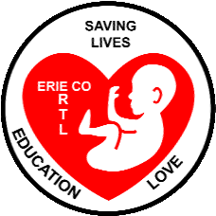 Erie County Right to Life News
eriecountyrighttolife@gmail.com.
February-March 2021
TAKE THIS OPPORTUNITY TO SUPPORT LIFE
November 2020’s Presidential Election underlined our need to boost our support for Life! More Americans than ever before voted, but it appears roughly half of them voted for a platform and candidates that will significantly boost abortion!

We in Erie County, the hub of Ohio's North Coast, have a tremendous opportunity to be a force for Life simply because (pre-COVID and hopefully again soon), we have millions of visitors taking advantage of our tourist attractions every summer.

The ECRTL Board has identified Five Opportunities to undertake in the coming year to boost our support for Life in our community:
1. Communications
2. Summer Festivals and Fairs
3. The ECRTL Annual Fall Prayer Breakfast
4. Legislative Outreach
5. Work Team

While we're waiting for the COVID Pandemic to subside, we invite YOU to prayerfully discern if you are being called to play a greater role in supporting Life in our community with Erie County Right to Life. To learn more about these Five Opportunities, or to discuss your ideas about supporting Life in our community, please send us an email at: eriecountyrighttolife@gmail.com
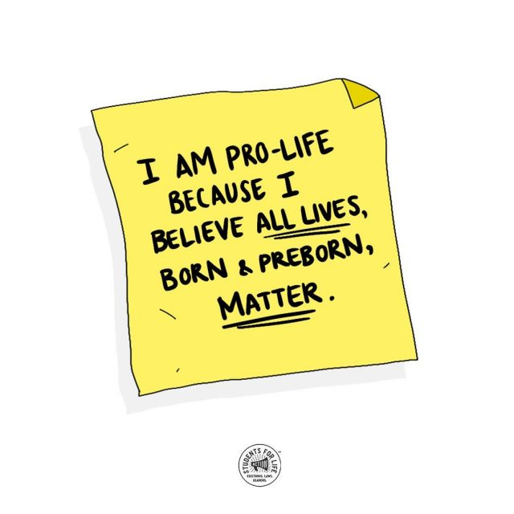
March for Life 2021
About fifty cars carrying Pro-Life signs and messages on their doors and back windows were part of the Huron County Right to Life Car Caravan on Sunday January 17 in Norwalk. The large group that included Erie County Pro-Life Supporters joined in the Opening Rally at Whitney Field before separating into two groups to drive through both the northern and southern areas of Norwalk. The event closed with a Benediction back at Whitney Field.
A Prayer Service in Memory of Unborn Babies Lost to Abortion was held at Huron St. Peter Catholic Church. About 30 people joined with Pastor Jeff McBeth near the parish’s Memorial to the Unborn in the Holy Family Garden for Scripture reading, prayer, and song on Sunday January 17.
At Calvary Baptist Church in Sandusky Church on Sunday January 24, Pastor David Hixson delivered a powerful homily on Sanctity of Human Life Sunday. (http://www.calvarysandusky.org/sermons/when-jesus-says-come-to-me/ move ahead to the 19 minute mark to hear the homily at this link)
At the Annual Vigil for Life Mass at the National Basilica of the Immaculate Conception in Washington, D.C., Archbishop Joseph Naumann, of Kansas City, gave a powerful homily on the need to strengthen our national protection of Life. (https://www.youtube.com/watch?v=BXciMljWVHs move ahead to the 55 minute mark to hear the homily at this link)
Because of Covid-19, the National March for Life in Washington, D.C., was held virtually for the most part on January 29. Many from around the country “joined in” the March through live-streaming and on TV. Only a small number of Pro-Life supporters were invited to march down Constitution Ave to the Supreme Court. (to see a slideshow of images: https://aleteia.org/slideshow/slideshow-exclusive-photos-the-48th-annual-march-for-life-in-washington/ )
Political Action Alert
--by Mary Ann Chimera
NOW is a great time to contact Congresswoman Marcy Kaptur to urge her to keep the Hyde Amendment. You can reach her by phone or letter or going to her website to state your case. Suggest to your pro-life friends and neighbors that they also contact her. To show how important this issue is to you, contact her again next month and the month after that until the vote is taken.

Please remember that persuasion is more effective than attack! Give her as many positive reasons as you can to continue to protect the preborn through the shelter of this Amendment.

Marcy has just announced that she plans to run again in 2022. As her constituent, it is important to let her know what you think on this important amendment. Even if you don't live in her district, this year will see redistricting based on Census results. You can count on those district lines changing!

The move to overturn the Hyde Amendment is racist at its heart. It is designed to fulfil Margaret Sanger's aim of eliminating "human weeds" and people of "inferior stock," i.e., people of color who already make up 60% of abortions in America. Blacks, 13% of our population, get 35% of abortions, while Hispanics, 16%, get 25%. The removal of the Amendment targets single moms, especially women of color.

When she voted for Obamacare and many times since, Marcy stated that she is opposed to taxpayer support of abortion. Hold her to her promise!

(If you are in the 9th Congressional House District, you may email Rep. Kaptur by going to https://kaptur.house.gov/contact/email or call her Lorain Co. office at 440-288-1500.)

More info: The Hyde Amendment prohibits federal Medicaid dollars from paying for abortion. It was originally enacted in September 1976, and was written by Rep. Henry Hyde, of Illinois. It has been passed each year since with bipartisan support. –compiled from https://www.humanlifeaction.org/issues/hyde-amendment/ and https://marchforlife.org/live-saving-hyde-amendment/

Let’s Hear It for Gov. Noem!
South Dakota Governor Kristi Noem has introduced a bill that will ban abortions based on a Down syndrome diagnosis. –for more info https://www.siouxlandproud.com/news/south-dakota-news/south-dakota-gov-noem-introduces-bill-to-ban-down-syndrome-abortions/
What Millennials and Gen Xers Really Think
Asked directly about reversing Roe to return the issue of abortion to the states, more Millennials and Gen Z supported reversing Roe and sending abortion policy to the voters than opposed it, by a margin of 44 % in favor to 36 % opposed and 18 % unsure. –from a Students for Life Jan. 2021 poll https://studentsforlife.org/2021/01/26/new-poll-millennials-and-gen-z-more-pro-life-than-pop-culture-would-have-you-believe/
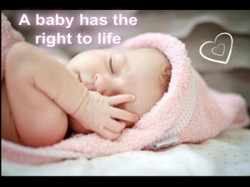 ***UPCOMING LIFE EVENTS***
**ECRTL monthly meetings are currently suspended because of the Covid-19 Pandemic, but are usually held at Calvary Baptist Church – Family Life Center (rear building) located at 1810 E. Perkins Ave. --on the 1st Monday of the month at 7 p.m. Notification of the resumption of meetings will be made through this newsletter and on our Facebook page.

**EWTN-TV airs EWTN Pro-Life Weekly each Thursday at 10 p.m., with encore presentations on Sunday at 10 a.m. and Tuesday at 1:30 p.m. “Every week, Catherine Hadro and a team of pro-life experts shine the light of truth on abortion, euthanasia, assisted suicide, and the culture of death.

***To receive this newsletter
via email, send a note to eriecountyrighttolife@gmail.com

