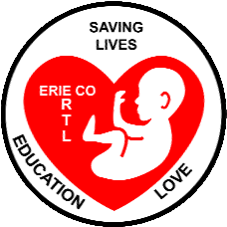 Erie County Right to Life News
eriecountyrighttolife@gmail.com.
September-October 2021

**2021 ECRTL Respect Life Prayer Brunch**
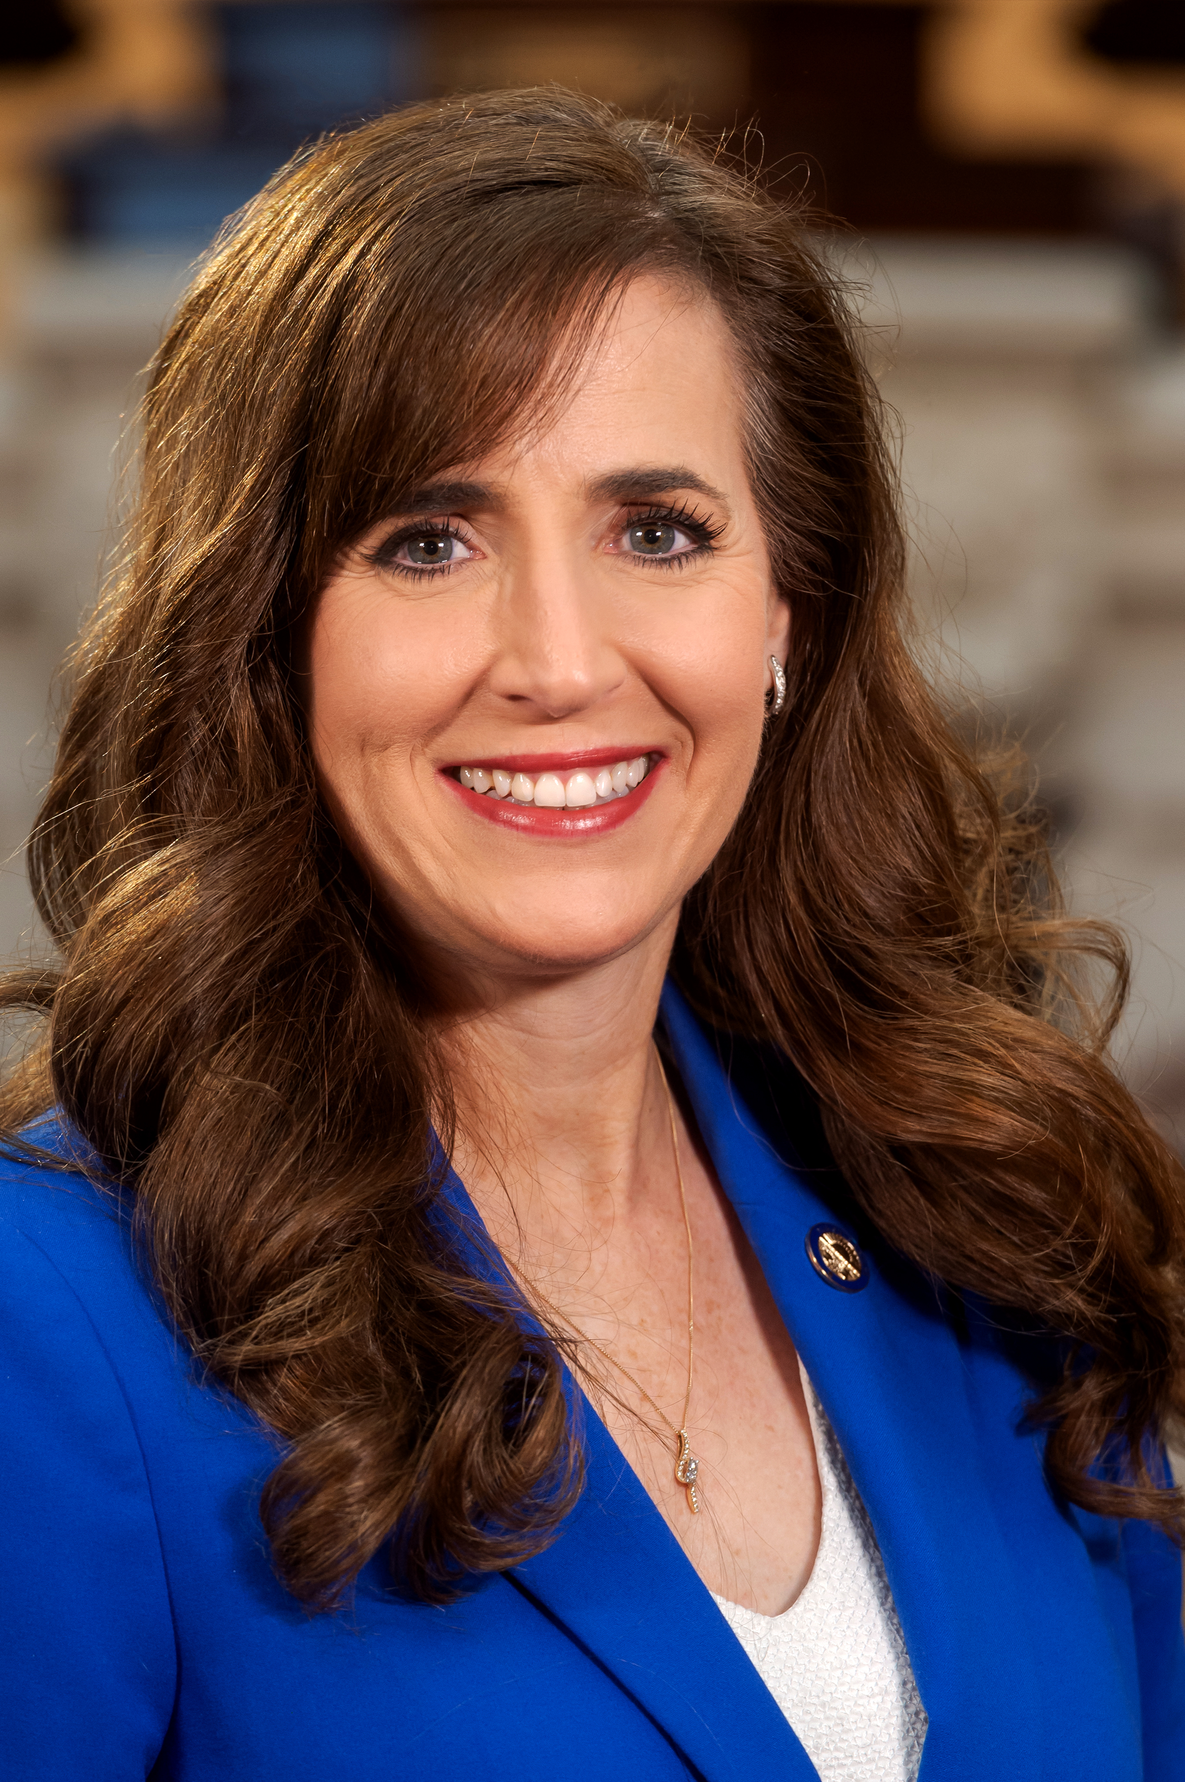
Ohio State Senator Theresa Gavarone will be the featured speaker at the 2021 ECRTL Respect Life Prayer Brunch.
Saturday October 2 is the date, and 10 a.m. to noon is the time, for the 2021 ECRTL Respect Life Prayer Brunch!
This year’s Prayer Brunch will be held at The Chapel, 4444 Galloway Rd., in Sandusky.
Ohio State Senator Theresa Gavarone, and Ohio Right to Life President Mike Gonadakis will be featured speakers at the event. Pastor Mark Geissbauer, of The Chapel, will offer the opening prayer, and Father Jeff Mc Beth, Pastor of St. Peter Catholic Church in Huron, will conclude the event with a prayer. Come and be inspired to help win hearts and minds for preserving precious Lives.
Everyone is welcome at our annual celebration of life. Spread the word! BRING THE FAMILY, especially tweens, high schoolers and young adults, the FUTURE of the Right to Life movement!
Good News!! In May, the U.S. Supreme Court agreed to hear Mississippi’s appeal of a 2019 appeals court decision striking down a state law prohibiting abortions after the 15th week of pregnancy. The case, Dobbs v. Jackson Women’s Health Organization, is to be argued after the court’s new term begins in October, with a decision expected by next summer. Mississippi is asking the Court to abolish federal abortion rights, stating that states’ 10th-Amendment powers to decide public policy within their borders has been ignored by the Roe v Wade decision back in 1973, and subsequent federal Court decisions since then. For more info: https://www.catholicnewsagency.com/news/247681/supreme-court-will-consider-mississippis-15-week-abortion-ban For information about a prayer vigil at the U.S. Supreme Court, Oct. 2-3, the weekend before the Court begins its fall deliberations: https://purplesashrevolution.com/pray-to-end-abortion/
Did You Know…. Many European countries restrict abortion even earlier than 15 weeks, which is the gestational age after which the Mississippi law (discussed above) would prohibit abortions. For more info: https://www.dailywire.com/news/mississippis-15-week-limit-on-abortion-is-mainstream-in-european-law-study
THANK YOU!!…..and CAN YOU continue to HELP? THANK YOU to all of you who volunteered to help out at the ECRTL Booth, at the Sandusky Hometown Celebration, at the Cold Creek Festival, and at the Erie County Fair! THANK YOU for reaching out to our community with the message that LIFE is precious and a RIGHT for all, from conception to natural death.We are continuing to work on the Five Opportunities identified by the ECRTL Board earlier this year, to boost our support for Life in our community:1. Communications 2. Summer Festivals and Fairs 3. The ECRTL Respect Life Prayer Breakfast 4. Legislative Outreach 5. Work Team. THANK YOU to the ECRTL supporters who have already chosen the Opportunity Group they will work on! If you have not chosen one yet, we invite you to prayerfully discern if you are being called to play a greater role in supporting Life in our community with Erie County Right to Life. To learn more about these Five Opportunities, or to discuss your ideas about supporting Life in our community, please send us an email at: eriecountyrighttolife@gmail.com
Upcoming Events
Erie County Right to Life is back on track with our monthly meetings!!! Please mark your calendar for ECRTL meetings on the 2nd Monday of each month, 6:30 p.m., at Calvary Baptist Church (back building), 1810 E. Perkins Ave., Sandusky, as we go forward. Meeting dates for the remainder of this year: Mon. Sept. 13, Mon. Oct. 11, Mon. Nov. 8, and Mon. Dec. 13.

Heartbeat of Sandusky will hold their Family Walk at the Mall in the Fall on Saturday October 9 from 11 a.m. to 1 p.m.. Individual walkers and teams are invited to have sponsors. Come to the Walk at the Mall on Oct. 9, and help out Heartbeat!!! Heartbeat of Sandusky has had a big increase in requests for help during the last few months. Also, Heartbeat is continuing to collect toiletries for families in need, to continue Rylee’s (age 10) and Jurnee’s (age 6) project in memory of their Grandmother, Mary Cornwell. Toiletries requested are: paper, deodorants, feminine hygiene items, laundry detergent, toothpaste, toothbrushes, and dish detergent. For more info about either of these projects, please call Heartbeat of Sandusky (419) 625-9511.

Abigail Pregnancy Services is holding their Annual Fundraising Banquet on September 30 at The Colonnade, 11001 Milan Rd, Milan, OH, beginning at 6 p.m. Guest Speaker is Kailee Perrin, a Mother who chose LIFE for her beautiful baby. Tickets are $35 per person, $65 per couple. For more info, contact Bill Scheible, Abigail Board Member, at:
billscheible@reagan.com

40 Days for Life Fall Campaign in Toledo: September 22– October 31
40 Days for Life begins at Wednesday September 22, with a Prayer Vigil in Toledo at the Capital Care Abortion Clinic, 1160 W. Sylvania Ave, at 7 p.m. All are welcome. All are invited to pray during this nationwide 40-Day Campaign for Mothers who are considering abortion, that they will receive the care they need to bring their babies to birth and the help they need to provide for their babies after birth. If you would like to pray on the public sidewalk outside the abortion clinic with other Pro-Life advocates, please go to this website to register for a particular time: www.40daysforlife.com/toledo This website also has more info about the Campaign and other planned local events.
*WE HAVE A NEW WEBSITE ADDRESS*
eriecountyrighttolife.org
Check it out for photos from the Fair!!!!!

*Stand Up For Life*

The Annual ECRTL Appeal is on! Again this fall we will be making an Appeal to those of you in our Community who want to STAND UP FOR LIFE by having your name appear in an ad in the Sandusky Register near the January 22, 2022, anniversary date of the U.S. Supreme Court Roe v Wade decision that legalized abortion in our country. The ad will commemorate the over 65 million Babies who have been aborted in the U.S. since that decision. Your name in the ad will let our community know that YOU STAND UP FOR LIFE!

2022 RIGHT TO LIFE AD INFORMATION / DONATION FORM
A donation is not required for you to be included in the ad.

Name(s)__________________________________
(to appear on the ad)
Donation $5 ___ $10 ___ Other $______

Address___________________________________

City ____________________, OH ZIP__________

Phone ___________________________________

E-mail ___________________________________

Signature: _________________________________

Church attending: __________________________

I would like to help save lives by (check as many as you can): PLEASE RETURN BY 12/23/21

___ Prayer ___ Periodic Financial Support ___ Home activities (letter writing or phone calls)
___ helping hand (stuffing newsletters, etc) ___ activism (educating, attending events, etc)

Please make check payable to “Erie County Right to Life” and mail along with this coupon to Erie County Right to Life, P.O. Box 1385, Sandusky, OH 44871-1385. Donations are NOT tax deductible.

