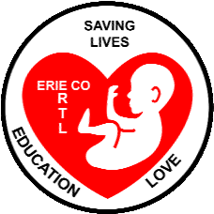 Erie County Right to Life
eriecountyrighttolife@gmail.com.
February-March 2022
If you would like to receive this newsletter by email, please contact us at: eriecountyrighttolife@gmail.com

** NEW ECRTL OFFICERS**
Elections were held at the January 2022 ECRTL meeting, and we are happy to announce that our new ECRTL Officers are:
Raine Faulkner—President
Jan Hime—Vice-President
Dan Weisler—Treasurer
Kim Johnson—Secretary
CONGRATULATIONS to our New Officers!!
**AND, a BIG THANK YOU to our outgoing officers:
KEN SWANK—President
KEVIN MICHEL—Vice-President
SHELLE MILLER—Treasurer
DEBBIE SWANK—Secretary
These folks have served ECRTL as officers for many many years. Shelle has been Treasurer since the beginning of ECRTL in 1988! Shelle and her husband Steve Miller have both given many hours and years to ECRTL. Our entire Erie County community is better because of the untold volunteer hours of all these wonderful people!
**THANK YOU!!**

*2022 March for Life*
While neither the March for Life organization nor the D.C. Police ever give estimates of the crowds attending the annual event, the Students for Life for America did study video of this year’s March for Life held on January 21 in Washington, D.C. Their estimate?
150,000 people marched down Constitution Avenue, for LIFE! For the details of how the estimate was made: https://www.catholicnewsagency.com/news/250217/march-for-life-crowd-estimate

Those of us who were there agree that at least that many people, young and old -----and in between—marched for LIFE January 21 in D.C.! Speakers at the Rally on the Mall before the March stepped off included Fr. Mike
Schmitz, Catholic priest and well-known“Bible in a Year” podcaster, who in speaking about the Marchers, said that abortion has “broken our hearts”. Katie Shaw, a 36-year-old woman with Down Syndrome from Indiana, quoted Psalm 139 in her speech, reminding us all that we are all “wonderfully made”. Let’s all hope and pray that this March for Life on the 49th anniversary of Roe v Wade, will be the last March marking years of legalized abortion across our country.
Next year might be the First March for Life in a post-Roe v Wade U.S.A.!

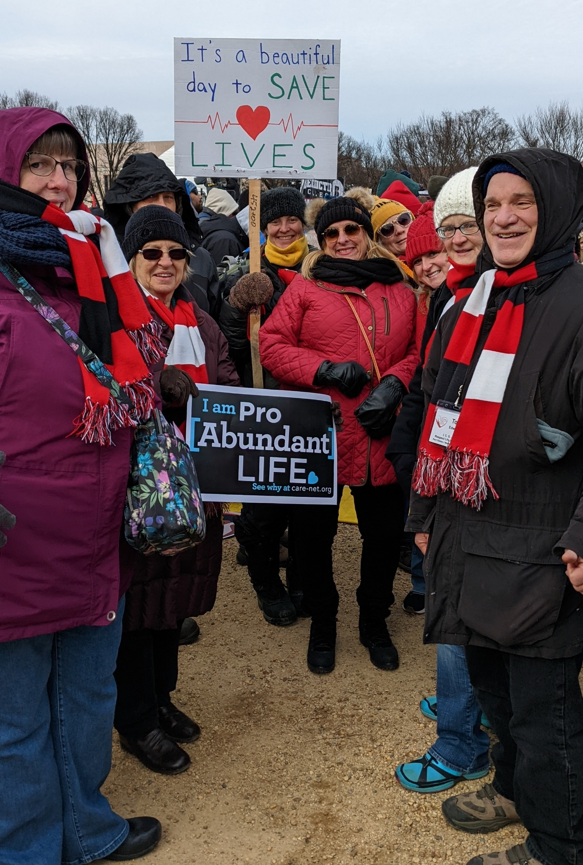
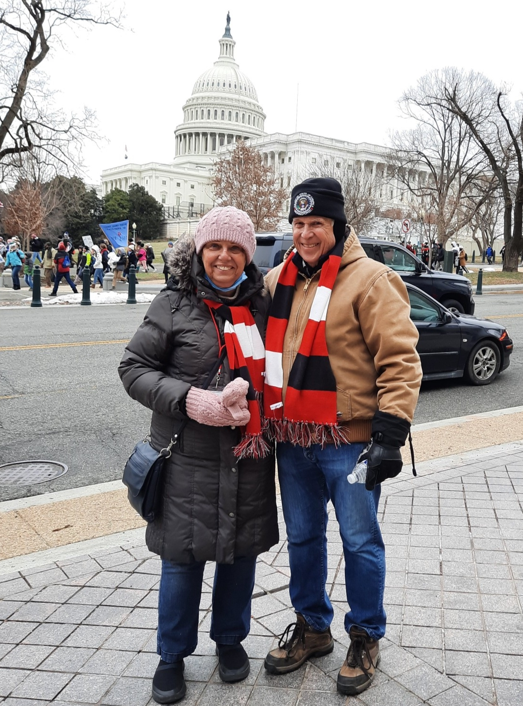
For more info: https://www.catholicnewsagency.com/news/250182/father-mike-tells-marcher-every-person-matters and
https://www.catholicworldreport.com/2022/01/21/march-for-life-underway-with-hopes-rising-that-roes-days-are-numbered/ and for Katie Shaw’s speech https://www.youtube.com/watch?v=Gp78qqzdNTM

**NEWS from our
Local Pregnancy Resource Centers**
In 2021, Abigail Pregnancy Services (APS) had 724 Client Visits, 177 parenting classes completed, 1730 Volunteer Hours donated (savings of @$23,000), 5500 Diapers distributed, 7,586 Items distributed from our boutique, updated branding and marketing platforms. Thank you for your part in our success--donors, volunteers and evangelists spreading the word or inviting us to your church or event!
The project to launch a mobile pregnancy Center by Abigail Pregnancy Center is ongoing but seeking alternatives (including used medical RV vehicles) due to the lack of availability of new vehicles and the almost 50% increase in acquisition cost from Save the Storks and other national mobile ministries. If you or someone you know has an RV to donate, or would like to contribute to this cause, please contact Bill Scheible at 216-401-2100 email: billscheible@reagan.com.
Heartbeat of Sandusky, located at 3423 Columbus Ave. in Sandusky, continues to offer pregnancy tests, lay/peer counseling, maternity clothes, children’s clothes up to size 4, starter packs for newborns, baby food, as well as a 24-hour-Hotline, 800-712-HELP (4357). All services are free and confidential.

*S.B. 123 Human Life Protection Act*
On March 9, 2021, Ohio State Senators Kristin Roegner (R) and Sandra O’Connor (R) introduced a bill into the Ohio Senate that would bar all abortions in Ohio if the U.S. Supreme Court overturns Roe v Wade. The Heartbeat Bill (which bans abortion after a heartbeat in detected, usually when the baby is about 6 weeks old in utero) was passed into law by the 2019 by the Ohio Legislature, but has been held up in courts since then and never enforced. This new bill, the Human Life Protection Act, has been held up in the Ohio Senate for much of 2021. So far, 12 states have passed similar laws that would ban abortions immediately upon the overturn of Roe v Wade. Please contact your state senators and representatives, urging them to move along on this most important bill! For more info: https://www.legislature.ohio.gov/download?key=15987&format=pdf and
https://www.cleveland.com/opinion/2021/10/ohio-senate-bill-123-is-cruel-and-unusual-punishment-krysta-aulak.html and https://www.usnews.com/news/best-states/articles/2021-12-10/the-states-likely-to-ban-abortion-if-roe-v-wade-is-overturned and https://www.wtol.com/article/news/politics/state-politics/federal-judge-extends-stay-ohio-heartbeat-abortion-ban/512-9a88fc3a-d215-4f1f-99be-5e83bcbd1d21

**UPCOMING EVENTS**
Bringing America Back to Life Convention, March 11-12 in Cleveland-- https://bringingamericabacktolife.org/

The next ECRTL meeting will be Monday March 14 at 6:30 p.m., at Calvary Baptist Church (back bldg..), 1810 E. Perkins Ave., Sandusky. PLEASE COME!!!

*ANNUNCIATION of the INCARNATION*
We are in a crucial time period with the possibility of Roe v Wade being overturned. We all need to be on our knees praying!!! On Friday March 25, exactly nine months before Christmas, we will celebrate the greatest day in the history of the world: The day God became Man, in the womb of the Virgin Mary! All people who want to save children from abortion are invited to join in prayer at St. Mary’s Church, 429 Central Ave., Sandusky on that evening. A Rosary will begin at 5:30 p.m., followed by a Mass at 6 p.m., and, then a special dramatized Prayer Service in front of the picture of the Angel Gabriel’s appearance to Mary. SPREAD THE WORD! FILL THE CHURCH!! We hope to compile the numbers of people committed to attending, to publicize the event and create enthusiasm! Text Tom Edwards @419-503-5041, or email us at eriecountyrighttolife@gmail.com. Watch for emails on how the number is growing!!

**ECRTL MOVIE NIGHT!!**
Thursday April 7
“Roe v Wade” will be the movie
@Boeckling Hall, 614 Columbus Ave., Sandusky
6 p.m.
Refreshments served!
This is the 2021 movie dramatizing the story behind the U.S. Supreme Court’s 1973 Roe v Wade decision, based on the true story of former abortionist turned pro-life advocate Dr. Bernard Nathanson. It is rated PG-13 and is 112 minutes in length.
ALL are WELCOME!!! Bring a friend, or two, or three!

