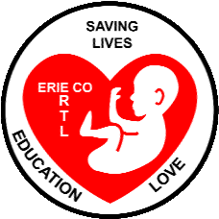 Erie County Right to Life
eriecountyrighttolife@gmail.com.
April-May 2022
If you would like to receive this newsletter by email, please contact us at: eriecountyrighttolife@gmail.com

**Bringing America Back to LIFE Convention**
—by ECRTL President Raine Faulkner

A couple of weeks ago, my husband and I had the opportunity to attend a portion of the Bringing America Back to Life convention. What an uplifting event! It was full of like-minded individuals who were there to grow and expand their impact within the Right to Life movement.
Having the opportunity to attend many of the speaking events was such a blessing. There were a wide range of speakers who shared pertinent information to our cause and provided insight into many controversial topics that exist today. If asked who my favorite speakers were, I would have to say Milo Yiannopoulos, Joe Allen, Pamela Acker and Donna Marie Murphy. You are able to listen to each of the speakers from the convention for free at bringingamericabacktolife.org. I highly recommend checking them out as well as praying about attending the convention yourself next year. You won’t be disappointed!

It’s Almost Summer…..!
…and that means Summer Festivals and The Erie County Fair!!! We want to get out the Pro-Life message to more and more people in our community, and we believe one way to do that is by continuing to have our information booth at area festivals, and of course, at the Erie County Fair. Last summer we were present at the Sandusky Stars and Stripes Festival, the Cold Creek Festival in Castalia, and at the Erie County Fair. This summer, WITH YOUR HELP, we can to take the pro-life message to
more of our area festivals. Here are the festivals, the Fair, and the dates we are considering:
Vermilion Fish Festival—June 17-19; Sandusky Stars and Stripes Festival—July 4; Huron River Fest—July 8-10; Erie County Fair—Aug. 10-15; Milan Melon Fest—Sept. 2-5; and Vermilion Wooly Bear Festival—Sept. 18. We need to know that we have people willing to staff our booth at each event we want to attend! The usual commitment a person makes is for two or three hours during a given day at the festival or fair. Training in presenting the Pro-Life message will be provided ahead of time; the booth has lots of Pro-Life info, including the Truth Booth video.
Please call Amy Hayes, Festivals/Fair chairperson @ 419-357-6211 (you can leave her a message) with the Festival(s), the Fair, and dates that are good for you. OR, send an email with that info to eriecountyrighttolife@gmail.com.
Please check your summer calendar, and pencil in some time to promote LIFE right here in our community!
We need to hear from you right now…
…because we need to register for booth space at the festivals and the fair ASAP! We need to know how many people are willing to help staff our booth at each festival/fair.

*ECRTL Movie Night on April 7*
A good-sized crowd of thirty-five pro-life community members came together Thursday April 7 to view the movie: Roe v Wade. Erie County Right to Life sponsored the Movie Night at the Boeckling Club in Sandusky. A BIG THANK YOU to Tom Bodner for the use of the Boeckling Club for the event!

Thanks to Patrick McLaughlin for the photos!
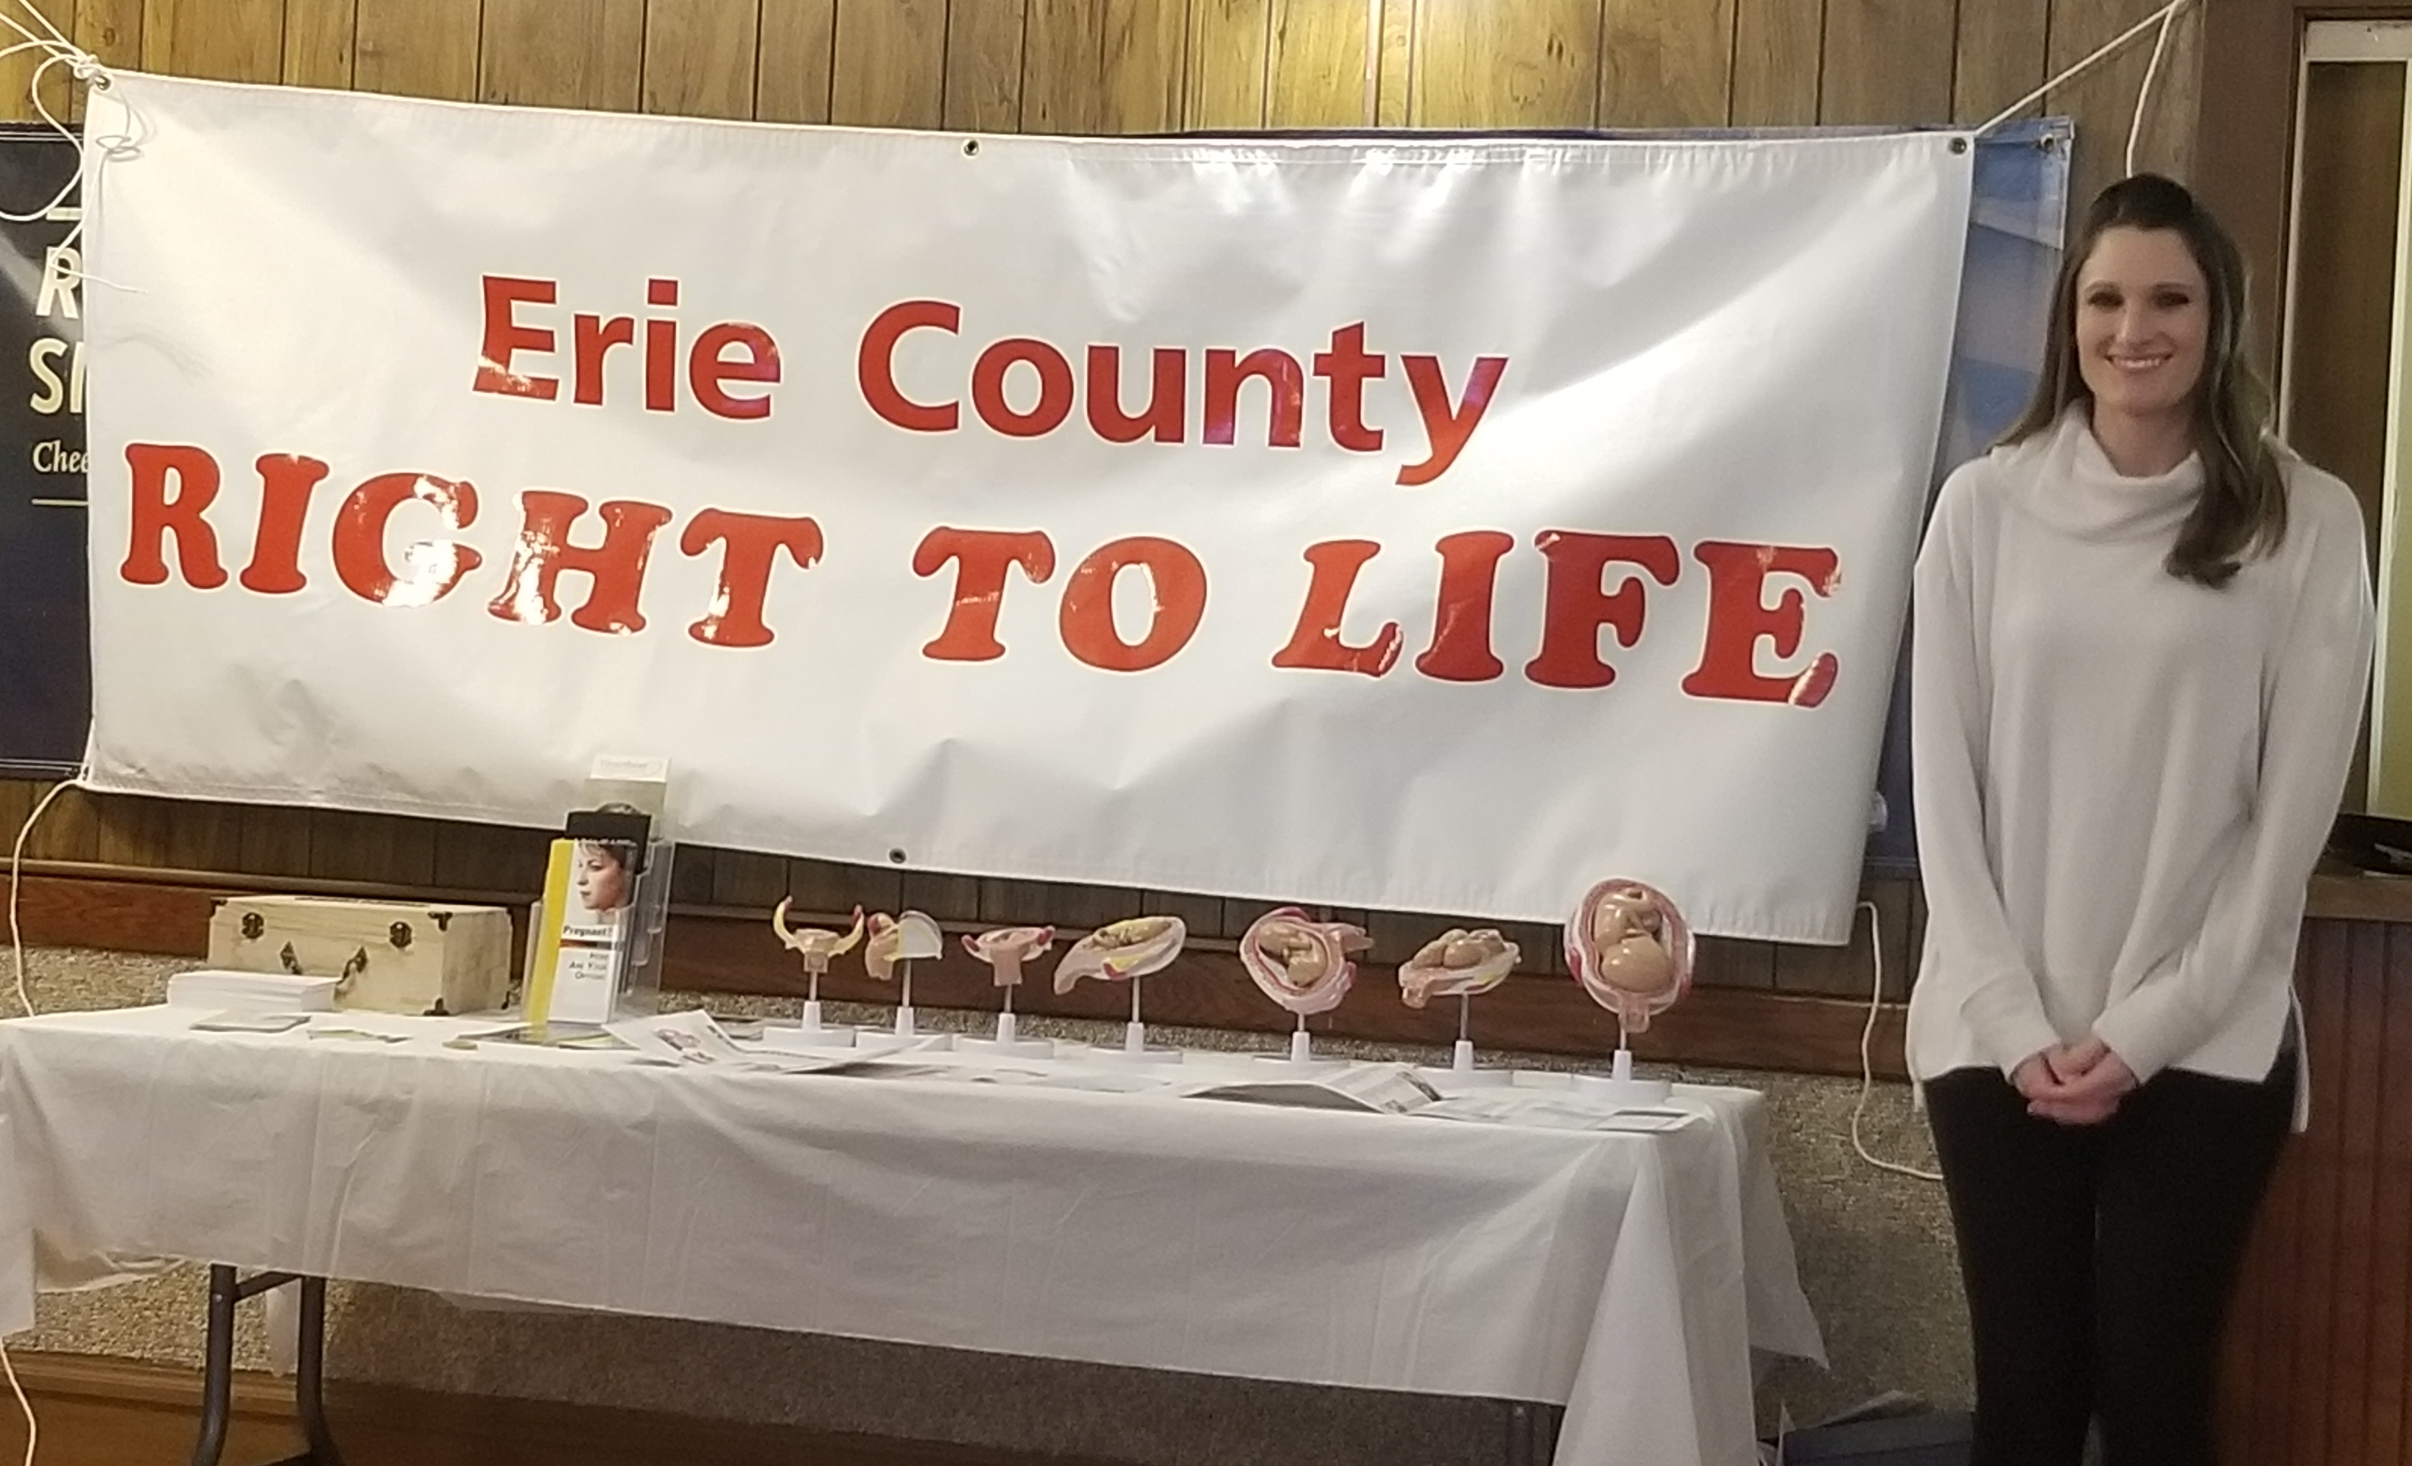
ECRTL President Raine Faulkner
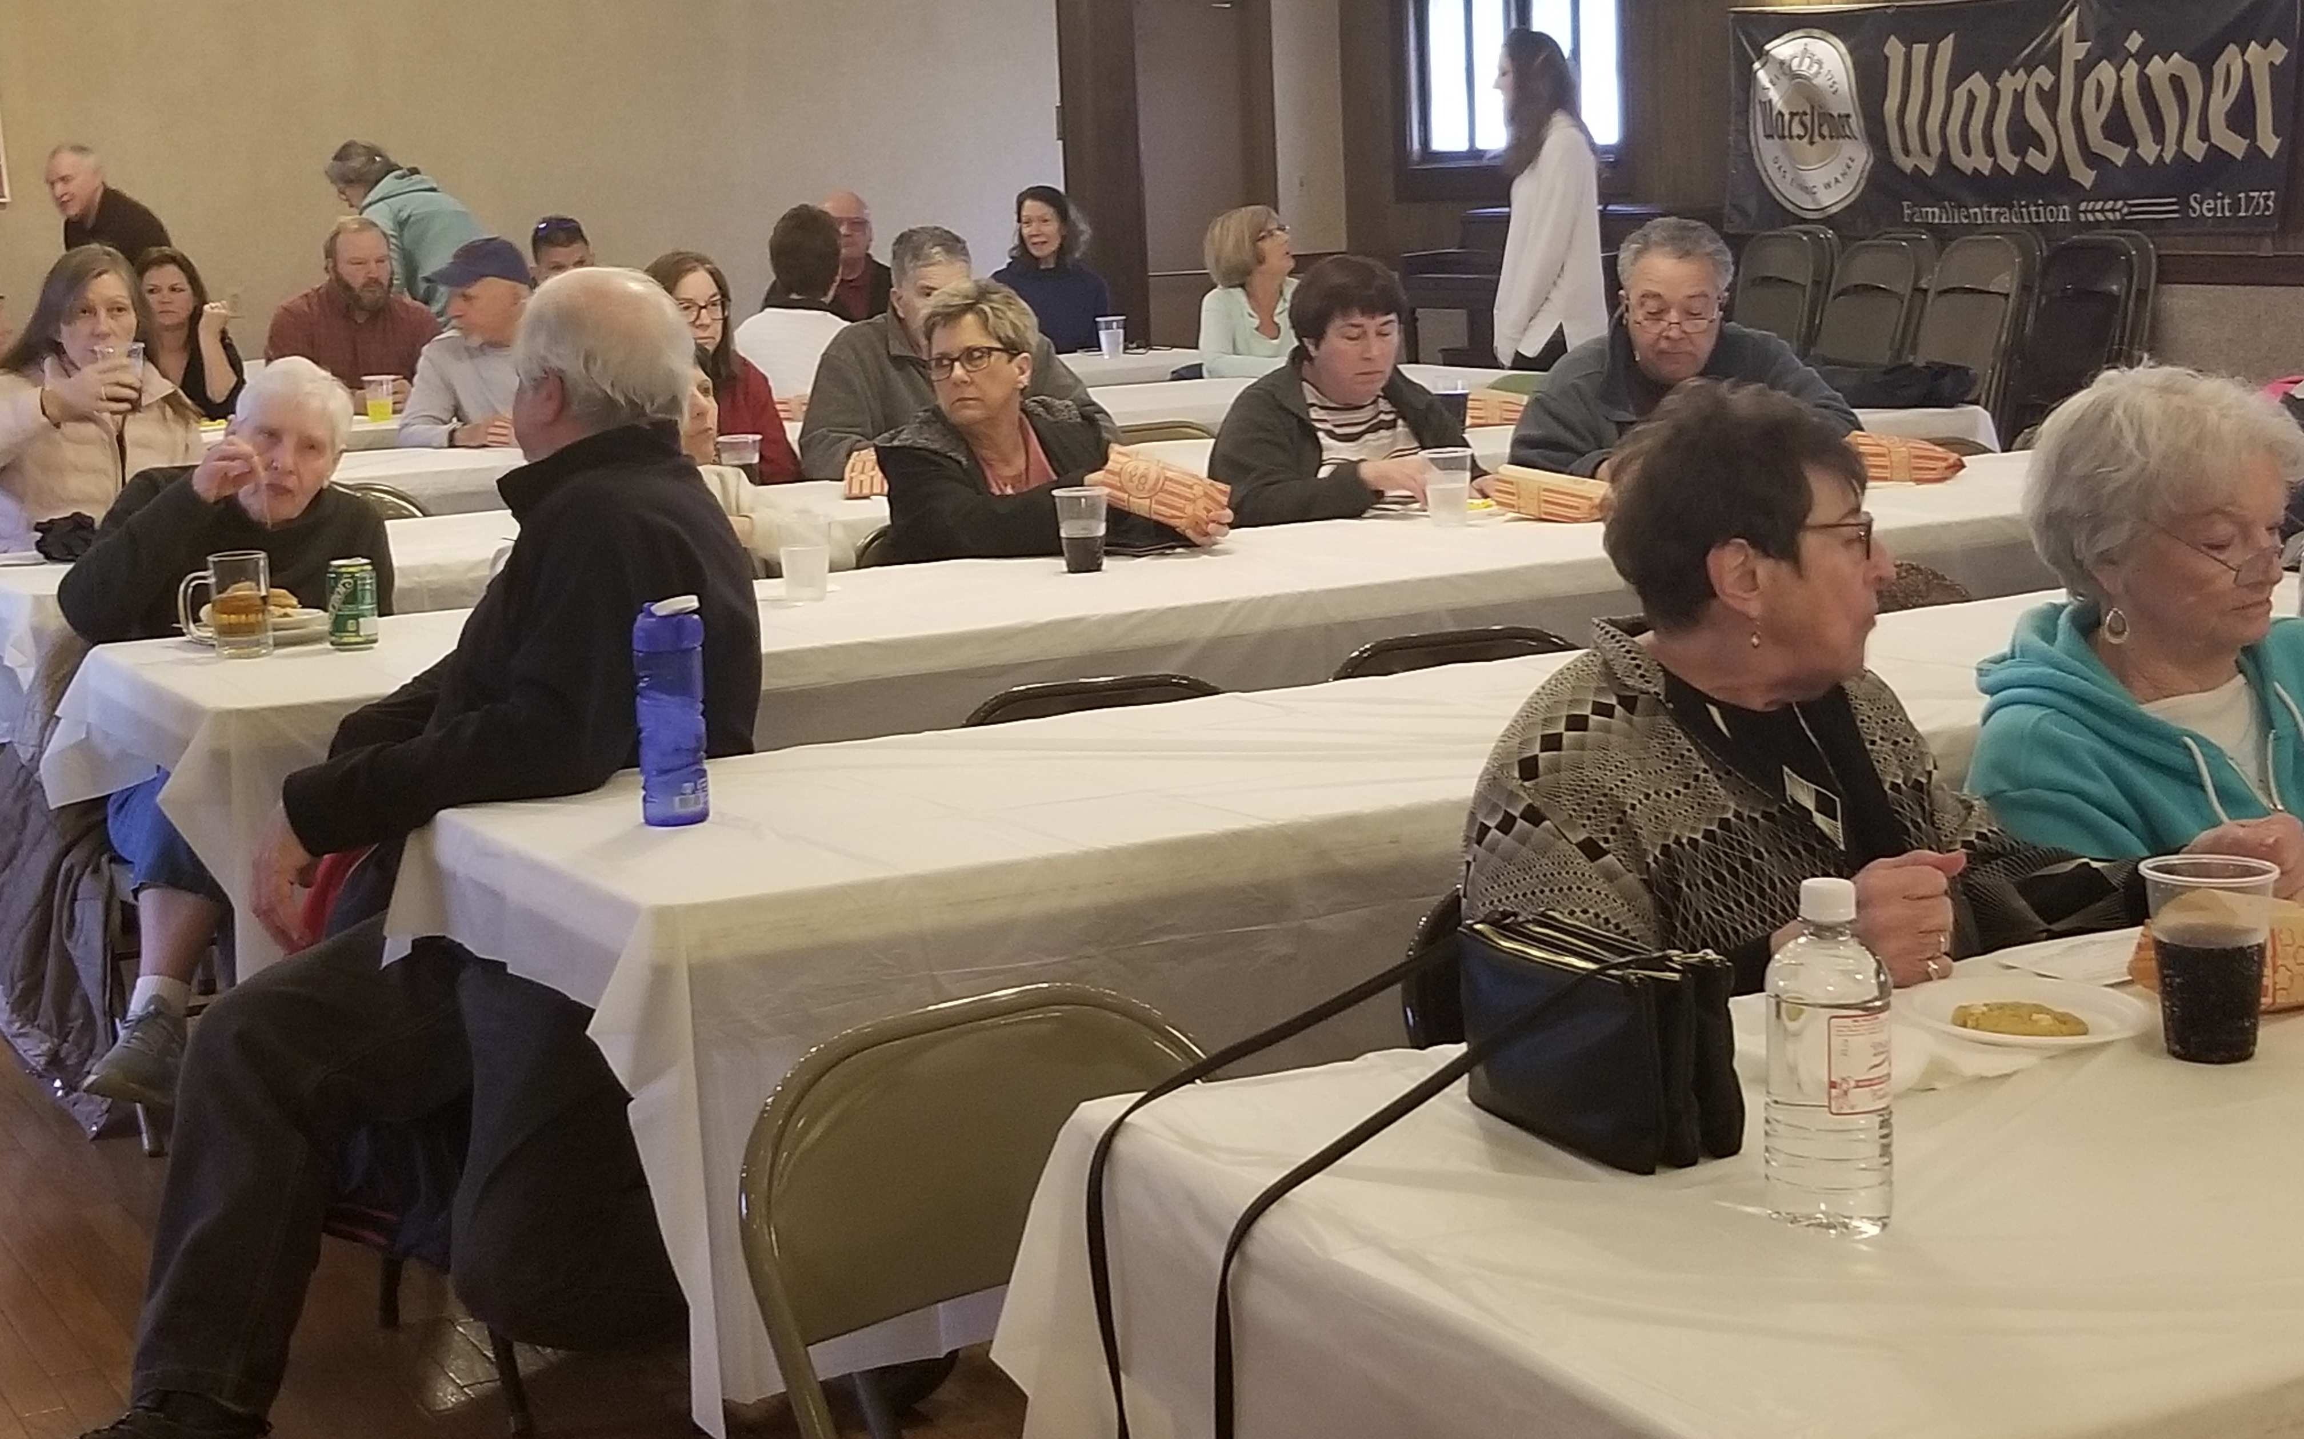

Toledo Abortion Facility has a New Owner and a New Name
After being shut down for several weeks last fall and winter, the only remaining abortion center in the greater Toledo area has re-opened. The business was bought by Dr. David Burkons, a retired ob-gyn, who also owns the Northeast Ohio Women’s Center. He renamed the facility on West Sylvania Ave. the Toledo Women’s Center. In 2017, Dr. Burkons’ physician’s license was revoked for six months because of unsigned prescriptions he left with his staff at his northeast Ohio facility. For more info about this abortionist and his work see this article from the Akron Beacon Journal: https://archive.ph/8lNyT

Did you know……?
Alabama, Arkansas, Arizona, Florida, Georgia, Idaho, Indiana, Iowa, Kentucky, Louisiana, Michigan, Mississippi, Missouri, Montana, Nebraska, North Dakota, Ohio, Oklahoma, South Carolina, South Dakota, Tennessee, Texas, Utah, West Virginia, Wisconsin and Wyoming—These 26 states either have enacted “trigger laws” that will make abortion illegal in their states if Roe is overturned by the U.S. Supreme Court (12 states) or have laws making abortion illegal that pre-date the 1973 Roe v Wade decision. For a very interesting graphic on this topic: https://reproductiverights.org/maps/what-if-roe-fell/

“Medical Waste” to Electricity
The Curtis Bay Waste Medical Waste Services, based in Baltimore, MD, collects the remains of aborted babies from abortion centers such as the Washington Surgi-Clinic in our nation’s capital. The “medical waste” Curtis Bay collects throughout the East Coast is then burned to produce electricity for the Baltimore area. For more info: https://projectweaklink.com/1359-2/ This article includes a link for readers to voice their opposition to this situation

Free Abortions in California
By signing CA Senate Bill 245, California Gov. Newsom has made abortions free in that state. And, CA lawmakers are considering a new bill that would cover travel costs for out-of-state women who want an abortion in California. For more info: https://www.breitbart.com/politics/2022/03/23/gavin-newsom-signs-law-to-make-abortions-free-in-california/

When is a Heartbeat not a Heartbeat??
An article in the New York Times in February reported that what doctors, ultrasound technicians, and parents call a heartbeat of a six-week-old in-utero Baby is really not a heartbeat, but instead “pulses” coming from “a primitive tube of cardiac cells”! To read more, https://www.ncregister.com/blog/we-all-hear-a-heartbeat?utm_campaign=NCR%202019&utm_medium=email&_hsmi=204123200&_hsenc=p2ANqtz-8hgJiATp0tUcohwFaw_FgYffBFnQsCrY56jG7WZAG87_A7_r33Iky969lluDF9YT9N3M42WNLR_OA31iBn8KuClgiA9A

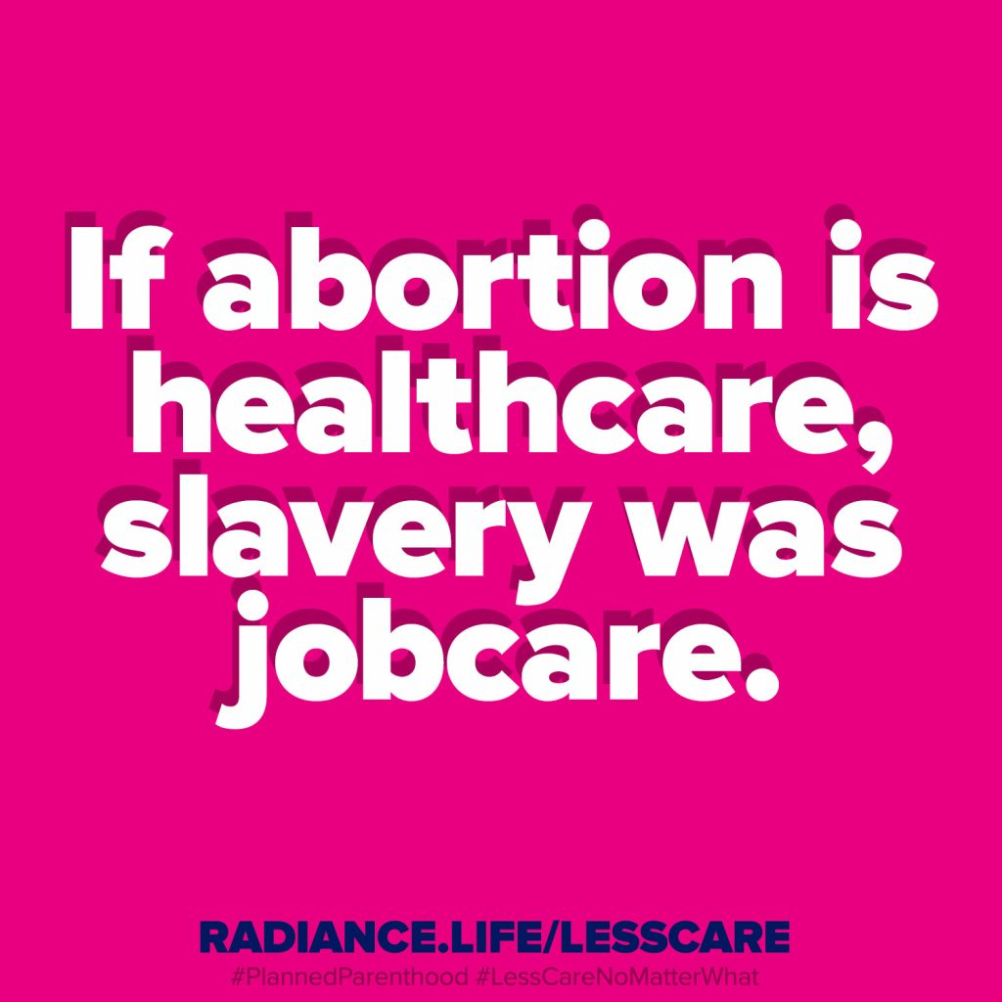

*NEWS from our
Local Pregnancy Resource Centers**
Abigail Pregnancy Services in Norwalk’s
Walk for Life is scheduled for Saturday May 21 at Willard Park at the Depot, 542 S. Main St. in Willard, OH. Check in begins at 8:15 a.m. with the Walk beginning at 9:30 a.m. The Walk’s distance is just under 1.5 miles. Organize a group of friends, and/or bring the family! Collect sponsors for your walk (and/or make your own donation!); all money goes to Abigail Pregnancy Services to support Mothers and their Babies. Every walker who collects $25 or more will receive a t-shirt. This year’s event will include a 5K Run as well. For more details and to register, go to: FriendsOfAbigail.com
Heartbeat of Sandusky, located at 3423 Columbus Ave. in Sandusky, continues to offer pregnancy tests, lay/peer counseling, maternity clothes, children’s clothes up to size 4, starter packs for newborns, baby food, as well as a 24-hour-Hotline, 800-712-HELP (4357). All services are free and confidential.

*UPCOMING EVENTS*
ECRTL General Meetings are held on the 2nd Monday of each month. The next ECRTL meeting will be Monday May 9 at 6:30 p.m., at Calvary Baptist Church (back bldg.), 1810 E. Perkins Ave., Sandusky. PLEASE COME!!! All are welcome!!

Ohio Right to Life announces a partnership with the national March for Life Organization and Center for Christian Virtue to organize the first
Ohio March for Life at the State Capitol in Columbus on Wednesday October 5, 2022. More details to come…..

