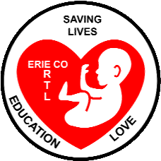 Erie County Right to Life
eriecountyrighttolife@gmail.com
Find us at: http://www.eriecountyrighttolife.org
September 2023
If you would like to receive this newsletter by email, please contact us at: eriecountyrighttolife@gmail.com

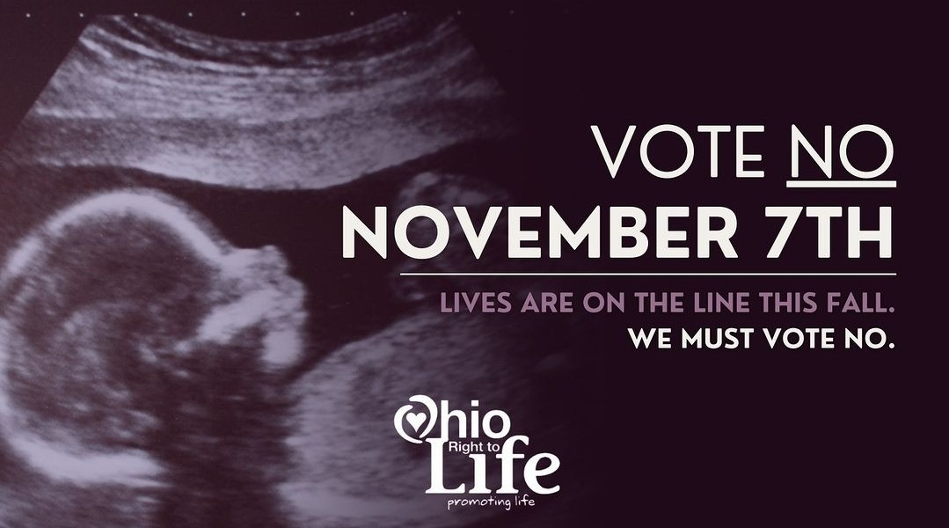
**Pro-Abortion Amendment to the Ohio Constitution to be on November Ballot**
The pro-abortion supporters gathered enough signatures on their petitions to put the proposed “Right to Reproductive Freedom” amendment on the ballot this fall. Please learn more about this at: https://ohiolife.org/legislation/defeating-the-abortion-ballot-initiative/ and at https://protectwomenohio.com/
And, please see page 2 of this newsletter to learn more about the “ECRTL Believers’ Alliance”….
**News from Festivals/Fairs**
THANK YOU to all our ECRTL Volunteers who have worked at our ECRTL Booth, witnessing to LIFE at area Festivals and at the Erie County Fair this summer!!
We have another opportunity to spread the Pro-Life message, at the ever-popular Woollybear Festival in Vermilion, Sunday October 8, 9 a.m. to 5 p.m. Our ECRTL Booth will be there!! Please contact Kim Johnston, at 419-271-3086, to volunteer to help out at our ECRTL Booth in Vermilion on Sunday October 8.

*Local Pregnancy Resource Centers*
Abigail Pregnancy Services, 3900 Laylin Rd., Norwalk,. Call: (419) 668-9500
Heartbeat of Sandusky, 3423 Columbus Ave., Sandusky. Please contact Director Mattie Sparks at 419-625-9511.
*ECRTL Prayer Brunch*
Our Annual ECRTL Prayer Brunch is Saturday October 7, 10 a.m. to noon, at the St. Mary Catholic Church Commons, 429 Central Ave., Sandusky. Guest Speaker will be Allison Stump, Students for Life Coordinator for Diocese of Toledo. Speakers from Heartbeat of Sandusky and Abigail Pregnancy Services will also be there. Please join us for this gathering of pro-Life supporters in our community!
*40 Days for Life*
September 27-November 5 are the dates for the Fall 2023 40 Days for Life Prayer Campaign.
And this fall, 40 Days for Life will have a presence locally, at the CVS Pharmacy, 513 E. Monroe St., in Sandusky. Nationwide, CVS Pharmacies have agreed to sell the abortion drug, mifepristone, in effect making CVS an abortion provider. Join us at the Vigil Kick-Off Sunday Sept. 24 @6:30 p.m, at the Sandusky CVS. Speaker will be former Planned Parenthood Director Ramona Trevino. Vigil hours at the Sandusky CVS will be 9 am to 9 pm daily. Call Sandusky 40 Days for Life Coordinator Lisa Maczuga at 419-366-9006 to sign up for your prayer hour. Or go to: www.40daysforlife.com/sandusky
40 Days for Life in Toledo will continue on the same dates, at the only remaining abortion center in northwest Ohio, 1160 W. Sylvania Ave., Toledo. Sign up to pray there at: www.40daysforlife.com/toledo
*UPCOMING EVENTS*
ECRTL General Meetings are held on the 2nd Monday of each month. Upcoming ECRTL meetings will be Monday Sept. 11, Oct. 9, and Nov, 13 at 6:30 p.m., at Calvary Baptist Church, Family Life Center, 1810 E. Perkins Ave., Sandusky.
PLEASE COME!!! All are welcome!!
*Ohio March for Life Fri. Oct. 6,
10 a.m. to 1 p.m., Ohio Statehouse, 1 Capitol Square, Columbus, OH 43215
*ECRTL Prayer Brunch, Sat. Oct. 7, see article above for details!
*Abigail Pregnancy Services Annual Banquet,
Thurs. Oct. 19, at The Colonnade, Milan; speaker Peter Range, Ohio Right to Life CEO; call 419-668-9500; https://www.facebook.com/AbigailPregnancyServices
*Sandusky-Huron Knights of Columbus 3rd annual Walk for Life to support Abigail Pregnancy Services and Heartbeat of Sandusky, Sat. Oct. 21, 8 a.m. at the Sandusky Sailing Club, more info and to register: https://sanduskycatholic.org/koc
Erie County Right to Life
BELIEVERS’ ALLIANCE
--statement by ECRTL officers and committee chairpersons

The Cultural Revolution that began in the 1960s is still wounding all of God’s people. Today we live in a culture that denies Truth and instead embraces Lies and Relativism. And this is happening right here in Ohio!
This Fall we will be voting on legalizing killing Pre-Born Babies (abortion) right here in Ohio! Abortion supporters are proposing an amendment to the Ohio Constitution—“The Right to Reproductive Freedom with Protections for Health and Safety”—that would make it legal to kill pre-born Babies up until birth! Please go to this link for details on what this proposed amendment states: https://rtlaohio.org/resources/
Your NO vote on this amendment is a vote AGAINST legalizing abortion. Let’s keep pre-born Babies alive in Ohio! Let’s protect Life! Let’s admit that Life IS precious!
This is undoubtedly THE MOST IMPORTANT VOTE in our lifetime! Human lives are at stake.
There are lots of reasons given for killing pre-born Babies (abortion): pressure from others, finances, the Mother’s education, inconvenience, circumstances of the pregnancy. But none of these reasons recognizes the Truth of the matter—the pre-born Baby is a Human Person with the God-given Right to Life!
You will hear a lot of messages this Fall about all this, but it comes down to this question for each of us: Do we support legalizing the killing of pre-born Babies (abortion)? Please answer with your NO vote this Fall, a resounding NO!
*****************************************

Please fill out the following form to commit to what you can do to defeat this proposed amendment. We believe prayer is powerful! Educating our community about what this proposed pro-abortion amendment says and what it would mean for our families is crucial. Please check as many of the activities as you can!

If someone in your household is eligible to vote but not yet registered, please contact the Erie County Board of Elections at: 419-627-7601, or find the forms to register at: https://www.boe.ohio.gov/comoh/VoterRegistrationForm.pdf

2023 ECRTL RIGHT TO LIFE
Believers’ Alliance
We are opposed to the killing Pre-Born Babies!

Please PRINT clearly
Name(s) of registered voters at this address
__________________________________________

_________________________________________

Address___________________________________

City ____________________, OH ZIP__________

Phone ___________________________________

E-mail ___________________________________

Signature: _________________________________

Church attending: __________________________

I would like to help defeat the pro-abortion amendment on the November 7 ballot by (check as many as you can):

___ Prayer ___ Phone Calling
___ Distributing info cards to friends, neighbors, co-workers, family
___ Placing a yard sign in my yard
___ Donation (donations are NOT necessary but will be gratefully accepted)
Mail this completed form to: Erie County Right to Life, P.O. Box 1385, Sandusky, OH 44871-1385. If you are making a donation, please make check payable to “Erie County Right to Life” and mail it along with this form. Donations are NOT tax deductible.
PLEASE RETURN ASAP
by 10-10-23 at the latest

