**Erie County Right to Life**

[**eriecountyrighttolife@gmail.com**](mailto:eriecountyrighttolife@gmail.com)

**Find us at: eriecountyrighttolife.org**

**SPECIAL EDITION—Election 2024**

***If you would like to receive this newsletter by email, please contact us at:*** [***eriecountyrighttolife@gmail.com***](mailto:eriecountyrighttolife@gmail.com) ***or through our website.***

**\*\*National Election Day\*\***

**Tuesday November 5, 2024**

**Early in-person voting until Nov. 3**

**Absentee ballots by mail until Nov. 6**

**For more info: voteohio.gov**

***As with every election in our country, there are important issues to consider and important decisions to be made in choosing between candidates for office. This 2024 National Election is no different. Following are some resources you might find helpful in making your choices on this year’s ballot, from the perspective of our shared Respect for Life.***

**\*\*Ohio Issue One: Establish the Citizens Redistricting Commission Initiative**

**Right to Life Action Coalition of Ohio (RTLACO) supports voting NO on Issue 1.**

***For more info:*** [***https://ohiocapitaljournal.com/2024/09/25/what-is-ohio-issue-1-we-explain-novembers-proposed-redistricting-reform-amendment/***](https://ohiocapitaljournal.com/2024/09/25/what-is-ohio-issue-1-we-explain-novembers-proposed-redistricting-reform-amendment/) ***and*** [***https://ohiosenate.gov/news/on-the-record/ohio-ballot-board-sets-clear-ballot-language-for-novembers-constitutional-amendment***](https://ohiosenate.gov/news/on-the-record/ohio-ballot-board-sets-clear-ballot-language-for-novembers-constitutional-amendment)

**\*\*For candidate recommendations from Ohio Right to Life: *ohiolife.org/2024-ortl-pac-recommendations/***

**\*\*For candidate recommendations from Right to Life Action Coalition of Ohio: *rtlaco/learn/candidates-and-elections/***

**The following candidate recommendations are a compilation of those from ORTL and RTLACO:**

**\*\*\*Ohio Supreme Court: Justice Joe Deters, Judge Megan Shanahan, and Judge Dan Hawkins**

**\*\*\*U.S. House District 9: Craig Reidel**

**\*\*U.S. Senate: Bernie Moreno**

**\*Ohio House District 89: DJ Swearingen**

***Neither ORTL nor RTLACO has recommended candidates for U.S. President or Vice-President.***

**\*\*To compare the National Democratic and Republican Party platforms, go to: *https://lifeissues.org/article/comparing-party-platforms/***

**\*\*A resource for Life issues in the 2024 Election**

[***www.ewtnnews.com/election***](http://www.ewtnnews.com/election)

**\*REMEMBER TO VOTE!\***

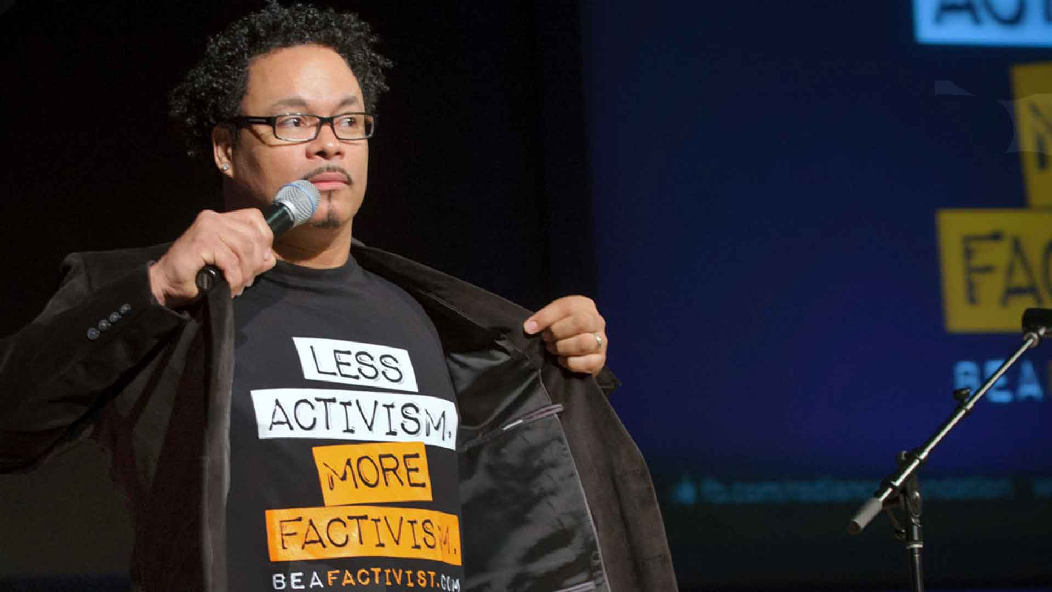

***Speaker Ryan Bomberger***

**\*\*SAVE the DATE\*\***

**\*SATURDAY OCTOBER 26\***

**RYAN BOMBERGER**

**will be the Main Speaker at the**

**ECRTL Prayer Brunch,**

**Saturday October 26,**

**10 a.m.,**

**@ Holy Angels Parish Hall,**

**428 Tiffin Ave., Sandusky.**

**Ryan Bomberger**, photo above, is an international speaker, columnist, educator, broadcast media designer, producer, writer and a *factivist* He REALLY likes to tell the TRUTH!!*.* Ryan is also the Emmy Award-winning Creative Professional who founded The Radiance Foundation, a life affirming 501c3. <https://radiancefoundation.org/>

***Come hear what this staunch supporter of the TRUTH has to say about the LIFE ISSUE***

***in our country today!***

**The Prayer Brunch is FREE** (donations will be accepted at the event), *but we do need to have RSVPs.*  Please register **TODAY** for the Prayer Brunch at the ECRTL website:

<https://eriecountyrighttolife.org/prayer-brunch>

**\*Local Pregnancy Resource Centers\***

\*\*\***Abigail Pregnancy Services**, 3900 Laylin Rd., Norwalk. **Call 419-668-9500**

follow Abigail on Facebook: facebook.com/AbigailPregnancyServices

\*\*\***Heartbeat of Sandusky**, 3423 Columbus Ave.,. **Call 419-625-9511**

**Erie County Right to Life General Meetings**

**are held on the 2nd Monday of each month. NEXT MEETINGS are November 11, and December 9, 6:30 p.m., at Calvary Baptist Church, Family Life Center, 1810 E. Perkins Ave., Sandusky.**

**YOU are WELCOME! PLEASE COME!**

**And….More Upcoming Events…**

**\*\*The 2024 Fall 40 Days for Life Prayer Campaign is underway and will continue until Sun. Nov. 3, in over 1000 cities and towns across the U.S. and 64 countries around the world. We are all encouraged to pray and fast during these 40 days for an end to the scourge of abortion. If you would like to join others in praying and giving witness to Life along with other pro-Life supporters locally, you are invited to come to the Sandusky CVS Pharmacy, 513 E. Monroe St., Sandusky, where we will be praying on the public sidewalk there, from 9 a.m. to 9 p.m. each day. To sign up for your time slot, go to: *40daysforlife.com/Sandusky*****. In Toledo, we are invited to pray outside the Toledo Abortion Center, 1160 W. Sylvania Ave., Toledo. Go to: *40daysforlife.com/toledo* to claim your hour there. Please call ECRTL President Lisa Maczuga at 419-366-9006 with your questions.**

**\*\*The National March for Life will in Washington, D.C. on Friday January 24, 2025. More info at:** [***https://marchforlife.org/***](https://marchforlife.org/)

**\*\*Did You Know….?**

**……that, etched into the stone at the World Trade Center 9/11 Memorial, are the names of 11 pregnant mothers and their unborn children?

To see images, please go to: [***https://www.catholicnewsagency.com/news/252260/new-911-book-husband-writes-about-losing-wife-unborn-child***](https://www.catholicnewsagency.com/news/252260/new-911-book-husband-writes-about-losing-wife-unborn-child)

**\*\***……that, in the state of Ohio, baby supplies such as diapers, wipes, and car seats are tax-exempt? [***https://dam.assets.ohio.gov/image/upload/tax.ohio.gov/sales_and_use/information_releases/information-release-st2023-01.pdf***](https://dam.assets.ohio.gov/image/upload/tax.ohio.gov/sales_and_use/information_releases/information-release-st2023-01.pdf)

**\*\*\*Remember to Vote\*\*\***

**S.T.O.R.K. Act**

Ohio State Representative Gary Click, a Republican from Vickery, OH, recently introduced the Strategic Tax Options for Raising Kids (STORK) Act to provide tax relief for Ohio’s young families and expectant mothers. Among other provisions, the S.T.O.R.K. Act would allow parents to claim their children as tax deductions in the year they are conceived, rather than in the year they are born. To read more, go to: [***https://ohiohouse.gov/members/gary-click/news/click-introduces-stork-act-to-help-ohio-families-121506***](https://ohiohouse.gov/members/gary-click/news/click-introduces-stork-act-to-help-ohio-families-121506)

**Abortion Pill and Death**

Abortion pills now account for over 63% of all abortions in the U.S. Unfortunately, more and more women are now dying after taking these dangerous abortion pills. To read just two of these sad stories, go to: ***https://www.lifenews.com/2024/09/18/abortion-pill-kills-yet-another-woman-leaving-parts-of-her-baby-inside-her/***

The American Life League is reporting that Mexican drug cartels are illegally funneling abortion pills into the U.S. Read more at: [***https://all.org/press-releases/abortion-pill-the-latest-illegal-import-flowing-into-the-us***](https://all.org/press-releases/abortion-pill-the-latest-illegal-import-flowing-into-the-us)

**Right to Life Action Coalition of Ohio**

RTLACO was founded in 2017 by a group of nine staunchly Pro-Life supporters from all “four corners” of Ohio. Their purpose was to provide a voice for those in Ohio who strongly believe in Pro-Life protection for all persons, from “womb to tomb”, with no exceptions. On September 14, RTLACO held a Founders Salute Banquet in Columbus, to celebrate the nine founders, to review RTLACO’s work over these seven years, and to outline their plans going forward. Ohio Rep. Melanie Miller from Ashland, member of the Pro-Life Caucus in the Ohio House, told the banquet attendees that she believes that saving Babies from abortion must be a “heart issue” rather than just a legislative issue. Several speakers quoted the words God spoke to Joshua following the death of Moses, Joshua 1:9***--“I command you: Be firm and steadfast! Do not fear nor be dismayed, for the Lord your God, is with you, wherever you go.”*** All the speakers spoke of their hope for the future, acknowledging that the work ahead will be difficult. One of the founders, Paul Coudron, summed up RTLACO’s philosophy with this: **There is nothing we can do in this life greater than to promote Life.**

*24 hour waiting period for abortion in Ohio stayed by Franklin Co. Judge--https://ohiocapitaljournal.com/2024/08/26/ohios-24-hour-waiting-period-abortion-law-paused-by-judge/

<https://catholicvote.org/report-reveals-network-of-black-market-abortion-pill-drug-cartels-enabled-by-fda-and-usps/?mkt_tok=NDI3LUxFUS0wNjYAAAGV0cqxIrI12C5GIumofY0R7Uk6jmPjZxPGRo8Qc6cIxI8csYxOR6QVDP-h4FSSSLN0urg4E_yQ45jKN2hmMY1ituFn9rZcnql77TQyy34d> Mexican drug cartels selling abortion pills into the U.S.