**Erie County Right to Life**

[**eriecountyrighttolife@gmail.com**](mailto:eriecountyrighttolife@gmail.com)

**Find us at: eriecountyrighttolife.org**

***August 2024***

***If you would like to receive this newsletter by email, please contact us at:*** [***eriecountyrighttolife@gmail.com***](mailto:eriecountyrighttolife@gmail.com) ***or through our website.***

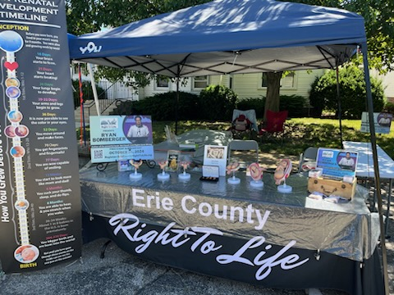

**\*Summer Festivals and the Fair\***

**Check out photos above and below of our 2024 Erie County Right to Life Booth!! Our Booth had its Summer Debut at the Vermilion Fish Festival June 14-16. Weather was glorious, our ECRTL volunteers were awesome, and our message of the sanctity of Life was evident to all who passed by or stopped at our Booth. Many supporters approached us with positive comments, including Right to Life friends from Columbus, Wooster, Cincinnati, and the states of Georgia and Louisiana. And, we realized that we are providing an opportunity for Pro Life supporters to share their hearts and voices with fellow believers and ProLife advocates, since many do not have the opportunity to do that in their daily lives and encounters.**

***--Thanks to Kim Johnson for photos and info for this article***

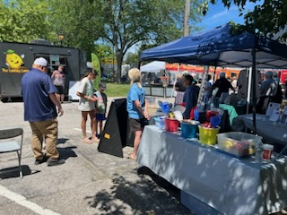

**\*Can You Help?\***

**Please plan to help out at the Erie County Right to Life Booth this summer at one of the local festivals and at the Erie County Fair!**

**Here’s where we will be:**

**\*Berlin Heights Basket Festival-Aug. 2-4**

**\*Erie County Fair--Aug. 5-10**

**\*Wooly Bear Festival—Sept. 29**

**Setting up and taking down the Booth at each event, and of course, being at the Booth and witnessing to Life to those who stop by--there are jobs for all of us!! These summer festivals and the Fair give us a great opportunity to share our Pro-Life message with our community. YOU are invited to come witness to LIFE with us! Text or call ECRTL Festival and Fair chairperson Kim Johnston at 419-271-3086 to offer your help!**

**\*Local Pregnancy Resource Centers\***

\*\*\***Abigail Pregnancy Services**, 3900 Laylin Rd., Norwalk. **Call 419-668-9500**

**Annual Fundraising Banquet** at the Colonnade in Milan—Thurs. October 10

For updates on events and more, follow Abigail on Facebook: facebook.com/AbigailPregnancyServices

\*\*\***Heartbeat of Sandusky**, 3423 Columbus Ave.,. **Call 419-625-9511**

Plans are being made to do some scraping and repainting on the trim at their Columbus Ave building this summer. If you, or your youth group, can help, please call Director Mattie Sparks at the number above.

**\*\*\**to Benefit Both Local Pregnancy Resource Cente*rs\*\***

**Knights of Columbus Pro-Life 5K Walk/Run**, at the Sandusky Sailing Club, 814 E. Water St., Sandusky, **Sat. Oct. 19**

100% of the proceeds benefit Heartbeat of Sandusky and Abigail Pregnancy Services. Register now at **kofcsandusky.org**

**\*Pro-Life Music!\***

Check out this song, “I Was Gonna Be”, sung by 18-year-old Rachel Holt and written by renowned Nashville songwriter Chris Wallin: <https://www.youtube.com/watch?v=JECbfKi90rA>

**\*How “Popular” is the Abortion Pill?\***

According to Guttemacher Institute, the news arm of Planned Parenthood, **in 2023, 63% of all abortions in the U.S. were chemical abortions.** Here are the numbers: **642,700** chemical (abortion pill) abortions were recorded by Guttmacher, which works out to be **53,558** a month, **1,761** daily, **73** hourly, and one abortion pill abortion **every 49 seconds.** The total number of surgical abortions and chemical abortions in 2023 is **1, 037,000.** For more info: <https://www.liveaction.org/news/abortion-data-2800-daily/>

**\*U.S. Supreme Court and the Abortion Pill\***

On June 13, the U.S. Supreme Court’s announced its unanimous decision in *U.S. Food and Drug Administration v. Alliance for Hippocratic Medicine*, that the doctors who had brought the case to the Supreme Court lacked the legal right to sue over the federal Food and Drug Administration’s approval of the medication, [mifepristone](https://apnews.com/article/mifepristone-supreme-court-abortion-d451e14148ffbe6ce4811b1a37651480), and the FDA’s subsequent actions to ease access to it. Because of that decision, the Court failed to address the merits of the FDA’s lawless removal of commonsense safety standards for abortion drugs. To read more: <https://adflegal.org/press-release/fdas-recklessness-continues-now?utm_source=google&utm_medium=search>

**“The Dark Side of Deregulation:**

**Coerced Abortion Incidents on the Rise”**

To learn more about how the current FDA guidelines for the use of Mifepristone, the Abortion Pill, are playing out: <https://www.ncregister.com/news/fda-abortion-deregulation-forced-coercion?utm_campaign=NCR&utm_medium=email&_hsenc=p2ANqtz--lis1009BPU9KiY2Qc38N4IxRJFzgPlxZyZb6FXCQ76qrx6Vi6rwpyrfOjdHGvKloEn5KLTvSw1nv12Abw_inHI2stMA&_hsmi=314819812&utm_content=314819812&utm_source=hs_email>

**\*Upcoming Events\***

**\*\*ECRTL General Meetings are held on the 2nd Monday of each month. NEXT MEETINGS are August 12, September 9, and October 14, 6:30 p.m., at Calvary Baptist Church, Family Life Center, 1810 E. Perkins Ave., Sandusky.**

**YOU are welcome—PLEASE COME!**

**\*\*Looking ahead, the Fall 2024 40 Days for Life Prayer Campaign will be held Wed. Sept. 25 to Sun. Nov. 3. Locally, we will again pray and give witness to Life at the Sandusky CVS Pharmacy from 9 a.m. to 9 p.m. each day. To sign up for your time slot, please call ECRTL President Lisa Maczuga at 419-366-9006.**

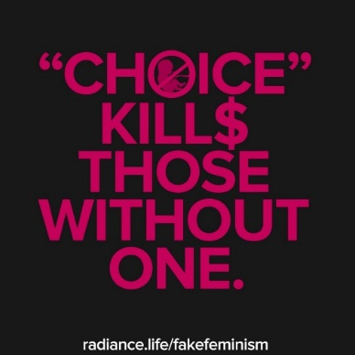

**\*Save the Date: Oct. 26\***

**Ryan Bomberger**, who designed the above graphic and the one at the end of the next column, is an international speaker, columnist, educator, broadcast media designer, producer, writer and a *factivist.* Ryan is also the Emmy Award-winning Creative Professional who founded The Radiance Foundation, a life affirming 501c3. AND,

**Ryan Bomberger**

**will be the Main Speaker at the**

**ECRTL Prayer Brunch,**

**Saturday October 26,**

**10 a.m.,**

**@ Holy Angels Parish Hall,**

**428 Tiffin Ave., Sandusky.**

Ryan has a lot to say about abortion. His birth mother was the victim of rape and chose to have her bi-racial Baby adopted.

**The Prayer Brunch is FREE** (donations will be accepted at the event), but we do need to have RSVPs. Please register TODAY for the Prayer Brunch at the ECRTL website:

<https://eriecountyrighttolife.org/prayer-brunch>

Please check out The Radiance Foundation website: <https://radiancefoundation.org/> to learn more about Ryan’s work. His op-eds are well- written with clarity and truth! Check out his recent video post called “Rise”: <https://radiancefoundation.org/portfolio-posts/rise/>