**Erie County Right to Life**

[**eriecountyrighttolife@gmail.com**](mailto:eriecountyrighttolife@gmail.com)

**Find us at: eriecountyrighttolife.org**

**Fall 2025 Edition**

**\*\*COMING SOON\*\***

**ECRTL Annual Prayer Breakfast**

**\*\*Saturday October 25\*\***

**10 am to 12:30 p.m.**

**@Holy Angels Church Hall**

**428 Tiffin Ave., Sandusky**

***Speakers include:***

**Dr. Anthereca Lane, Board Member from American Association of Pro-Life Obstetricians & Gynecologists (AAPLOG) speaking on the Abortion Pill and Reversal**

**Ed Sitter, Toledo Foundation for Life, speaking on In Vitro Fertilization (IVF)**

**and Aisha Taylor, author of “Navigating the Impossible: A Survival Guide for Single Moms”**

**This is a FREE event!!!**

***So that we can be sure to have enough seating and food for all who come:***

**Please register now at: eriecountyrighttolife.org *or***

** Scan this QR code with your phone to get a link to the ECRTL website, where you can register for the Prayer Brunch, access recent ECRTL newsletters, and see links to informative articles cited in our newsletters.**

**\*Summer Festivals and Fair Time\***

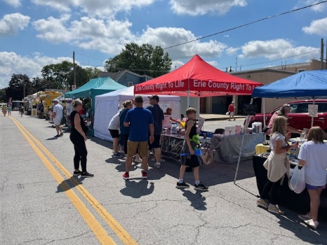--Cold Creek Festival photo taken by Kim Johnston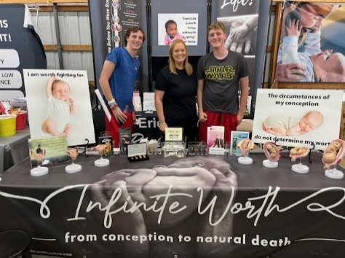--Erie County Fair photo taken by Kim Johnston

**ECRTL was there!! Castalia’s Cold Creek Festival in mid July and the Erie County Fair in early August were both big successes as always! Thanks to Kim Johnston and many ECRTL supporters, people at the Festival and the Fair learned a little more about LIFE issues when they stopped by our Booth. AND, the children had fun playing Plinko--400 played Plinko at the Fair! *The following is from Kim about the Fair:*  
*A noticeable observation and connection with our visitors to the booth is that we not only display our message of Sanctity of Life at our booth.  
We also provide a safe haven area where those who have fertility issues, post abortion guilt or loss of precious babies can stop and share with our  Volunteers who listen, care, and understand.  
One Mother, in particular, stopped to look closely at our fetal models. She shared that she had experienced 3 miscarriages, she felt comfort in looking at our models, and seeing the ages/sizes of her precious babies when she lost them.***

**Sunday October 5 is the date of the Vermilion’s 53rd Annual Woolly Bear Festival, and the ECRTL Booth will be there! Why not come volunteer at the Booth for an hour or two, help witness to Life, and check out this time-honored festival, too? October weather is (usually) great for a festival!! Call Kim, 419-271-3086, to tell her you’ll be there!**

**\*New Website from the Sisters for Life\***

**The Sisters of Life have been working with young pregnant women in need of help since 1991 in New York City and beyond. (Learn their story here: *sistersoflife.org/who-we-are/who-we-are*/) The name of their new website, Vis Center** **(based on the Latin “Vis” meaning power)** **highlights the Sisters’ belief that women have power when someone listens to them. The Sister for Life empower women by meeting them where they are, and walking with them in their needs. Check out this very powerful website: *viscenter.orgw*** that real power is unleashed when you feel listened to.

**\*Assisted Suicide Legal in 10 States\***

**California, Colorado, Hawaii, Maine, Montana, New Jersey, New Mexico, Oregon, Vermont, Washington, and the District of Columbia currently allow assisted suicide. All, currently require a diagnosis of a terminal illness. But California currently has a bill that would eliminate that requirement, as well as make it legal for non-CA residents to come to CA for assisted suicide, allowing for “suicide tourism”. New York Governor Kathy Hochul has the Medical Aid in Dying Act on her desk since June, but has not signed it. (Let’s pray she doesn’t !!) Legislation to introduce or expand assisted suicide has been proposed in 21 states this year. For more on all this: *www.humanlifeaction.org/state-updates/assisted-suicide/***

**\*More News on Mifepristone\***

***ppc.org/publication/insurance-data-reveals-one-in-ten-patients-experiences-a-serious-adverse-event/* and *washingtonstand.com/article/senators-ask-ag-bondi-to-investigate-if-abortion-pill-manufacturers-deceived-women***

**\*Erie County Right to Life Meetings\***

**Meetings are held on the 2nd Monday of each month at 6:30 p.m. NEXT MEETINGS are October 13 and November 10 at Calvary Baptist Church, Family Life Center, 1810 E. Perkins Ave., Sandusky.**

**\*40 Days for Life Prayer Campaign\***

**September 24-November 2**

**Public right-of-way outside Toledo Abortion Center**

**7 a.m. to 7 p.m. daily**

**Sign up for prayer times and for more info: *40daysforlife.com/Toledo***

**(Or choose your own time and place to pray daily, or weekly, for unborn Babies and their Mothers!)**

***\*\*Tune in to Castalia Radio station WGGN, FM97.7, for Christian music and news, including ECRTL news!***

**\*UPCOMING EVENTS\***

**\*Abigail Pregnancy Services* Annual Fundraising Banquet, Oct. 2 @ the Colonnade, 1100 Milan Rd, Milan--for more info, and to RSVP, call 419-668-9500**

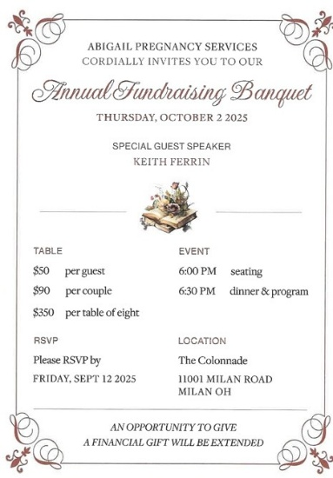

**\*Ohio March for Life\***

**Friday Oct. 3**

**beginning at the Ohio State House in Columbus**

**Rally at 11 a.m., March at 12 noon**

**For more info: *marchforlife.org/ohio/***

**\*Moms’ Walk in the Fall at the Mall\***

**A fundraiser for Heartbeat of Sandusky**

**Saturday October 11**

**10 a.m.—1 p.m.**

**@t the Sandusky Mall**

**Collect sponsors for your walk (forms available from Heartbeat of Sandusky's office), or make a donation the day of the Walk at the Mall.  Several area service and public health organizations—Erie County Health Dept., area counseling services, and Perkins Police to name a few-- will be at the Mall during the Walk, to share with the community what they offer.  For more info, please call Beth at 419-357-0714.  Hope to see you at the Mall!**

**\*Rosary for America\***

**Sat. Oct. 11, @11:45 a.m., Shade-Mylander Plaza, Downtown Sandusky, Rain or Shine**

**ALL are WELCOME**

**\*Sandusky/Huron Knights of Columbus**

**Walk/Run for Life\***

**\*Sat. Oct. 18\***

**9 a.m.**

**Sandusky Sailing Club, 814 E. Water St., Sandusky**

**Proceeds will be divided evenly between Heartbeat of Sandusky and Abigail Pregnancy Services. (Last year each group received $4200 from this event!! Goal this year is to raise $10,000, again to be divided evenly between the two groups.)**

**For more info and to register/donate: *kofcsandusky.org/prolife5k.html***