**Erie County Right to Life**

[**eriecountyrighttolife@gmail.com**](mailto:eriecountyrighttolife@gmail.com)

**Find us at: eriecountyrighttolife.org**

**May 2025 Edition**

***If you would like to receive this newsletter by email, please contact us at:*** [***eriecountyrighttolife@gmail.com***](mailto:eriecountyrighttolife@gmail.com) ***or through our website: eriecountyrighttolife.org***

**\*Summer Festivals and Fair Time\***

**ECRTL’s Festivals and Fair committee has been working to update our table display, and to reserve space at the summer events. Here’s our schedule so far:**

**Vermilion Fish Festival - June 13-15  
  
July 4th Sandusky Stars & Stripes  
  
Castalia Cold Creek Festival – July 18-20   
  
Erie County Fair - Aug 4 - 9  
  
Wooly Bear Festival in Vermilion – date to be announced**

**We need YOUR help to bring the Right to Life message to our community! CAN YOU SPARE TWO HOURS TO HELP OUT AT ONE OF THESE EVENTS THIS SUMMER? At least two volunteers are at the booth for each two hour shift. With questions and/or to volunteer, please contact Kim Johnston at 419-271-3086 !**



**\*‘Baby Olivia’ Laws Around the Country**

**North Dakota, Idaho and Tennessee have already passed laws requiring that high school students view videos of fetal development, while many others, including Iowa, Oklahoma, West Virginia, Missouri, Kentucky, Idaho, and Louisiana are discussing similar bills in their statehouses. The video that is at issue in all these states is “Baby Olivia”, a three-minutes video depicting the development of Life from fertilization to the time of birth, produced by Live Action and endorsed by the American Association of Pro-Life Obstetricians and Gynecologists (AAPLOG). You can view the short video here*: babyolivia.liveaction.org.* It is possible that similar legislation will be introduced into the Ohio House soon. *See next article.***

**\*Ohio Legislative Briefing Breakfast*--written by ECRTL President Lisa Maczuga**

**There are great pro-life leaders at the Ohio State House! On March 28 I attended Greater Toledo RTL's *Legislative Briefing Breakfast* as a guest of the Right to Life Action Coalition of Ohio. I am so impressed with our great Ohio leaders who are marching forward to protect life and support families in-spite of the devastating 2023 constitutional amendment. Here are some of the great leaders and initiatives I heard about: Representative Gary Click (Vickery) has introduced the "Stork Act" which would make Ohio's Child Tax Credit applicable *at conception*. (for more info on the Stork Act: *www.ohiohouse.gov/news/republican/click-klopfenstein-reintroduce-stork-act-127508* Representative Melanie Miller (Ashland) is working on legislation which would mandate education on fetal development in Ohio schools (for example Live Action's Baby Olivia). Rep Miller & Representative Josh Williams (Sylvania) introduced the Paid Parental Leave Act which would incentivize employers to offer paid parental leave benefits with tax credit. (For more info: *ohiohouse.gov/members/josh-williams/news/representatives-williams-and-miller-reintroduce-the-paid-parental-leave-act-130687* Also great news, Ohio's 2025 budget includes many pro-family items including expanded funding for pregnancy resource centers.**

**\*New Findings on the Abortion Pill\***

**As our readers know from previous ECRTL articles, the abortion pill, Mifepristone, now is used for more than half of all abortions. The FDA has been reporting that the drug is “safe” for women, causing serious problem for just .5% of the users. New research, from the Ethics and Public Policy Center, shows that to be untrue. “10.93 percent of women experience sepsis, infection, hemorrhaging, or another serious or life-threatening adverse event within 45 days following a mifepristone abortion, far greater than the summary figure of ‘less than 0.5 percent’ in clinical trials reported on the drug label.” No other drug with this high of rate of dangers for its use has been okayed by the FDA. For more details: eppc.org/wp-content/uploads/2025/04/25-04-The-Abortion-Pill-Harms-Women.pdf For info about the research group conducting the new study: eppc.org**

**\*Letter to President Trump\***

**Pro-Life groups from around the country have written a letter to President Trump about the new abortion pill research from the Ethics and Public Policy Center. *WE URGE YOU TO READ THE LETTER AT THE FOLLOWING LINK, FOR LOTS OF SOLID INFO!!***  [**https://downloads.frc.org/EF/EF25D92.pdf**](https://downloads.frc.org/EF/EF25D92.pdf)

***\*\*Remember Ryan Bomberger from the ECRTL October Prayer Brunch? Here is what he has to say to those who say that abortion is necessary because of rape.*** [***www.youtube.com/watch?v=taPCIwMFxbw***](http://www.youtube.com/watch?v=taPCIwMFxbw)

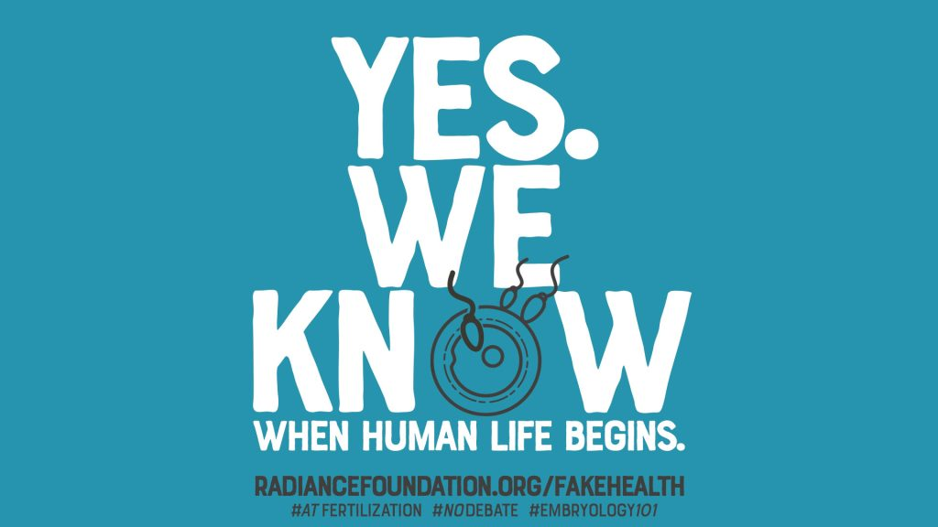

***\*\*Tune in to Castalia Radio station WGGN, FM97.7, for Christiam music and news, including ECRTL news1***

**\*Erie County Right to Life General Meetings\***

**are held on the 2nd Monday of each month at 6:30 p.m. NEXT MEETINGS are and June 9, July 14, and August 11 at Calvary Baptist Church, Family Life Center, 1810 E. Perkins Ave., Sandusky.**

***WE MISS YOU!!!***

***PLEASE COME TO A MEETING!!!***

**\*Local Pregnancy Resource Centers\***

\*\*\***Abigail Pregnancy Services**, 3900 Laylin Rd., Norwalk. **Call 419-668-9500**

**Abigail Pregnancy Services is celebrating their 35th Anniversary in Huron County with a**

**Walk & 5K Run for LIFE**

**Saturday June 7**

**Willard Park at the Depot**

**542 S. Main St., Willard, 44890**

**Walk check in @ 8:30 am, walk begins @ 9:30 am.**

**5K Run check-in @8 am, and begins @8:30 am**

**Live Music and Picnic Lunch @ 11 a.m.**

**For more info, call 419-668-9500, or check out Abigail @**

**facebook.com/AbigailPregnancyServices**

\*\*\***Heartbeat of Sandusky**, 3423 Columbus Ave.,. **Call 419-625-9511**

**\*MARK YOUR CALENDARS NOW* Saturday October 25, 2025**

**ECRTL Annual Prayer Breakfast**

**10 am to noon**

**@Holy Angels Church Hall**

**428 Tiffin Ave., Sandusky**

**Speakers include: Dr. Anthereca Lane, Board Member from American Association of Pro-Life Obstetricians & Gynecologista (AAPLOG) speaking on the Abortion Pill and Reversal;**

**Ed Sitter, Toledo Foundation for Life; and**

**Aisha Taylor, author of “Navigating the Impossible: A Survival Guide for Single Moms”**

***\*\*Tune in to Castalia Radio station WGGN, FM97.7, for Christiam music and news, including ECRTL news!***

***Check out our updated website at: eriecountyrighttolife.org***