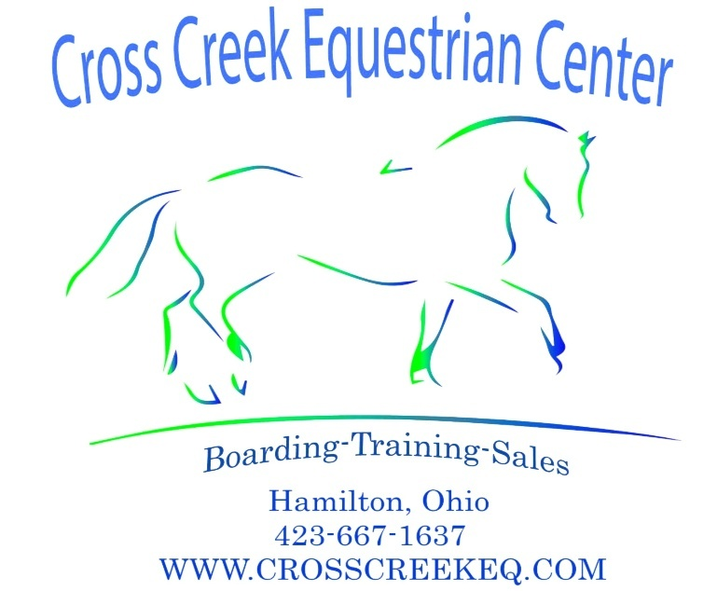

WAIVER OF EQUINE ACTIVITY LIABILITY
The undersigned does hereby agree that [circle one:] (myself/my child/my ward) is an
equine activity participant by way of presence upon the premises of this business. This
Voluntary Waiver and Release from tort and civil liability is made this _____ day of
__________, 20__ (year), between Participant Releasor [insert name of
self/child/ward], ________________ _____________, and Releasee, the Kerr Family Revocable Living Trust, and Counterra LLC d.b.a. Cross Creek Equestrian Center on behalf of and for the benefit of itself and including but not limited to its President, owners, officers, directors, employees, contractors, and agents; and related real property owners (collectively, “CCEC”) :
1. The foregoing release is given for the purpose, among other things, of providing a
release under Section 2305.321(C) of the Ohio Revised Code. The term "equine
activity" is defined in Section 2305.321(A)(2)(a) to include, among other things, the
activities Participant engages in at CCEC with respect to the riding, watching,
enjoyment and physical location near horses upon an equine property. The term
"equine activity participant" includes Participant/Releasor, spectators, other riders,
and boarders in that regard.
2. For the purposes of this agreement, “Participant Releasor” refers to any and all
individuals who enter the premises of CCEC for the purpose(s) of enjoyment,
business, invitation, or engagement in mounted or unmounted activities. The entirety
of CCEC exists as an equine property with inherent risk, regardless of Participant’s
seemingly unrelated enjoyment of premises, plants, property, people, animals, nature,
housing, communal areas, facilities, and structures therein.
3. Participant has had the opportunity to inspect the premises and has satisfied himself
or herself that the general condition of the premises and the facility will provide an
adequate and reasonable level of safety for Participant, Participant’s equine and
Participant’s family, guests and visitors who enter the premises. Participants also
understand that CCEC serves as an equine property in a dynamic state that can and
will change over time. Regardless of whether the Participant is mounted or

unmounted, all activities on the premises of this equine property present the risk of
unexpected injury, horse-related or otherwise.
4. The Participant will be held responsible for any costs and damage accrued by
Participant’s use beyond normal wear and tear upon the premises of CCEC, mounted
or unmounted. Damage beyond normal wear and tear from horses or riders includes,
but is not limited to the destruction and cost of repairing/replacing fences, fencing,
gates, stalls, walls, wood, latches, posts, hooks, doors, jumps, arenas, communal
property, etc.
5. The undersigned hereby acknowledges that horseback riding and equine activities
are classified as a recreational sport activity with numerous obvious and non-obvious.
inherent risks always present in such activity despite all safety precautions.
6.PROTECTIVE EQUESTRIAN RIDING HELMETS ARE ENCOURAGED AT ALL
TIMES, ESPECIALLY WHILE MOUNTED. CCEC hereby encourages Participant that
all equine handlers and riders should purchase and wear a properly fitted and
secured riding helmet. Wearing such headgear while mounted, riding, dismounting, or
even just being around equines may prevent or reduce severity of some head injuries
and may even prevent death from occurring as a result of a falling, rearing, untrained,
startled, or otherwise dangerous occurrence.
7. The undersigned Participant/Releasor, on behalf of (himself / herself) or the
applicable minor child, and (his / her) respective representatives, heirs and assigns,
hereby releases, waives, discharges and agrees not to sue CCEC, including its
officers, directors, shareholders, employees, agents, contractors, farriers,
veterinarians and trainers and their successors and assigns (the “Releasees”), with
respect to any loss or damages, injuries or death to Participant/Releasor and the
equine (“horse/pony”) owned or utilized by Participant/Releasor or to any property of
Participant/Releasor, whether caused by the acts of any such Releasees or
Otherwise, to the extent of Ohio law.
8. Participant, on behalf of himself or herself and his or her designees, and their
respective representatives, heirs and assigns, hereby releases, waives, discharges
and agrees not to sue CCEC, its officers, its directors, shareholders, employees,
agents and contractors and their successors and assigns with respect to any liability
or claim made by any person with respect to the loss, sickness, disease, theft, injury
or death of the equine, whether caused by the negligence of CCEC or otherwise.
9. This release specifically covers, but is not limited to, the inherent risks of an equine
activity. Inherent risks refer to the danger or condition that is an integral part of an
equine activity, including, but not limited to, any of the following:
(a) the unpredictability of any equine's reaction to sounds, sudden movements,
unfamiliar objects, persons, or other animals;
(b) the possibility of any equine’s collision with another equine, another animal, a
person, or an object;
(c) the potential of an equine activity participant to act in a manner that may
contribute to injury, death, or loss to the person of the Participant or to other
persons, including, but not limited to, failing to maintain control over an equine
or failing to act within the ability of the equine activity participant;
(d) the unpredictability of how any equine may successfully or unsuccessfully
traverse over hazards, including, but not limited to, surface or subsurface
conditions; and/or
(e) the propensity of any equine to behave in ways that may result in injury,
death, or loss to persons on or around the equine.
10. With full understanding of the inherent risks involved in equine activity, some of
which have been described in Paragraph 11 above, Participant hereby waives and
releases Releasees from all tort and civil liability arising from or related to
Participant's participation in any equine activity to the extent of Ohio Law and the
Ohio Revised Code (O.R.C). This waiver and release hereunder includes all
Releasees including CCEC, its owners, property owners, officers, directors,
employees, agents, and independent contractors whether they be trainers, veterinary
personnel, farriers, equine care providers, maintenance personnel and any other
party engaging in equine activity as referred to under O.R.C. §2305.321(A)(2)(a).
11. The Participant/Releasor further understands that examples of the equine activity in
which Participant may be exposed to or engage in while on the premises of CCEC
include, but are not limited to:
(a) riding, jumping, showing, trail riding, and the like;
(b) teaching, instructing, and evaluation, of both the rider and the equine;
(c) routine care and feeding of the equine, including veterinary and farrier;
(d) trailering, transporting, loading and unloading of equines.
(e) placing or replacing horseshoes on an equine, removing of horseshoes or
the trimming of the hooves of an equine;
(f) breeding activity, both natural and artificial; and/or
(g) the provision of or assistance in the provision of veterinary treatment or
maintenance care for an equine.
12. Participant must carry their own health, accident, and/or major medical insurance to
cover injuries as a result of an equine activity. By signing below, Participant consents
for any emergency medical treatment that may be necessary or appropriate while at
CCEC. Participant also similarly and to the same extent, releases the Releasees from
any claims or demands with respect to any first aid, treatment or other services
rendered to Releasor or Releasor’s designee or to the equine utilized by Participant
or Participant’s designee in connection with the services contemplated by this
agreement.
13. CCEC shall not be responsible for any personal property belonging to Participant
and specifically disclaims any damage related to any loss, damage, theft or injury
occurring at CCEC facilities. Participant must carry his or her own personal property
insurance under an insurance policy or under a separate policy.
14. Participant agrees that Participant has been given sufficient time to read,
understand, and ask questions, if any, concerning the nature and scope of this
Voluntary Waiver Agreement.
15. This agreement shall be governed by and construed in accordance with the laws of
the State of Ohio. Participant further agrees that any cause of action related to or
arising out of this agreement shall be brought in the state or federal courts finding
venue in Butler County, Ohio.
16. In the event that any portion or clause of this agreement is found to be invalid and/or
unenforceable, any and all remaining provisions of this agreement shall remain
enforceable and in full effect.
SIGNATURES
_________________________________
CCEC, RELEASEE SIGNATURE

_________________________________
CCEC RELEASEE PRINTED NAME/
TITLE
DATE: ___________

_______________________________
PARENT/LEGAL GUARDIAN
SIGNATURE
_______________________________

PARENT/LEGAL GUARDIAN PRINTED
NAME
_________________________

PARTICIPANT/RELEASOR/BOARDER
PRINTED NAME
_________________________________

PARTICIPANT/RELEASOR/BOARDER
PRINTED NAME
DATE: _________________

PARTICIPANT EMERGENCY
CONTACT:
Name:___________________________

Phone number: ____________________
Relationship to
Participant________________________

