FULL CARE BOARDING AND SECURITY AGREEMENT
IT IS HEREBY AGREED TO/AS FOLLOWS:
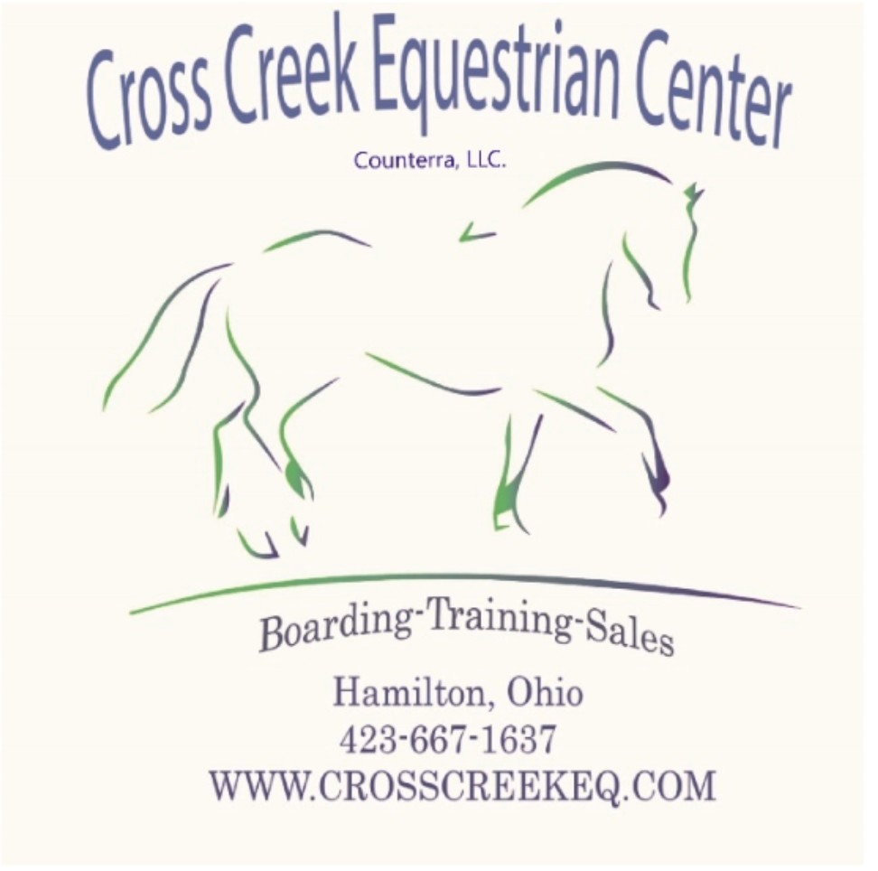
- DEFINITIONS. The term “OWNER” shall herein refer to the owner, part-owner, or lessee of the animal(s) which are contracted to be boarded under this Agreement. The terms “EQUINE” shall herein refer to all equine species or otherwise as boarded with this facility under this agreement. The terms “BOARD” and “BOARDING” shall herein refer to compensation for the provision of daily routine care, husbandry, food, and physical space for equine(s) by a party who generally does not otherwise have financial interest in the boarded equines(s). The term “RIDER” shall herein refer to a person who rides a horse mounted or otherwise handles or comes near a horse from the ground. “THIS STABLE” refers to the property and premises of the Kerr Family Revocable Living Trust and Counterra LLC d.b.a. Cross Creek Equestrian Center (CCEC).
- AGREEMENT PURPOSE and CONSIDERATION. At the commencement of this agreement Owner agrees to pay the monthly board of $________ per month (OPTIONS BELOW), per equine. This monthly board will be recurring monthly and shall be required at the time of move-in for undertaking of the board of the equine listed below. If move-in occurs after the 1st of the month, the first month’s board rate will be prorated by the days remaining in the current month. Monthly charges to be paid in advance and are due by the fifth day of each month or a $35 late fee will be accumulated each week payment(s) are late.
*Cancellation of this Boarding Agreement will require thirty (30) days written notice of cancellation to this stable, at the ordinary mailing address or email address with confirmation, and the date that the horse will be leaving. Board will not be prorated when horse(s) leave the premises.
- OWNER DISCLOSURES
Horse #1.
Registered Name: _______________________
Barn Name: _____________________________
Sex: _____________________ In Foal?: _______
Age/Foaling year : _______
Coat Pattern/Color:_______________________________
Markings: __________________________________
Tattoo/Microchip No.: _______________________________
Hoof Care:_____ Shod (front shoes only) ____ Shod (all four) _____ Barefoot ____ Other ___________________

*Please detail any medications, dosages, and medical conditions:
___________________________________________________________________________
____________________________________________________
*Please detail any behavioral issues or vices:
___________________________________________________________________________
____________________________________________________
Preferred/Current Farrier: ______________________ Phone Number:________________________
Preferred/Treating Veterinarian: ____________________ Phone Number:______________________

*Current vaccinations and date of administration: Administered by: _________________________ Please attach vaccination records

Horse #2
Registered Name: _______________________
Barn Name: _____________________________
Sex: _____________________ In Foal?: _______
Age/Foaling year : _______
Coat Pattern/Color:_______________________________
Markings: __________________________________
Tattoo/Microchip No.: _______________________________
Hoof Care:_____ Shod (front shoes only) ____ Shod (all four) _____ Barefoot ____ Other ___________________
*Please detail any medications, dosages, and medical conditions:
___________________________________________________________________________
____________________________________________________

*Please detail any behavioral issues or vices:
___________________________________________________________________________
____________________________________________________

Preferred/Current Farrier: ______________________ Phone Number:________________________
Preferred/Treating Veterinarian: ____________________ Phone Number:______________________

*Current vaccinations and date of administration: Administered by: _________________________ Please attach vaccination records

Horse #3.
Registered Name: _______________________
Barn Name: _____________________________
Sex: _____________________ In Foal?: _______
Age/Foaling year : _______
Coat Pattern/Color:_______________________________
Markings: __________________________________
Tattoo/Microchip No.: _______________________________
Hoof Care:_____ Shod (front shoes only) ____ Shod (all four) _____ Barefoot ____ Other ___________________

*Please detail any medications, dosages, and medical conditions:
___________________________________________________________________________
____________________________________________________
*Please detail any behavioral issues or vices:
___________________________________________________________________________
____________________________________________________
Preferred/Current Farrier: ______________________ Phone Number: ________________________
Preferred/Treating Veterinarian: ____________________ Phone Number: ______________________

*Current vaccinations and date of administration: Administered by: _________________________ Please attach vaccination records
D. FEE SCHEDULE.
Please Note–Fee schedule subject to change at any time. Should such a change be required, boarders will be provided with at least thirty (30) days’ notice.

CO OP BOARD: $765_/MONTHLY
- Box Stall provided and cleaned 5 days a week, with additional shavings added as needed. Owners are required to clean stall(s) twice weekly. **No more than one small wheelbarrow of shavings is allowed per day. NOTE: Additional bedding materials beyond the depth/amount provided by This Stable may be provided for an additional $_30_ per month.
- Owner provides all feed and supplements. Cross Creek will feed your provided grain/supplements twice daily.

- Alfalfa or Grass hay or other suitable grass/legume hay 2-3 times daily. NOTE: Additional forage/feed beyond the amount provided by this stable may be added for an additional charge of $30 per month
- Holding for scheduled farrier, veterinarians, chiro, etc. visits at additional cost of $_10_ minimum.
- Blanketing in accordance with weather conditions, as supplied by Owner
- Leg wraps on/off, as supplied by Owner
- Fly spray applied, Owner provided.

FULL CARE Board: $900/MONTHLY
- Box Stall provided and cleaned 7 days a week, with additional shavings added as needed. NOTE: Additional bedding materials beyond the depth/amount provided by This Stable may be provided for an additional $__30__ per month.
- Tribute Brand feeds, and beet pulp/alfalfa pellet mash soaked twice daily.
- Alfalfa or Grass hay or other suitable grass/legume hay 2-3 times daily. NOTE: Additional forage/feed beyond the amount provided by this stable may be added for an additional charge of $30 per month
- Holding for scheduled farrier, veterinarian, chiro, etc. visits included.
- Blanketing in accordance with weather conditions, as supplied by Owner. Plus, packaging and sending out blankets for repair or laundry. Will wash sheets or light blanket twice monthly if needed. Anything over 150grams needs to be sent out.
- Leg wraps on/off, as supplied by Owner
- Owner provided fly spray applied as needed.
TRAINING BOARD: $1450/MONTH
- 3 Training rides/Groundwork, weekly
- Box Stall provided and cleaned 7 days a week, with additional shavings added as needed. NOTE: Additional bedding materials beyond the depth/amount provided by This Stable may be provided for an additional $__30__ per month.
- Tribute Brand feeds, and beet pulp/alfalfa pellet mash soaked twice daily.
- Alfalfa or Grass hay or other suitable grass/legume hay 2-3 times daily. NOTE: Additional forage/feed beyond the amount provided by this stable may be added for an additional charge of $30 per month
- Holding for scheduled farrier, veterinarian, chiro, etc. visits included. Plus, package and send out all blankets for repair or laundry. Will wash sheets or light blanket twice monthly if needed. Anything over 150grams needs to be sent out.
- Blanketing in accordance with weather conditions, as supplied by Owner
- Leg wraps on/off, as supplied by Owner.
- Owner provided fly spray applied as needed.

AMENITIES FOR ALL BOARDERS INCLUDE:
- Tack room
- Lounge
- Restroom
- Daily paddock/pasture turn-out by staff, seven days/nights per week–weather and fields permitting.
- Wash rack access.
- Arena use/other boarder facilities. NOTE: Scheduled lessons/training times & Special Events will have priority for access and use of these facilities.
Description and fees of any additional service, feed, hay, supplement, etc. not listed must be attached in writing to this agreement, and charges will become
in addition to the board cost. The board amount will be entered in the signature block on the last page, and any additional or future changes shall be billed on a monthly basis.

- HEALTH REQUIREMENTS. The following up-to-date document must be presented to this stable by Owner prior to the entry of equine(s) onto the premises: (1) Deworming and Immunization Record and (2) Proof of a negative Coggins Test within 1 year of date of actual arrival.
Each horse to be boarded shall enter the premises free from transmissible diseases, and must be effectively wormed, and current on immunizations for Eastern/Western encephalomyelitis, tetanus, Potomac, rabies, West Nile virus and a Biannual flu/rhino. If boarded horses cannot receive immunization(s) due to pre-existing conditions/negative reactions to previous vaccinations, Owner must present a letter from the veterinarian stating this fact.
This stable reserves the right to have any new horse quarantined on the property for no more than 30 days in efforts to decrease the risk of transferable diseases to other boarded horses.
Additionally, as part of required routine care, the boarded horse(s) must participate in the immunization/ veterinary care, deworming protocol and regular farrier visits of this stable, the cost of which shall be borne by Owner.
- RIGHT TO REFUSE BOARD. This stable reserves the right to deny board and services to any equine(s) for any reason, including but not limited to: animal’s poor health or unsoundness; dangerous propensities, habits and/or vices; Owner’s refusal to obey stable rules or to cooperate with this stable on reasonable requests relative to the management, welfare and safety of animals and people on premises; or the discontinuation of the equine boarding business. This stable has the right to require immediate removal shall give Owner fifteen days written notice to remove boarded animal(s) from premises but has the right to request immediate removal of any horse and or person from the premises. After all fees have been paid in full, this Agreement is concluded. Failure to pay boarding fees or other charges as due, shall also entitle this stable to immediately terminate this Agreement, and to keep the horse(s) in the possession of this stable until all fees and charges are paid in full.
R.C.  §1311.48 | This Ohio law states that any person who feeds or boards an animal under contract with the owner shall have a lien on such animal to secure payment for food and board furnished.

- IN EVENT OF BOARDED HORSE ILLNESS OR INJURY. Should the
horse(s) become sick or injured, this stable shall attempt to telephone the Owner immediately. If the Owner does not immediately inform this stable regarding measures to be taken, or if the state of the animal’s health requires immediate emergency action, reasonable efforts will be made to contact your preferred veterinarian. However, this stable is authorized to request the services of a veterinarian of its choice or to give any other attention that appears necessary if you or your preferred veterinarian cannot be reached. This stable will not be responsible for any cost incurred in the course of emergency medical services. The Owner shall promptly pay all expenses for all services to whomever is owed.
Please check one:

______ I do authorize treatment for injuries or illness if I or my contacts cannot be reached. *Cross Creek will do their best to reach your preferred veterinarian, if we cannot reach them, we reserve the right to choose a veterinarian to treat your horse that is in our care. The Owner will incur ALL costs associated with any Injury or illness.
______ I solely authorize treatment for the purpose of comfort and/or euthanasia at the discretion of the veterinary services provider. Owner will incur any costs associated with any injury or illness.
______ I solely Decline any treatment for my horse(s) from any veterinarian at this time.
- VISITOR PERMISSION TO HANDLE HORSE(S). In the event someone other than the Owner and/or his/her family members call for the boarded horse(s) at this stable, such parties shall have written permission from the Owner or other agreed Party upon pre- arranged permission with this stable to remove, handle, or ride specific boarded horse(s) and must sign a liability release waiver.
- OWNER ACCEPTANCE OF RESPONSIBILITY. Owner/Parent/Legal
Guardian has inspected this stable’s premises and/or is in some other way satisfied with the condition of the premises and ability of the facility to provide an adequate and reasonable level of safety for the horse(s), owners, family, guests, and visitors who enter upon the premises. Owner agrees to be responsible and indemnify this stable for any and all damages, injuries, loss of life caused by or to the animal(s) while in the care, custody and control of the Owner, Owner’s family members, guest or other handler or agent appointed by them, and also for any acts of the horse(s) caused by vices or dangerous behavior to this stable by Owner. Owner is solely responsible for accidents, injuries, and loss of life sustained by Owner, Owner’s family members, guests, and agents caused by or in relation to the Owner’s boarded horse(s). Owner agrees to at all times maintain adequate accident/medical/health insurance to cover Owner and family members. Owner will hold harmless this stable and its employees for any damages, injuries, loss of life caused by or to the animal(s) while in the care, custody and control of the Owner, Owner’s family members, guest or other handler or agent appointed by them, and also for any acts of the horse(s) caused by vices or dangerous behavior not disclosed by this stable by Owner, regardless of whether the Owner ultimately decides to avail or opt out of the suggested insurance coverages.
- RELEASE OF LIABILITY. In consideration of this stable undertaking the board and related services under the terms set forth herein, I, the undersigned Owner, do agree to hold harmless and release this stable, its owners, agents, employees, officers, ensigns, members, premises owners, insurers and affiliated organizations from all legal liability for any economic and non-economic losses due to bodily injury, death, property damage, and injury to or loss by death of the boarded animal(s), and/or sustained by me and/or my minor child or legal ward in relation to the premises and operations of this stable, except as is due to willful and wanton or intentional misconduct.

- INHERENT RISKS AND NATURE OF THE HORSE WARNING. Owner is advised and agrees that Horseback (Equine) riding and horse (Equine) driving is classified as an inherently dangerous activity with inherent risks that this stable cannot be held liable for as Owner is a participant in inherently dangerous activities. Equestrian sport, handling, and ownership
is a RUGGED ADVENTURE RECREATIONAL SPORT ACTIVITY, and there are numerous obvious and non-obvious inherent risks always present in such activity despite all safety precautions. No horse is a completely safe horse. Horses are 5 to 15 times larger, 20 to 40 times more powerful, and 3 to 4 times faster than that of a human. If a rider falls from horse to the ground, it will generally be at a distance of from 3 1/2 feet to 5 1/2 feet, and the impact may result in injury to the rider. Horseback riding/driving is the only sport where one much smaller, weaker predator animal, the human, tries to control and become one unit of movement with another much larger, stronger prey animal, the horse, with each having a limited understanding of the other. If a horse is frightened or provoked, it may divert from its training and act according to its natural survival instincts which may include, but not limited to stopping short, changing direction or speed at will, shifting its weight from side to side, bucking, rearing, kicking, biting, striking, or running from danger.
- RIDING HELMET WARNING. Owner is hereby warned by this stable that all horse handlers and riders should purchase, and wear properly fitted and secured protective headgear (equestrian riding helmet), and that wearing of such headgear while mounted, riding, dismounting and being around horses, may prevent or reduce severity of some head injuries and may even prevent death happening as a result of a fall or other occurrence. PROTECTIVE EQUESTRIAN RIDING HELMETS ARE REQUIRED WHILE
GOING OVER FENCES, JUMPS, POLES, OR ANY OBSTACLE RAISED ABOVE THE GROUND LEVEL. Failure to comply with the safety rules required at the discretion of this stable management can result in board cancellation and/or dismissal or permanent suspension from the premises.
- DIRECT LOSS TO PERSONAL PROPERTY WARNING. Owner is hereby warned that while on this stable’s premises direct loss, damage, theft, or injury to Owner’s equine(s), tack, equipment and trailer is not covered by this stable’s insurance. The actual Owner, having financial interest in such items, must carry his own personal property insurance under a homeowner’s, tenants or other insurance policy, or under a separate policy as in the case of equine mortality. This stable cannot be held liable for third party activities resulting in direct loss, damage, theft, or injury to the Owner’s equine(s), tack, equipment, or trailer where there is no willful and wanton or intentional misconduct exercised by this stable and its agents.
- AGREEMENT SCOPE AND TERRITORY. This agreement shall be legally binding upon this stable and the Owner, and Owner’s parents or legal guardians, should Owner be a minor, when signed by both parties. This agreement is entered into in the state and county of domicile of this stable and will be interpreted and enforced under the laws of Ohio. Any disputes
by the Owner shall be litigated and venue shall be the county in which this stable is physically located. If any clause, phrase or word is in conflict with the State Law, then that single part is null and void.

- LIEN AGAINST BOARDED ANIMAL(S).
The Owner hereby grants a possessory lien against the boarded animal(s) to this stable for the value of all unpaid charges resulting from boarding and rendering any other services to the animal(s). Should such charges go unpaid this stable shall be entitled to exercise the right to enforce said lien according to the laws of Ohio. The Owner is advised that a Lien will be placed after sixty days of nonpayment.
- OWNER RIGHT OF TERMINATION. Upon thirty days written notice to this stable, the Owner may terminate this Agreement for any reason, and such Agreement with this stable shall be concluded.

R.C. §  2305.321 | This act stipulates that an equine sponsor, equine activity participant, equine professional, veterinarian, farrier, or any other person is not liable in damages in a tort or other civil action for harm that an equine activity participant allegedly sustains during an equine activity, which resulted from the inherent risks of equine activities.
ALL OWNERS AND PARENTS OR LEGAL GUARDIANS, OR AUTHORIZED AGENT FOR SUCH PARTIES, MUST SIGN BELOW AFTER READING THIS ENTIRE DOCUMENT.
I/WE THE UNDERSIGNED, HAVE READ AND DO UNDERSTAND THE
FORGOING AGREEMENT, WARNINGS, ASSUMPTIONS OF RISK AND RELEASE AGREEMENT. I/WE FURTHER ATTEST THAT ALL STATED FACTS ARE TRUE AND ACCURATE.
1st Owner/s Signature: Date:
Print Name:
Address: ___________________________________________________
Phone _______________________ ALT Phone #____________________________
Emergency Contact
Emergency Phone #
Email ___________________________________________________
2nd Owner/s Signature: Date:
Print Name:
Address: __________________________________________________________
Phone: ______________________ ALT Phone:___________________________
Emergency Contact
Emergency Phone #
Email:__________________________________________________

