Jackson Center Presbyterian Church
June 21, 2026 4th Sunday after Pentecost

Pastor Bill Spangler Organist – Jane Buckley
Welcome/Announcements

Prelude "Faith of Our Fathers"

Call to Worship
L: Praise be to the God and Father of our Lord Jesus Christ, who has blessed us in the heavenly realms with every spiritual blessing in Christ.
P: For He chose us in Him before the creation of the world to be holy and blameless in His sight.
L: In love, He predestined us for adoption to sonship through Jesus Christ, in accordance with His pleasure and will
P: To the praise of His glorious grace, let us worship our God!

*Hymn of Praise The Church’s One Foundation #277

*Prayer of Confession (in unison, followed by a moment of silence)

Merciful God, you pardon all who truly repent and turn to you. We humbly confess our sins and ask your mercy. We have not loved you with a pure heart, nor have we loved our neighbor as ourselves. We have not done justice, loved kindness, or walked humbly with you, our God. Have mercy on us, O God, in your loving-kindness. In your great compassion, cleanse us from our sin. Create in us a clean heart, O God, and renew a right spirit within us. Do not cast us from your presence, or take your Holy Spirit from us. Restore to us the joy of your salvation and sustain us with your bountiful Spirit. Amen.

*Assurance of Pardon
*Gloria Patri #623

Children’s Sermon Marilyn and Marmee Snyder

Duet: “In the Garden” June Montgomery and Marmee Snyder
Presentation of our Tithes and Offering
"Take the Name of Jesus With You"

*Doxology #625
*Dedication

Pastoral Prayer and the Lord’s Prayer

*The Apostles’ Creed

Old Testament Lesson Psalm 118: 18-24

*Hymn of Preparation Teach Me Thy Way, O Lord (1,4) #395

New Testament Lesson 1 Peter 2: 1-9

Morning Message “Why are we so driven by acceptance?”

*Closing Hymn Go Tell it on the Mountain #138

*Benediction
*Musical Benediction "God Will Take Care of You"
*Organ Postlude

*Those who are able to stand comfortably, may do so
(Please silence your devices for worship)
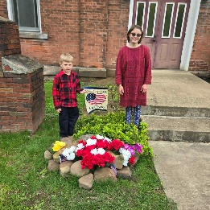
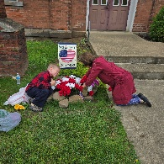
Jackson Center Presbyterian Church
1227 Franklin Rd. PO Box 66
Jackson Center, Pennsylvania 16133

Pastor Bill Spangler
Call/Text (724) 300-0396
sportsboi854@gmail.com
jcpc66@outlook.com

Social Media/Website
http://www.thejcpcpa.com

Church Staff:

Ministers: All members
Lead Pastor: Bill Spangler
Clerk of Session Jan Lawrence
Organist/Pianist Jane Buckley

The Session of Elders:
Bill Spangler (Pastor), Jan Lawrence (Clerk of Session), Ellen Swartz, Paul Buckley, Wayne Mittelmeier

The Deacons:
Jane Buckley, Abbey Clark, Evelyn Boggs, Barb Dye

Membership at JCPC
Becoming a member of Jackson Center Presbyterian Church only requires a public profession of faith in Jesus Christ. To learn more about membership at JCPC, feel free to contact Pastor Bill.

