Jackson Center Presbyterian Church
December 31, 2025 New Year’s Eve Service
Pastor Bill Spangler Organist – Jane Buckley

Prelude

Call to Worship

L: A new day has dawned, a new year begun O Lord, call us so we may hear Your voice.

P: The world turns to hopes and dreams of the future O Lord, keep us in Your ways and on Your path.

L: We enter this new year with hope and excitement O Lord, remind us that You lead us.

P: O Lord, guide us as we look to You and worship You.

All: Let us worship God

*Hymn of Praise Great is Thy Faithfulness #43

*Invocation and Lord’s Prayer

Children’s Sermon

Scripture Readings Isaiah 43:18-19 Anna Riddle
2 Corinthians 5:17

*Hymn of Preparation Hark the Angels Sing #133

Text: Philippians 3:13-14

New Year’s Eve Message “Forgetting the Past”

*Closing Hymn Lead on, O King Eternal #483

*Benediction
*Organ Postlude

*Those who are able to stand comfortably, may do so

Everyone is invited to the fellowship hall following the service for Pizza, snacks, cake, games, movies, and good fellowship.

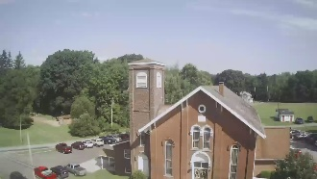
Jackson Center Presbyterian Church
1227 Franklin Rd. PO Box 66
Jackson Center, Pennsylvania 16133
jcpc66@outlook.com

Pastor Bill Spangler
Call/Text (724) 300-0396
sportsboi854@gmail.com

Social Media/Website
http://www.thejcpcpa.com

Participating in Service tonight:
Anna Riddle Lector
Jane Buckley Organist

Membership at JCPC
Becoming a member of Jackson Center Presbyterian Church only requires a public profession of faith in Jesus Christ. To learn more about membership at JCPC, feel free to contact Pastor Bill.

