Jackson Center Presbyterian Church
May 31, 2026 Trinity Sunday

Pastor Bill Spangler Organist – Jane Buckley
Welcome/Announcements

Prelude "May Jesus Christ Be Praised"

Call to Worship
L: Come into this household of the living God, the Three in One.
P: We have come as the family of Christ, led by the Spirit of God.
L: Ascribe to the Divine glory and strength; ascribe to God the glory that is due. Worship the Triune God in the Beauty of Holiness.
P: Our hope is that in this time of worship and learning, we might embrace what lies beyond our imagination and understanding.
ALL: Let us Worship God!

*Hymn of Praise Holy, Holy, Holy #262

*Prayer of Confession (in unison, followed by a moment of silence)

Almighty God, forgive us for thinking small thoughts of you and for ignoring your immensity and greatness. Jesus Christ, forgive us when we forget that you rule the nations and our small lives. Holy Spirit,
we offend you in minimizing your power and squandering your gifts.
O triune God, we confess that our blindness to your glory, has resulted in shallow confession, tepid conviction, and only mild repentance. Holy God, Holy Mighty, Holy Immortal, have mercy on us.
Amen.

*Assurance of Pardon
*Gloria Patri #623

Children’s Sermon

Special Music: Duet by June Montgomery and Marmee Snyder
"In My Heart There Rings a Melody"

Presentation of our Tithes and Offering
"Waters of New Life"

*Doxology #625
*Dedication

Pastoral Prayer and the Lord’s Prayer

*The Apostles’ Creed

Old Testament Lesson Psalm 8: 1-9

*Hymn of Preparation Trust and Obey #349

New Testament Lesson Matthew 28: 16-20

Morning Message “We Love. We Go. We Serve.”

*Closing Hymn Take My Life and Let It Be #379

*Benediction
*Musical Benediction "God Will Take Care of You"
*Organ Postlude

*Those who are able to stand comfortably, may do so
(Please silence your devices for worship)
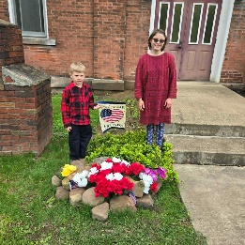
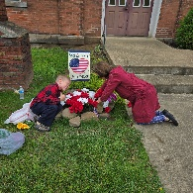
Jackson Center Presbyterian Church
1227 Franklin Rd. PO Box 66
Jackson Center, Pennsylvania 16133

Pastor Bill Spangler
Call/Text (724) 300-0396
sportsboi854@gmail.com
jcpc66@outlook.com

Social Media/Website
http://www.thejcpcpa.com

Church Staff:

Ministers: All members
Lead Pastor: Bill Spangler
Clerk of Session Jan Lawrence
Organist/Pianist Jane Buckley

The Session of Elders:
Bill Spangler (Pastor), Jan Lawrence (Clerk of Session), Ellen Swartz, Paul Buckley, Wayne Mittelmeier

The Deacons:
Jane Buckley, Abbey Clark, Evelyn Boggs, Barb Dye

Membership at JCPC
Becoming a member of Jackson Center Presbyterian Church only requires a public profession of faith in Jesus Christ. To learn more about membership at JCPC, feel free to contact Pastor Bill.

