Jackson Center Presbyterian Church
June 14, 2026 3rd Sunday after Pentecost

Pastor Bill Spangler Organist – Jane Buckley
Welcome/Announcements
Minute for Mission Jan Lawrence

Prelude "A Song of Rejoicing"

Call to Worship
L: The earth is the Lord's, and everything in it. Who may ascend the hill of the Lord? Who may stand in His holy place?
P: Those with clean hands and pure hearts. Those who do not lift up their souls to an idol.
L: Hear the invitation of our Creator: "Be holy, for I am holy."
P: We come not by our own righteousness, but by Your grace. We bow down to worship the Lord in the beauty of holiness.
All: Let us worship the Lord!

*Hymn of Praise Immortal, Invisible #25

*Prayer of Confession (in unison, followed by a moment of silence)

Father of mercies, we confess that we have sinned against you, chasing after that which cannot satisfy us. By your Holy Spirit, come and work repentance into our hearts. Help us to see you as you are: with outstretched arms, a loving heart, and power to save. Help us to see Jesus, the friend of sinners, and to follow him more faithfully. As we have received him, so strengthen us to walk in him, depend on him, commune with him, and be conformed to him. Give us an experience of your grace that makes us bold, that we might joyfully live for the good of others. Amen.

*Assurance of Pardon
*Gloria Patri #623
Children’s Sermon

Presentation of our Tithes and Offering
"Something for Thee"

*Doxology #625
*Dedication

Pastoral Prayer and the Lord’s Prayer

*The Apostles’ Creed

Old Testament Lesson Leviticus 19: 1-8

*Hymn of Preparation Take Time to be Holy #442

New Testament Lesson 1 Peter1: 13-25

Morning Message “Are you Committed to becoming Holy”

*Closing Hymn O for a Heart to Praise My God #440

*Benediction
*Musical Benediction "God Will Take Care of You"
*Organ Postlude

*Those who are able to stand comfortably, may do so
(Please silence your devices for worship)
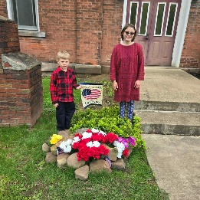
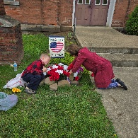
Jackson Center Presbyterian Church
1227 Franklin Rd. PO Box 66
Jackson Center, Pennsylvania 16133

Pastor Bill Spangler
Call/Text (724) 300-0396
sportsboi854@gmail.com
jcpc66@outlook.com

Social Media/Website
http://www.thejcpcpa.com

Church Staff:

Ministers: All members
Lead Pastor: Bill Spangler
Clerk of Session Jan Lawrence
Organist/Pianist Jane Buckley

The Session of Elders:
Bill Spangler (Pastor), Jan Lawrence (Clerk of Session), Ellen Swartz, Paul Buckley, Wayne Mittelmeier

The Deacons:
Jane Buckley, Abbey Clark, Evelyn Boggs, Barb Dye

Membership at JCPC
Becoming a member of Jackson Center Presbyterian Church only requires a public profession of faith in Jesus Christ. To learn more about membership at JCPC, feel free to contact Pastor Bill.

