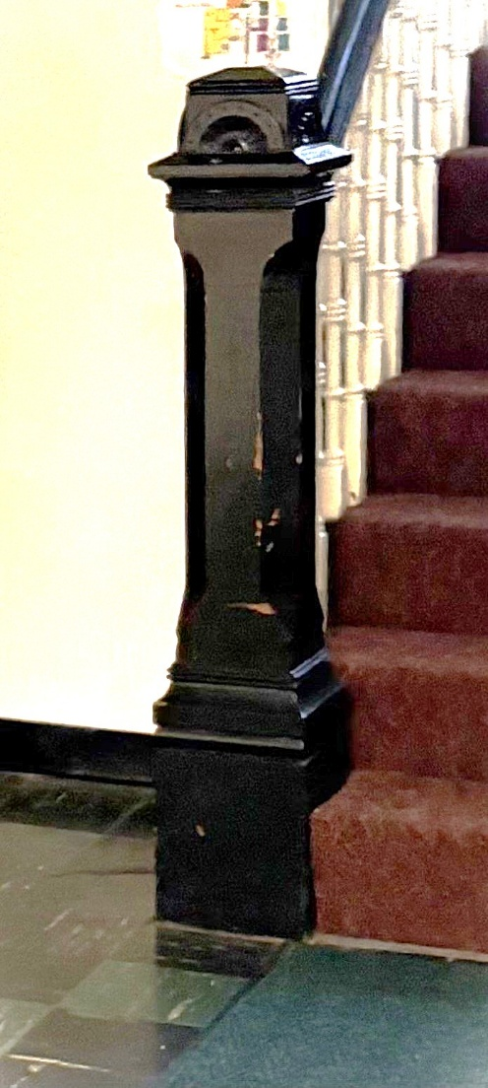**Nursery**

Children are always welcome in our worship service. We also have a nursery available during the 10:00 a.m. worship service.

**Adult Sunday School Class**

Join us for a Sunday Morning Adult Sunday School class from 9:00 a.m. – 9:45 a.m.  in the downstairs fellowship hall. All are welcome.

**Save the Date**

Mercer Back to School Prayer Party, August 24

Trinity’s Welcome Home Sunday and Tarry, September 7

Middler Night at Trinity, September 19

Trinity Rummage Sale, October 24 & 25

**Join Us for a Back to School Prayer Party Tonight**

Dr. Craley and the Mercer Ministerium invite you to join us as we pray together for our Mercer Mustang family tonight. If you plan to attend, please let Dr. Craley know. We are hoping to have representatives from various churches in Mercer. Prayers for teachers, bus drivers, administrators and students will be offered by different participants. At 6:00 p.m. meet at the Elementary school for prayer. Caravan to the High School. Pray at the High School. End by 7:15 p.m.

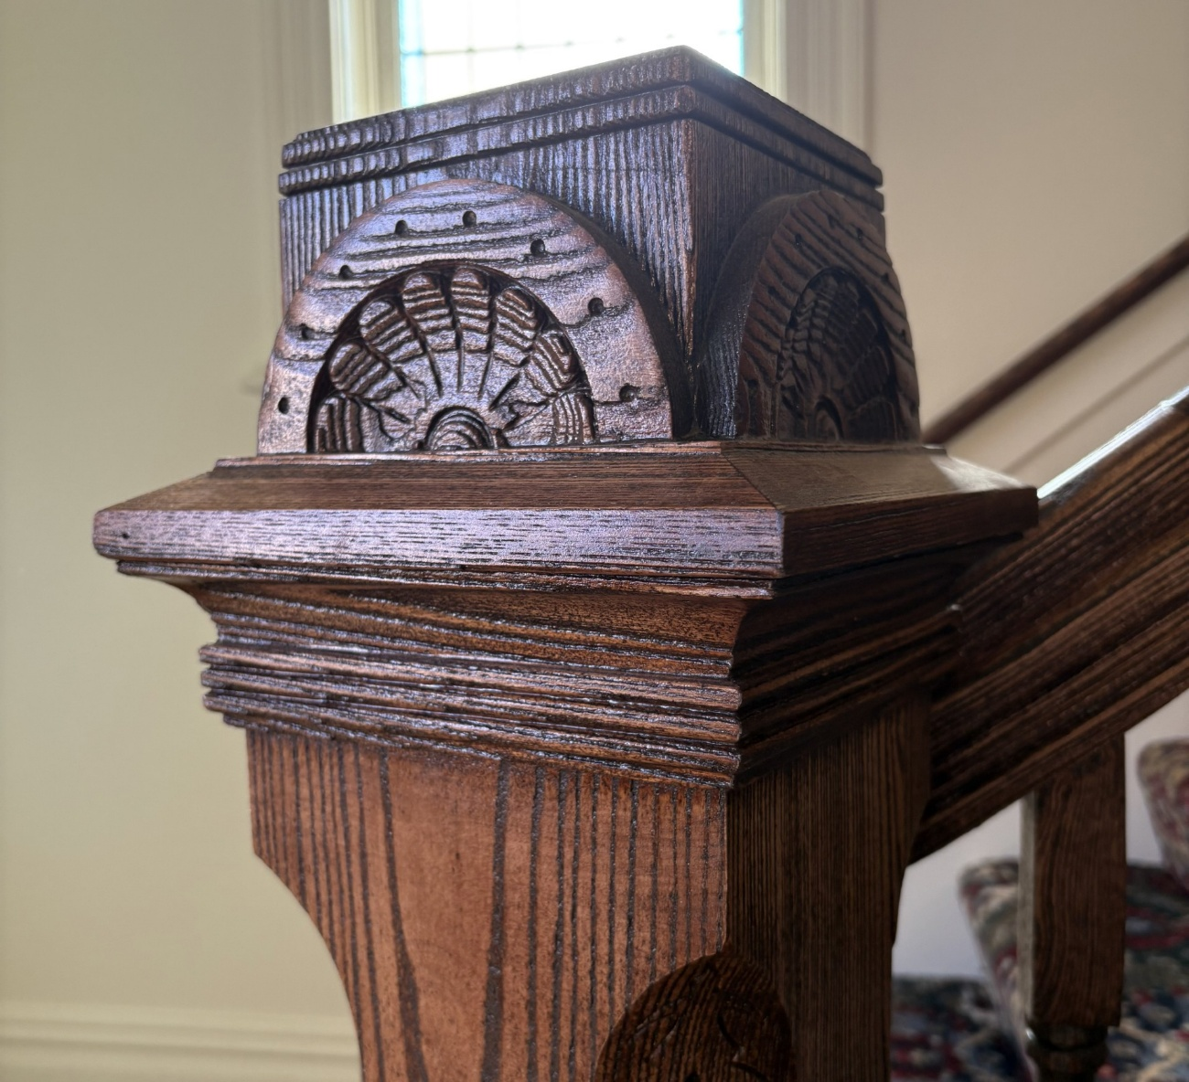

***ELEVENTH SUNDAY AFTER PENTECOST***

***August 24, 2025 10:00 A.M.***

***GATHERING IN GOD’S NAME***

*Vine of life, with thanksgiving we celebrate the growth and hope we have found in placing our roots in You. May our branches bow with the weight of the fruit you have bestowed. Amen.*

**Piano Prelude** "The Greatness of God Medley"      arr. Hugh Livingston, Jr.

**Organ Prelude “**Teach Me Thy Way, Lord” Gene Clark

**Welcome and News of the Church Family**

**Responsive Call to Worship**

**Leader:** Jesus said, *“I am the Bread of Life—whoever comes to me will never be hungry.”*  
**All:** **We come hungry for hope, and Jesus fills us up.**

**Leader:** Jesus said, *“I am the Light of the World—whoever follows me will never walk in darkness.”*  
**All:** **We come to walk in the light of His love.**

**Leader:** Jesus said, *“I am the Good Shepherd—I know my sheep, and my sheep know me.”*  
**All:** **We come as His people, known and loved.**

**Leader:** Jesus said, *“I am the Resurrection and the Life—those who believe in me will live.”*  
**All:** **We come to celebrate life that never ends.**

**Leader:** Jesus said, *“I am the Way, the Truth, and the Life.”*  
**All:** **We come to follow Him with our whole hearts.**

**Leader:** Jesus said, *“I am the Vine—you are the branches. Stay connected to me and you’ll bear fruit.”*  
**All:** **We come to stay rooted in His love.**

**Leader:** Friends, the great “I AM” is here.  
**All:** **Jesus is our Bread, our Light, our Shepherd, our Life — so let’s sing with joy and give Him our praise!”**

**\*Hymn of Praise #590** *(sing twice)* **“**This is the Day”

**Prayer of Confession** *(responsive)*

When we get lost in our social media feeds

**Jesus says “abide in my love”**

When we compare our lives, to the lives of the people in the next pew over

**Jesus says “abide in my love”**

When we look in the mirror and just feel old

**Jesus says “abide in my love”**

When we worry over a new school year, will our friends still like us? Will our team win? Will the tests be too hard?

**Jesus says “abide in my love”**

Lord, life is hard, but your love for us is eternal. Hear us as we silently confess to you, all the gets in the way of us abiding in your love.

**Silent Prayer**

**Assurance of Grace**

**\*Gloria Patri** “Gloria Patri” Greatorex

**Back to School Blessing**

**Moment of Offering and Thanksgiving:**

**Prayer of Dedication**

**\*Doxology** “Doxology” Old Hundredth

**Special Music** “For the Beauty of the Earth” Conrad Kocher, arr. Faye Lopez

*Jane Buckley, organ solo*

**Pastoral Prayer and the Lord’s Prayer**

***HEARING GOD’S WORD***

**First Scripture Reading**

**Hymn of Preparation #88** *(vs. 1-4)* **“**Fairest Lord Jesus”

**Second Scripture Reading**

**Meditation** Rev. Dr. Catherine Craley

***GOING IN GOD’S GRACE***

**\*Closing Hymn #551** *(vs. 1-4)*  “Soon and Very Soon **“**

\***Benediction** And let all God’s people say…**Alleluia, Amen**

****\*Organ Postlude** "To the Glory of God" Gerald Peterson

**Leading in Worship**

Rev. Dr. Catherine Craley

Pastor Bill Spangler

Organist Jane Buckley

"**Sing a New Song unto the Lord**"

One of the hymns from our Supplement is "Sing a New Song unto the Lord," in which we are challenged to "Shout with gladness! Dance for Joy!" for the Lords has "filled your soul with song." The music department is excited to return to our Sanctuary where we will fill the room with song. Kimberly and I look forward to long-time friends and new members singing a new song unto the Lord in the chancel choir and the worship band.

Our new schedule last winter allowed people to know exactly what they were getting into; as a result, both groups gained new members, so we will continue that schedule in 2025-2026. The worship band welcomes middle schoolers through adults and will sing and lead the service on the first Sunday of the month from October through December and February through May. The group will rehearse Sunday mornings at 9:00 a.m. in the sanctuary. Kimberly is working on the rehearsal schedule.

The chancel choir for middle schoolers and older will rehearse from 9:45-10:50 a.m. on the second Sunday of each month from September through April to rehearse and review the anthems to be sung on the third and fourth Sundays of each month. This schedule is ideal for those who head South in the winter, travel from time to time, visit family, or have a particularly "busy schedule" during a particular month. With this schedule, each month you can decide if you are available on the second, third, and fourth Sundays to allow you to sing that month. If Christmas music or Lent music really speaks to you, you can come at those times. Sounds pretty easy, right? So, we hope to see you in the choir room at 9:45 a.m. on September 14 and at 10:30 a.m. on September 21 and 28 for our first two anthems. And as a bonus, the choir will also sing at the 7:30 p.m. Christmas Eve service and during the Day of Resurrection service.

Please see Kimberly, Cary Cooper (if you're interested in the Trinity Hand Bell Choir), or me with any questions and let us know if you are coming so we can have the music ready for you. See all the features of our updated Sanctuary from a different perspective. You are always welcome...come, give us a try and "fill your soul with song."

~*Jim Sankey*