Jackson Center Presbyterian Church
August 2, 2026 10th Sunday after Pentecost

Pastor Bill Spangler Organist – Jane Buckley
Welcome/Announcements
Prelude "

Call to Worship
L: God's love surrounds us every day; our God is merciful and gracious.
P: Turn your backs upon idols, worship the Holy One of Israel.
L: Blessed are all who stand in awe before God; happy are all who walk in his ways.
P: The love of God has chosen us. The love of God unites us with all his people.
A: Let Us Worship God!

*Hymn of Praise For, the Beauty of the Earth #560
*Prayer of Confession (in unison, followed by a moment of silence)

Loving God, you have commanded us to love one another. Through your Son, you have shown what this love looks like, as he knelt to wash the feet of his disciples, as he laid down his own life out of love.
We confess that we have not loved our neighbor as ourselves. We do not lay down our pride in service of the other; but instead, we treat people as objects who might be of service to us. Yet, we expect unconditional love from our friends and family and partners. When their love is imperfect, even as our love is imperfect, we grow angry and bitter. Help us to forgive one another for our imperfect love,
even as you forgive us. Help us to love, and to love well, for in loving this world you have created, we live in love for you. Amen.

*Assurance of Pardon
*Gloria Patri #623

Children’s Sermon Marilyn and Marmee Snyder

Presentation of our Tithes and Offering
""
*Doxology #625
*Dedication

Pastoral Prayer and the Lord’s Prayer

*The Apostles’ Creed (#12 little blue book)

Old Testament Lesson Psalm 86: 11-17, Lamentations 3:22-23

*Hymn of Preparation Love Lifted Me #505

New Testament Lesson Romans 8:38–39

Morning Message God’s Love

*Closing Hymn Love Divine, All Loves Excelling #92

*Benediction
*Musical Benediction "God Will Take Care of You"
*Organ Postlude

*Those who are able to stand comfortably, may do so
(Please silence your devices for worship)

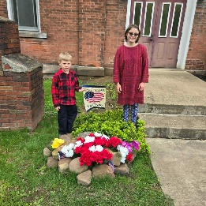
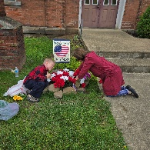
Jackson Center Presbyterian Church
1227 Franklin Rd. PO Box 66
Jackson Center, Pennsylvania 16133

Pastor Bill Spangler
Call/Text (724) 300-0396
sportsboi854@gmail.com
jcpc66@outlook.com

Social Media/Website
http://www.thejcpcpa.com

Church Staff:

Ministers: All members
Lead Pastor: Bill Spangler
Clerk of Session Jan Lawrence
Organist/Pianist Jane Buckley

The Session of Elders:
Bill Spangler (Pastor), Jan Lawrence (Clerk of Session), Ellen Swartz, Paul Buckley, Wayne Mittelmeier

The Deacons:
Jane Buckley, Abbey Clark, Evelyn Boggs, Barb Dye

Membership at JCPC
Becoming a member of Jackson Center Presbyterian Church only requires a public profession of faith in Jesus Christ. To learn more about membership at JCPC, feel free to contact Pastor Bill.

