Jackson Center Presbyterian Church
July 5, 2026 6th Sunday after Pentecost

Pastor Bill Spangler Organist – Jane Buckley
Welcome/Announcements
Prelude "My Shepherd Will Supply My Need"

Call to Worship
L: We gather this morning appreciating our freedom to worship God.
P: May God continue to bless the Church of Christ in this land.
L: We draw near to the God who rules over all nations
P: May God continue to bless our country and all the countries in the world.
L: We seek to live in harmony and peace together with all peoples on the earth.
P: May God continue to establish peace on earth and help us understand that it begins in our hearts.
A: Come, let us worship the Lord!

*Hymn of Praise This is the Day (3times) #590
*Prayer of Confession (in unison, followed by a moment of silence)

Almighty God, You love us, but we have not always loved You or our neighbors as we ought. Forgive us for our divisiveness, prejudice, and greed. Forgive us for times we have trusted in our own feeble plans rather than the solid rock of Christ. Forgive us for pledging our ultimate allegiance to the things of this world, and for the times we have turned a blind eye to injustice and cruelty. Heal our land, Lord, and wash us in Your mercy. Teach us to walk in Your ways and seek true justice and peace for all. In Jesus' name, Amen.

*Assurance of Pardon
*Gloria Patri #623

Children’s Sermon Marilyn and Marmee Snyder

Special Music How Great Thou Art Marilyn Rost

Presentation of our Tithes and Offering
"Mine Eyes Have Seen the Glory"

*Doxology #625
*Dedication

Pastoral Prayer and the Lord’s Prayer

*The Apostles’ Creed (#12 little blue book)

Old Testament Lesson Exodus 20: 1-6

*Hymn of Preparation Joy to the World (1,3,4) #125

New Testament Lesson John 8: 31-36; Galatians 5: 1

Morning Message “Let me Out of Here!”

*Closing Hymn God of Grace and God of Glory #292

*Benediction
*Musical Benediction "God Will Take Care of You"
*Organ Postlude

*Those who are able to stand comfortably, may do so
(Please silence your devices for worship)
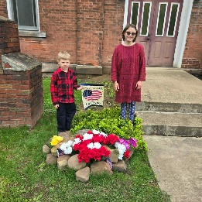
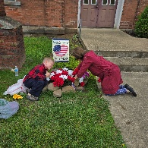
Jackson Center Presbyterian Church
1227 Franklin Rd. PO Box 66
Jackson Center, Pennsylvania 16133

Pastor Bill Spangler
Call/Text (724) 300-0396
sportsboi854@gmail.com
jcpc66@outlook.com

Social Media/Website
http://www.thejcpcpa.com

Church Staff:

Ministers: All members
Lead Pastor: Bill Spangler
Clerk of Session Jan Lawrence
Organist/Pianist Jane Buckley

The Session of Elders:
Bill Spangler (Pastor), Jan Lawrence (Clerk of Session), Ellen Swartz, Paul Buckley, Wayne Mittelmeier

The Deacons:
Jane Buckley, Abbey Clark, Evelyn Boggs, Barb Dye

Membership at JCPC
Becoming a member of Jackson Center Presbyterian Church only requires a public profession of faith in Jesus Christ. To learn more about membership at JCPC, feel free to contact Pastor Bill.

