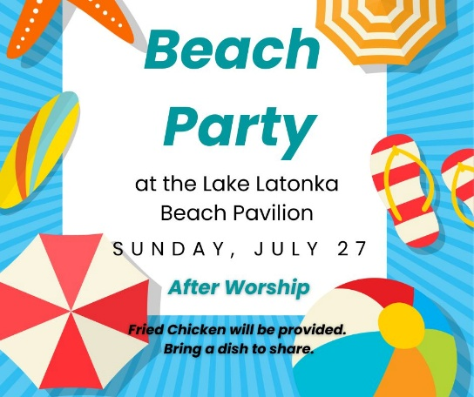

**Save the Date**

**July 27** Beach Party at Lake Latonka after Worship for Trinity and Jackson Center.

Fried chicken will be provided. Please bring a dish to share.

**“Get the Scoop”**

Want the "scoop" on Trinity’s Capital Campaign or the projects we have lined up for this summer? Click the "Get the Scoop" button in the Weekly Update. We will keep that information updated for you as we progress. You can also find this information on Trinity's website under the "About" page.

**Trinity’s Weekly Update**

If you’d like to receive the Trinity Presbyterian Church Weekly Update email, please email the Trinity Church office at [trinitymercer@hotmail.com](mailto:trinitymercer@hotmail.com) to sign up.

***FIFTH SUNDAY AFTER PENTECOST***

***July 13, 2025 10:00 A.M.***

***GATHERING IN GOD’S NAME***

*Lord Jesus, strengthen my faith so that I will neither fear nor doubt you.*

*Grant me the strength of your hand to help others who are afraid, like Simon Peter.*

**Piano Prelude** "Crown Him with Many Crowns" arr. James Koerts

**Organ Prelude** “Summer Leaf” E.L. Ashford

**Welcome and News of the Church Family**

**Responsive Call to Worship**

L: Jesus invited Peter to walk on the water with him.

**P:** **We hear that invitation today, to step out in faith, trusting in Jesus' power and presence.**

L: Let us not be afraid of the waves that buffet us, but trust in the one who walks with us.

**P:** **We come to worship the one who empowers us to overcome obstacles and to walk in his ways.**

**Let us worship God:**

**\*Hymn of Praise #353** “A Shelter in the Time of Storm”

**Prayer of Confession** (*unison)*

**Lord Jesus, you walked on the sea to bring comfort and assurance to your disciples. We confess that we often fail to trust you in the midst of our own storms. We allow fear and doubt to grip us, causing us to take our eyes off of you and sink under the weight of our circumstances. Forgive us for our lack of faith, for our tendency to focus on the waves rather than on your presence. Help us to fix our eyes on you, to trust in your power to calm the storms and lead us safely through. Grant us the courage to step out of the boat, even when we are afraid, and to walk by faith, not by sight. In your name, we pray. Amen.**

**Silent Prayer**

**Assurance of Grace** *(unison)*

**No matter how challenging life becomes, Jesus is always near, ready to support and guide us, offering His grace and strength. In Jesus Christ, we are forgiven. Thanks be to God!**

**\*Gloria Patri** “Gloria Patri” Greatorex

**Children’s Message**

**Moment of Offering and Thanksgiving:**

**Prayer of Dedication**

**\*Doxology** “Doxology” Old Hundredth

**Special Music** "I Found the Answer"               Johnny Lange

*Hugh Ringer, solo*

**Pastoral Prayer and the Lord’s Prayer**

***HEARING GOD’S WORD***

**First Scripture Reading** Matthew 14: 22-31

**Hymn of Preparation #329** “The Savior Is Waiting”

**Second Scripture Reading** John 6: 16-21

**Meditation** “Why Do We Doubt” Pastor Bill Spangler

***GOING IN GOD’S GRACE***

**\*Closing Hymn #410** “My Faith Looks Up to Thee”

\***Benediction** And let all God’s people say…**Alleluia, Amen**

**\* Organ Postlude** "Postludio Andantino"          LeFebure Wely



**Leading in Worship**

Pastor Bill Spangler

Organist Jim Sankey

**Please Keep Our Alaska Mission Team in Your Prayers**

Jeff and Marcia Colson

Ginny Highfield

Laurie Mahen

Debbie Moose

Michael Moose

Walt and Luanne Rock

**Men’s Breakfast**

All men are welcome to join us for a Men’s Breakfast at Jackson Center Presbyterian Church this Saturday, July 19, at 8:00 a.m.

**Urban Plunge 2025, July 31st**

On Thursday, July 31st, our youth are invited to join us for a day serving in the city of Pittsburgh. We will spend the morning cooking and serving a meal to about 150 neighbors at the East End Cooperative Ministry in East Liberty. After serving, we will learn more about the ministry from its Director, Rev. Darnell Leonard. Then, we will head out for a late lunch in the neighborhood. Our adventure is open to rising 7th graders and above. This includes our college students and young adults! We plan to be together from 7:30 a.m. - 4:00 p.m. Space is limited so sign up today using the link in our Weekly Update. Thanks to the Watsons for the gift of our transportation.

**Adult Sunday School Class**

Join us for a Sunday Morning Adult Sunday School class from 9:00 a.m. – 9:45 a.m.  in the downstairs fellowship hall. All are welcome.

**Nursery**

Children are always welcome in our worship service. We also have a nursery available during the 10:00 a.m. worship service.