**Join us for Worship Next Sunday Morning for "Christmas in July" at Jackson Center**

Our Christmas festivities will be followed by a Beach Party at the Lake Latonka Pavillion. Join us for fun, games, and free ice cream at Duke and Lolas. Fried Chicken will be provided, bring a dish to share.

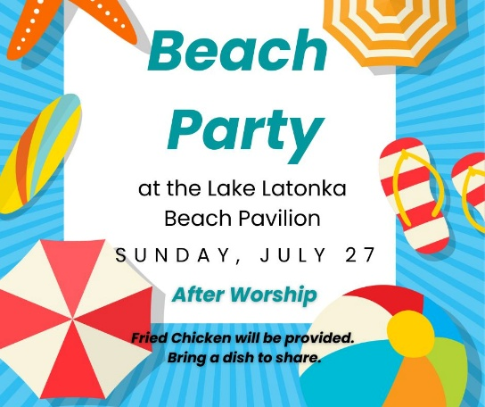

**Save the Date**

**July 20-23** New Wilmington Mission Conference

**July 27** Christmas in July andBeach Party at Lake Latonka after Worship

**July 31** Urban Plunge, 2025

***SIXTH SUNDAY AFTER PENTECOST***

***July 20, 2025 10:00 A.M.***

***GATHERING IN GOD’S NAME***

*God, show me the life I actually have, the reality that is truest now—the whole of it. Let me hold the doubts and questions together with the graces that are here too. And in your kindness, help me begin to understand how to live more, with fewer explanations. Amen. ~ Kate Bowler and Rev. Jessica Richie*

**Piano Prelude** "Living for Jesus" C. Howard Lowden, arr. Robert Thygerson

**Organ Prelude** "A Simple Prayer" Edward Grieg, arr. Lani Smith

**Welcome and News of the Church Family**

**Minute for Ministry** Common Grounds Coffeehouse

**Preparing Our Hearts for Worship** “Where Can I Turn for Peace?” Joleen Meredith

*Cary Cooper, violin and Ellen Campbell, piano*

**Responsive Call to Worship**

Those who rejoice and those who mourn,

**You are welcome here.**

Those who are sunburned and those who are road weary,

**You are welcome here.**

Those who have more questions than answers,

**You are welcome here.**

Kids, grandparents, parents, teenagers, gen-Zers, silver sneakers and everyone in between,

**Whatever your sorrow, whatever your joy, you are welcome here. Let us worship God.**

**\*Hymn of Praise #553** *(v. 1-3)*  “Sweet By and By”

**A Blessing for Stretching Your Heart** *(Unison) by Kate Bowler and Rev. Jessica Richie*

**God, my life has too many things. Awful. Lovely. Full. Shockingly incomplete. Will you help me learn to live with a greater capacity for this? …Let today be a divine exercise of yes ... *and*. Yes, I have so much to be thankful for, *and* this hasn't turned out like I thought it would. Yes, I feel moments of joy, *and* I have lost more than I could live without. Yes, I want to make the most of today, *and* my body keeps breaking. Yes, I am hopeful, *and* this is daunting. Yes, I am trying to be brave, *and* I feel so afraid. So bless me, trying to live in between those two words: yes ... *and*. May I understand this is where the real work of life is found. Where it takes courage to live. Where grief can strip me to the studs and love can remake me once again. Where my heart can be both broken and keep on beating. Never sorry to have broken at all. Yes ... *and*. Make me capable of great joy, great love, great risk, even fear, as you expand my heart with this *yes*... *and* today.**

**Silent Prayer**

**Assurance of Grace** *(unison)*

**No matter how challenging life becomes, Jesus is always near, ready to support and guide us, offering His grace and strength. In Jesus Christ, we are forgiven. Thanks be to God!**

**\*Gloria Patri** “Gloria Patri” Greatorex

**Children’s Message**

**Moment of Offering and Thanksgiving:**

**Prayer of Dedication**

**\*Doxology** “Doxology” Old Hundredth

**Special Music** “Turn Your Eyes Upon Jesus” Helen Lemmel

*Cary Cooper, violin and Ellen Campbell, piano*

**Pastoral Prayer and the Lord’s Prayer**

***HEARING GOD’S WORD***

**First Scripture Reading**

**Hymn of Preparation #463** *(v. 1-2)*  “Precious Lord, Take My Hand”

**Second Scripture Reading**

**Meditation**  Rev. Dr. Catherine Craley

***GOING IN GOD’S GRACE***

**\*Closing Hymn #202** *(v. 1-5)* “Amazing Grace”

\***Benediction** And let all God’s people say…**Alleluia, Amen**

**\*Postlude** "Our Lord, Master of All" Rex Koury******

**Leading in Worship**

Rev. Dr. Catherine Craley

Pastor Bill Spangler

Organist Jane Buckley

**Nursery**

Children are always welcome in our worship service. We also have a nursery available during the 10:00 a.m. worship service.

**Please Keep Our Alaska Mission Team in Your Prayers**

Jeff and Marcia Colson

Ginny Highfield

Laurie Mahen

Debbie Moose

Michael Moose

Walt and Luanne Rock

**Adult Sunday School Class**

Join us for a Sunday Morning Adult Sunday School class from 9:00 a.m. – 9:45 a.m.  in the downstairs fellowship hall. All are welcome.

**120th New Wilmington Mission Conference Runs Through July 23, 2025**

**At Westminster College, New Wilmington, PA**

The New Wilmington Mission Conference (also referred to as NWMC) is the longest-running Christian Mission-focused event in the United States. People from over 30 states and 20 countries attend and call NWMC home. The theme of this year's conference is Matthew 28:19 about being sent to tell the world about Jesus' love, that all may know. Check their website using the link in Trinity’s Weekly Update.

**“Get the Scoop”**

Want the "scoop" on Trinity’s Capital Campaign or the projects we have lined up for this summer? Click the "Get the Scoop" button in the Weekly Update. We will keep that information updated for you as we progress. You can also find this information on Trinity's website under the "About" page.