Jackson Center Presbyterian Church
July 12, 2026 7th Sunday after Pentecost

Pastor Bill Spangler Organist – Dick Croskey
Welcome/Announcements
Prelude "What a Friend We Have in Jesus"

Call to Worship
L: Come, sing and dance before the Lord.
P: Praise God with music and glad hearts!
L: Let every soul sing God’s great praises.
P: The earth rejoices in the heights and depths of God’s love.
L: Praise the King of glory who guides our lives.
P: Praise the Lord who watches over us today!

*Hymn of Praise The Solid Rock #404
*Prayer of Confession (in unison, followed by a moment of silence)

God of Salvation, we are grateful for the gift of your love. A love that has no bounds, a love that keeps reaching out to us, calling us to you.
We are more than your people. We are your beloved children. You reiterate throughout scripture your readiness to hear us when we pray to you. Forgive us when we forget how much you love us.
Forgive us for times we are unfaithful to you, times we fail to do as you’ve called. God, thank you for loving us in the most sacred and scandalous ways. You are God, and we trust that you journey with us in all things. Amen.

*Assurance of Pardon
*Gloria Patri #623

Children’s Sermon

Presentation of our Tithes and Offering
"The Emmaus Road"

*Doxology #625
*Dedication

Installation of New Members
Presentation
Profession of Faith
The Apostle’s Creed

Pastoral Prayer and the Lord’s Prayer

Old Testament Lesson Proverbs 16: 1-9, Psalm 90: 12

*Hymn of Preparation Take Time to Be Holy #442

New Testament Lesson 2 Corinthians 6: 1-13

Morning Message Now is the Time!

*Closing Hymn All Hail the Power of Jesus’ Name #97

*Benediction
*Musical Benediction "God Will Take Care of You"
*Organ Postlude

*Those who are able to stand comfortably, may do so
(Please silence your devices for worship)

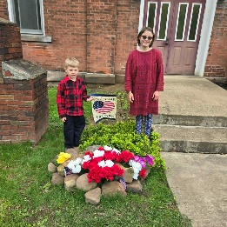
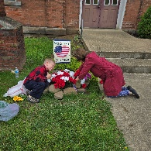
Jackson Center Presbyterian Church
1227 Franklin Rd. PO Box 66
Jackson Center, Pennsylvania 16133

Pastor Bill Spangler
Call/Text (724) 300-0396
sportsboi854@gmail.com
jcpc66@outlook.com

Social Media/Website
http://www.thejcpcpa.com

Church Staff:

Ministers: All members
Lead Pastor: Bill Spangler
Clerk of Session Jan Lawrence
Organist/Pianist Jane Buckley

The Session of Elders:
Bill Spangler (Pastor), Jan Lawrence (Clerk of Session), Ellen Swartz, Paul Buckley, Wayne Mittelmeier

The Deacons:
Jane Buckley, Abbey Clark, Evelyn Boggs, Barb Dye

Membership at JCPC
Becoming a member of Jackson Center Presbyterian Church only requires a public profession of faith in Jesus Christ. To learn more about membership at JCPC, feel free to contact Pastor Bill.

